SOFTWARE REQUIREMENT SPECIFICATION
DOCUMENT

DRUG TIME
Version: Version 1.0
ABSTRACT
This document is intended to be the SRS for developing DrugTime

Project Title | DrugTime
Project Mentor | B.Eng.Nguyen Trong Giap  PhD. Nguyen Duc Man
Contact Information
Start Date | 10/09/2026 | End Date

Table of Contents
1. Introduction 3
1.1. Purpose 4
1.2. Intended Audience and Reading Suggestions 4
1.3. References 5
2. Project Overview 6
2.1. Project Description 6
2.2. Business Problems 8
2.3. Business Need 8
2.4. Project Analyst 9
2.4.1. Business Function Diagram 10
2.4.2. System Context Diagram 11
2.4.3. Data Flow Diagram 13
2.5. Software Requirement Specification 14
2.5.1. High level Fucntional Requirement (FR) 14
2.5.2. Stakeholders 14
2.5.3. Usecase 14
2.5.3.1. List of use cases 15
2.5.3.2. <<project name>> Use Case Diagram Overview 15
2.5.4. List of business rule 15
2.5.5. Use Case Specification 19
UC 001: Register User Account 19
UC 02: Authenticate User 24
UC 03: Manage Purpose-Separated Consent 28
UC 04: Check Drug Safety / Drug Interaction 33
a) Use Case Diagram 34
b) Use Case Specification 34
c) Prototype 39
UC 05: Manage Medication 39
a) Use Case Diagram 39
b) Use Case Specification 39
c) Prototype 45
UC 06: Add Medication by Blister-Pack Scan 45
UC 07: Review and Confirm Scanned Medication 45
UC 08: Manage Recorded Medication 46
UC 09: Manage Medication Schedule 46
UC 10: Receive Medication Dose Reminder 46
UC 11: Confirm Medication Dose Intake 46
UC 12: Track Medication Adherence History 46
UC 13: Link Family Caregiver Account 46
UC 14: Manage Caregiver Permissions 46
UC 15: Manage Multiple Linked Patients 46
UC 16: Look Up Drug Information 47
UC 17: Check Drug-Drug Interaction 47
UC 18: Check Drug-Food Interaction 47
UC 19: Generate AI Meal Suggestion 47
UC 20: Configure Simple Mode Display 47
UC 21: Manage Medication Catalogue 47
UC 22: Manage Interaction Catalogue 47
UC 23: Synchronize Regulatory Drug Data 47
UC 24: Review Unmatched Medication Scan Results 48
UC 25: Submit Data-Deletion Request 48
UC 26: Manage Privacy, Compliance and Sensitive-Data Access 48
2.5.6. Software Quality Attributes 48
2.5.6.1. Usability 48
2.5.6.2. Reliability 49
2.5.6.3. Security 50
2.5.6.4. Maintainability 50
2.5.6.5. Portability 51
2.5.6.6. Performance 51
2.6. Software Design Description 52
2.6.1. Sequence Diagrams 53
2.6.1.1. Cập nhật thông tin nhân viên 53
2.6.1.2. Quan hệ Gia đình 53
2.6.2. Activity Diagrams 54
2.6.2.1. Cập nhật thông tin nhân viên 55
2.6.3. State Diagram 55
2.6.4. Class Diagram 55
2.6.5. Allocation Diagram 56
Appendix A: Glossary 56

Table 1. Team Members
No. | Full name | Role | Email
1 | Nguyen Ngoc Phuc | Team Leader/ Scrum Master
2 | Nguyen Quang Bao | Team Member
3 | Nguyen Van Nguyen | Team Member
4 | Dang Ngo Ngoc Viet | Team Member
5 | Nguyen Tan Duc | Team Member

Table 2. Revision History
Date | Change Iterm | Description | by | Version
10/09/2026 | Draft |  | All Team Member | 1.0

Introduction

Purpose
This Software Requirements Specification (SRS) defines the functional and non-functional requirements of DrugTime, a medication-management mobile application designed to help patients take medications on time, maintain accurate medication records, and be alerted to potential drug-drug and drug-food interaction risks, while allowing linked family members to monitor adherence remotely.
This document serves as the primary reference for the development team, the course mentor, and any pharmacy or pharmacist collaborators throughout the design, development, and evaluation of DrugTime under the PHM396D course ("Tranh tài giải pháp"). Section 1.2 identifies each intended reader group and the sections most relevant to them.
The specific objectives of DrugTime are to:
- Improve medication adherence through timely, multi-channel medication reminders.
- Reduce errors when patients enter and manage their medication information.
- Provide reliable medication information based on authoritative Vietnamese pharmaceutical sources.
- Support identification of potential drug-drug and drug-food interaction risks.
- Allow family members to monitor medication adherence remotely.
- Connect patients with partner pharmacists when questions exceed the scope of automated information retrieval.
- Provide a platform for cooperation between patients, pharmacies, and pharmacists while protecting users' personal information.
DrugTime is a medication-management and information-support system. It does not replace physicians or pharmacists in clinical decision-making, prescribing, or determining treatment plans — all medication and interaction information is provided for reference only, sourced from Dược thư Quốc gia Việt Nam 2022 and related authoritative references (see 1.3 References).

Intended Audience and Reading Suggestions

Intended Audience | Reading Suggestions
Patients | Account registration and purpose-separated consent, medication entry (manual input, blister-pack scan with mandatory confirmation), medication scheduling and local reminders, dose confirmation and adherence history, drug-drug/drug-food interaction warnings, AI meal-suggestion assistant, family-linking and consent management, and Simple Mode UI.
Family Members | Account linking to a patient, real-time missed-dose alerts, adherence history of linked patients, drug safety lookup for linked patients, and the AI assistant for linked-patient queries.
Admin | Medication and interaction catalog management, catalog synchronization from external sources, DPIA and PDPL 2025 / Decree 356 compliance oversight, data-deletion and consent-withdrawal processing, and the sensitive-data access log.
Project Mentor | The complete SRS, with particular attention to Business Need, Functional Requirements (FR01–FR10), Non-Functional Requirements, and Use Case Specifications, for evaluation against the Capstone Project 1 (C1SE.07) deliverable schedule.
Development Team | The complete SRS, with particular attention to functional and non-functional requirements, business rules, use case specifications, actors, system architecture, and technical/legal constraints.

References

No | References | Document Information
1 |  | Slide: Requirements Engineering
2 |  | SRS Template
3 | Dược thư Quốc gia Việt Nam 2022 | Source for medication information and food-related warnings associated with medications.
4 | Cục Quản lý Dược | Source for information related to medications authorized for circulation in Vietnam.
5 | Nghị định 356/2025/NĐ-CP | Reference for the official drug-drug interaction information used by the system.

Project Overview

Project Description
DrugTime is a medication management system that assists patients in organizing and monitoring their medication usage.
The system provides a centralized environment in which patients can create their medication profiles, register medications, configure medication schedules, receive reminders, confirm medication intake, and review medication-related information.
DrugTime also supports collaboration between patients and other parties involved in medication management. Patients can link their accounts with family members so that family members can monitor adherence and receive notifications when a medication dose is missed. Partner pharmacies can provide standardized medication QR/barcodes, while partner pharmacists can respond to questions that require professional assistance.
The system provides several major capabilities:
- Patient medication management
  - Create and manage medication profiles.
  - Add medications using QR/barcodes.
  - Add medications using OCR from medication packaging.
  - Confirm medication information before adding it to the medication list.
  - Configure medication schedules.
- Medication reminder and adherence management
  - Send medication reminders.
  - Allow patients to confirm, skip, or postpone a medication dose.
  - Support confirmation through button actions or voice commands.
  - Record medication adherence history.
  - Notify linked family members when a dose is not confirmed.
- Medication information and safety support
  - Provide medication information from authoritative sources.
  - Display potential drug-drug interaction warnings.
  - Display relevant drug-food warnings.
  - Provide source references for medication-related information.
- Family collaboration
  - Link patient and family-member accounts.
  - Monitor medication adherence.
  - Receive missed-dose notifications.
  - Review adherence reports.
- Pharmacy and pharmacist collaboration
  - Allow partner pharmacies to provide standardized medication codes.
  - Allow pharmacies to publish promotional information.
  - Allow patients to submit questions to partner pharmacists.
  - Provide pharmacists with a dedicated question-management queue.
- Administration
  - Manage medication data.
  - Manage interaction information.
  - Approve partner pharmacies and pharmacists.
  - Monitor system data and partner activities.
  - Manage data synchronization from external pharmaceutical information sources.
In summary, DrugTime aims to provide an integrated medication-management environment connecting patients, family members, pharmacies, pharmacists, and system administrators.

Business Problems
A preliminary survey of 60 respondents in Da Nang indicated that 75% had forgotten to take medication at least once during the previous week, while only 5% reported using a dedicated medication-reminder application. The survey also indicated that many respondents managed multiple medications and lacked a unified mechanism for medication scheduling, interaction checking, and family-based adherence monitoring.

Business Need
DrugTime is needed to improve the accuracy, adherence, safety, and accessibility of medication management for patients in Vietnam, particularly patients who take multiple medications and may require support from family members or healthcare professionals.
The current medication-management process can depend heavily on patients or caregivers remembering medication schedules, manually recording medication information, and independently searching for medication-related information. This fragmented process can increase the risk of missed doses, inaccurate medication records, and difficulty identifying relevant medication-related warnings.
DrugTime addresses these needs by providing a centralized medication-management platform that:
- Enables patients to store and manage medication information and schedules in one system;
- Provides timely medication reminders and adherence tracking;
- Reduces medication-entry errors through QR/barcode identification and OCR-assisted recognition, with user confirmation before information is stored;
- Provides medication information and relevant drug-drug and drug-food interaction information from defined and authoritative sources;
- Enables family members or caregivers to monitor medication adherence and receive notifications when a patient does not confirm a required dose;
- Provides a channel for patients to consult pharmacists when questions require professional assistance beyond automated information retrieval;
- Enables partner pharmacies to participate through medication identification, promotional activities, and pharmacy-related services;
- Enables administrators to manage medication information, interaction data, users, partners, and system operations.
Overall, DrugTime aims to transform medication management from a largely individual and memory-dependent process into a centralized, trackable, source-based, and collaborative process, while maintaining a clear boundary between medication information support and professional medical decision-making.

Project Analyst

Business Function Diagram

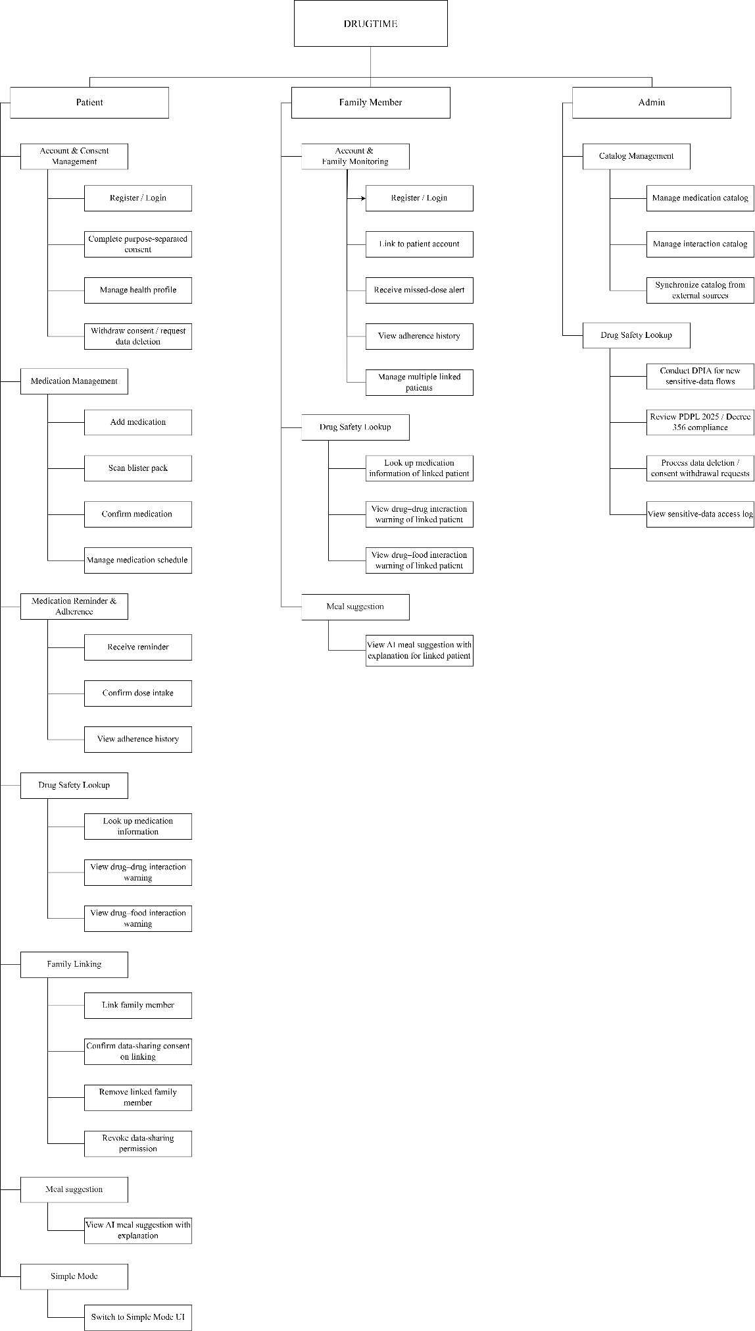

System Context Diagram

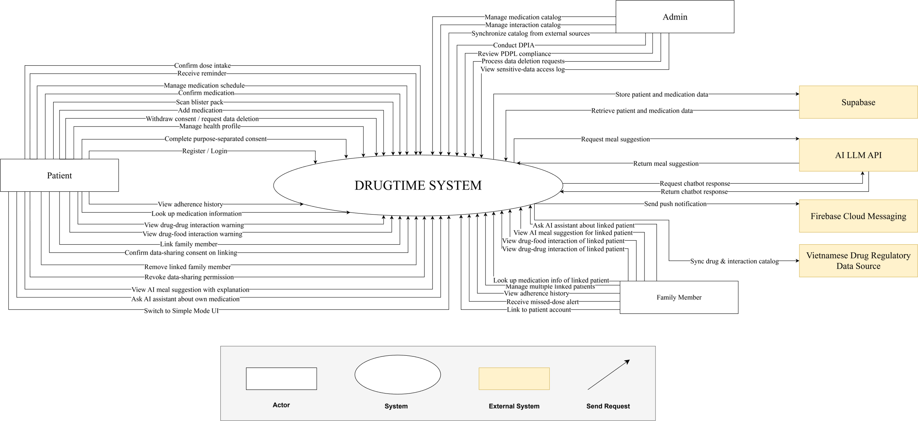

Data Flow Diagram

Software Requirement Specification

High level Fucntional Requirement (FR)
FR1.1 | Title | Account Registration, Login and Consent Management
FR1.1 | Stakeholder | Patient, Family Member
FR1.1 | Description | The system shall allow users to register and log in to DrugTime. The system shall collect consent separately for each applicable data-processing purpose and allow granted consent to be withdrawn.
FR1.2 | Title | Medication Management
FR1.2 | Stakeholder | Patient
FR1.2 | Description | The system shall allow Patients to add medication through manual input or supported on-device blister-pack scanning. Medication information obtained through blister-pack scanning shall require manual confirmation before being recorded.
FR1.3 | Title | Medication Reminder Management
FR1.3 | Stakeholder | Patient
FR1.3 | Description | The system shall allow Patients to schedule medication doses and shall deliver local on-device notification reminders for scheduled doses.
FR1.4 | Title | Drug Interaction Safety
FR1.4 | Stakeholder | Patient, Family Member
FR1.4 | Description | The system shall provide drug-drug and drug-food interaction warnings and display mandatory medical disclaimers with the interaction information.
FR1.5 | Title | AI Meal Suggestion
FR1.5 | Stakeholder | Patient, Family Member
FR1.5 | Description | The system shall generate suitable AI-based meal suggestions with explanations.
FR1.6 | Title | Simple Mode
FR1.6 | Stakeholder | Patient
FR1.6 | Description | The system shall provide a high-contrast and minimal user interface through Simple Mode.
FR1.7 | Title | Family Caregiver Linking and Adherence Monitoring
FR1.7 | Stakeholder | Patient, Family Member
FR1.7 | Description | The system shall allow Patient and Family Member accounts to be linked through QR or referral codes. Linked Family Members shall be able to receive real-time missed-dose alerts and access basic adherence history.
FR1.8 | Title | Medication and Interaction Catalog Management
FR1.8 | Stakeholder | Admin
FR1.8 | Description | The system shall allow Admin to create, read, update, and delete medication and interaction catalog data and periodically synchronize catalog data from the Vietnamese Drug Regulatory Data Source.
FR1.9 | Title | Compliance Management
FR1.9 | Stakeholder | Admin
FR1.9 | Description | The system shall support Admin compliance operations, including conducting DPIA, processing data-deletion and consent-withdrawal requests, and maintaining a sensitive-data access log
FR1.10 | Title | Extended Family Member Access
FR1.10 |  | Family Member
FR1.10 |  | The system shall allow Family Members to manage multiple linked Patients and perform drug-safety lookups for linked Patients within the scope of explicit Patient consent

Stakeholders

Stakeholder | Description
Patient | People who use DrugTime to receive reminder notification and suggested meal from AI
Family Member | People who use DrugTime to monitor their members who are patients and access suggested meal history
System Administrator | People who administer, configure, synchronize and manage private policies related to DrugTime

Usecase

List of use cases

Use case ID | Use case name | Functional Req.
UC.01 | Register User Account | FR1.1
UC.02 | Authenticate User | FR1.1
UC.03 | Manage Purpose-Separated Consent | FR1.1
UC.04 | Check Drug Safety / Drug Interaction | FR1.4
UC.05 | Add Medication Manually | FR1.2
UC.06 | Add Medication By Blister-Pack Scan | FR1.2
UC.07 | Review and Confirm Scanned Medication | FR1.2
UC.08 | Manage Recorded Medication | FR1.2
UC.09 | Manage Medication Schedule | FR1.3
UC.10 | Receive Medication Dose Reminder | FR1.3
UC.11 | Confirm Medication Dose Intake | FR1.3
UC.12 | Track Medication Adherence History | FR1.7
UC.13 | Link Family Caregiver Account | FR1.7
UC.14 | Manage Caregiver Permissions | FR1.7, FR1.10
UC.15 | Manage Multiple Linked Patients | FR1.10
UC.16 | Look Up Drug Information | FR1.4
UC.17 | Check Drug-Drug Interaction | FR1.4
UC.18 | Check Drug-Food Interaction | FR1.4
UC.19 | Generate AI Meal Suggestion | FR1.5
UC.20 | Configure Simple Mode Display | FR1.6
UC.21 | Manage Medication Catalogue | FR1.8
UC.22 | Manage Interaction Catalogue | FR1.8
UC.23 | Synchronize Regulatory Drug Data | FR1.8
UC.24 | Review Unmatched Medication Scan Results | FR1.8
UC.25 | Submit Data-Delection Request | FR1.9
UC.26 | Manage Privacy, Compliance and Sensitive-Data Access | FR1.9

<<DrugTime>> Use Case Diagram Overview
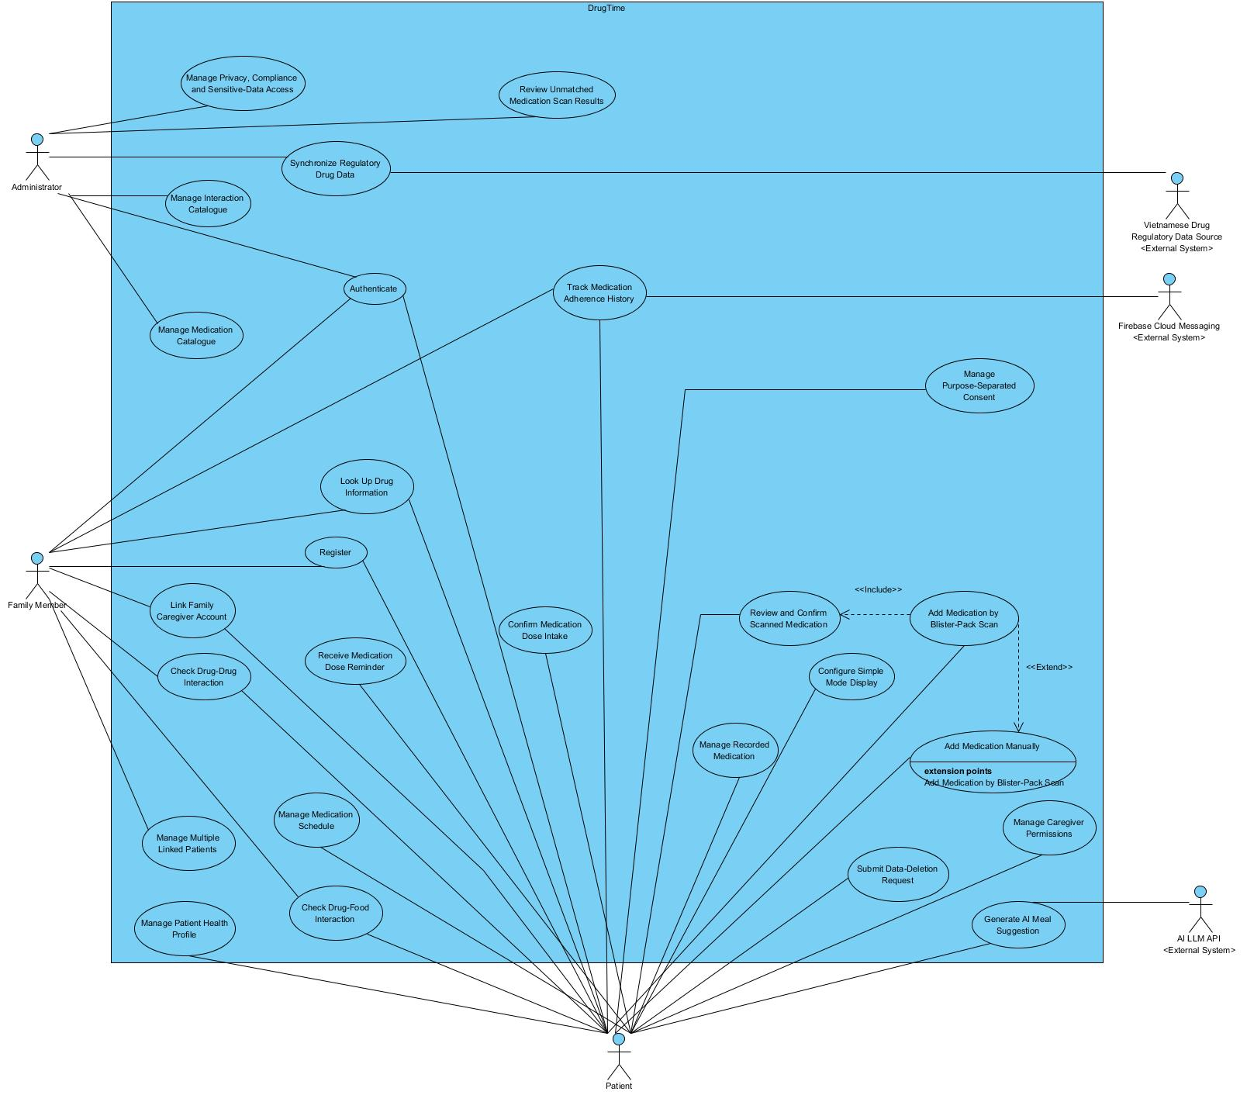

List of business rule

Code | Business rules | Use case
BR-01 | DrugTime Phase 1 supports three system roles: Patient, Family Member, and Admin. Partner Pharmacy Staff and Partner Pharmacist are supported in Phase 2. | UC.01,
BR-02 | Consent for each applicable data-processing purpose must be collected separately. A single bundled consent must not represent consent for multiple independent purposes. | UC.02
BR-03 | Consent granted for one data-processing purpose must not be treated as consent for another processing purpose. | UC. 02
BR-04 | A Patient can withdraw applicable consent through Account Settings. Withdrawal applies to the corresponding processing purpose. | UC.02
BR-05 | A Patient can submit a request for deletion of applicable personal and/or health data through Account Settings.
BR-06 | DrugTime collects only personal or health data that is necessary for an explicitly stated and approved processing purpose.
BR-07 | Linking a Family Member account to a Patient account does not automatically grant access to the Patient's health or adherence data. The Patient must explicitly authorize the applicable data-sharing scope.
BR-08 | A Family Member may access a linked Patient's data only within the data-sharing scope explicitly authorized by that Patient.
BR-09 | A Patient can revoke a Family Member's previously granted data-sharing permission. After revocation, the Family Member must no longer be authorized to access the revoked scope.
BR-10 | Medication information obtained through blister-pack scanning must be manually reviewed and confirmed by the user before it can be saved.
BR-11 | When automated blister-pack recognition or catalogue matching fails, DrugTime must provide a manual medication-entry fallback using the available medication catalogue.
BR-12 | An unmatched medication scan result must be recorded for Admin review and subsequent catalogue-management activities.
BR-13 | A medication dose is considered confirmed only when the Patient performs the supported explicit dose-confirmation action.
BR-14 | DrugTime maintains an adherence history for medication doses that are confirmed or classified as missed. The history is available to the Patient and authorized Family Members.
BR-15 | When a scheduled dose is classified as missed according to the defined missed-dose condition, DrugTime generates a missed-dose alert for eligible linked Family Members.
BR-16 | DrugTime must not present interaction or AI results as medical diagnosis, treatment decisions, or formal clinical advice.
BR-17 | Every drug-drug or drug-food interaction warning must display a medical disclaimer directing the user to consult a doctor or pharmacist.
BR-18 | Medication and interaction information must be based on the approved Vietnamese pharmaceutical reference sources defined by the project, including DAV, QĐ 5948/QĐ-BYT and “Dược thư Quốc gia Việt Nam 2022.”
BR-19 | AI-generated meal suggestions are informational recommendations associated with the Patient's active medications and must not be presented as medical or dietary prescriptions.
BR-20 | AI-generated meal suggestions must display an appropriate medical disclaimer and direct the user to consult a doctor or pharmacist when dietary changes relate to a medical condition.
BR-21 | Patient and Family Member accounts may be linked using the supported QR-code or referral-code mechanism.
BR-22 | A Family Member may perform drug-safety look-ups for a linked Patient only when the Patient has granted the corresponding data-sharing permission.
BR-23 | A Family Member may use AI-assisted functions involving a linked Patient only within the data-sharing scope explicitly authorized by that Patient.
BR-24 | A Family Member may manage multiple linked Patient accounts, subject to the authorization granted by each individual Patient.
BR-25 | Personal data and health data processed by DrugTime must comply with the applicable Vietnamese personal-data protection requirements, including the 2025 Personal Data Protection Law and Decree 356/2025/NĐ-CP.
BR-26 | An applicable DPIA must be completed before a new sensitive-data processing flow is used in production. The corresponding compliance operation is managed by Admin.
BR-27 | An applicable cross-border data-transfer assessment must be completed before a sensitive-data flow involving an overseas service is activated in production.
BR-28 | Every access to a Patient's sensitive health data by a Family Member or Admin must generate an auditable record containing actor identity, access timestamp, and accessed data scope.
BR-29 | DrugTime's medication and interaction catalogues must use the approved Vietnamese regulatory/reference sources defined by the project.
BR-30 | Medication and interaction catalogues must be synchronized periodically from approved Vietnamese regulatory/reference sources as part of Admin catalogue management.
BR-31 | Partner Pharmacy Staff must be approved by Admin based on a valid pharmacy business licence before receiving access to partner-pharmacy functions.
BR-32 | Partner Pharmacists must be verified by Admin based on a valid pharmacy practising certificate before receiving access to the pharmacist consultation queue.

Use Case Specification

UC 01: Register User Account
- Use Case Diagram
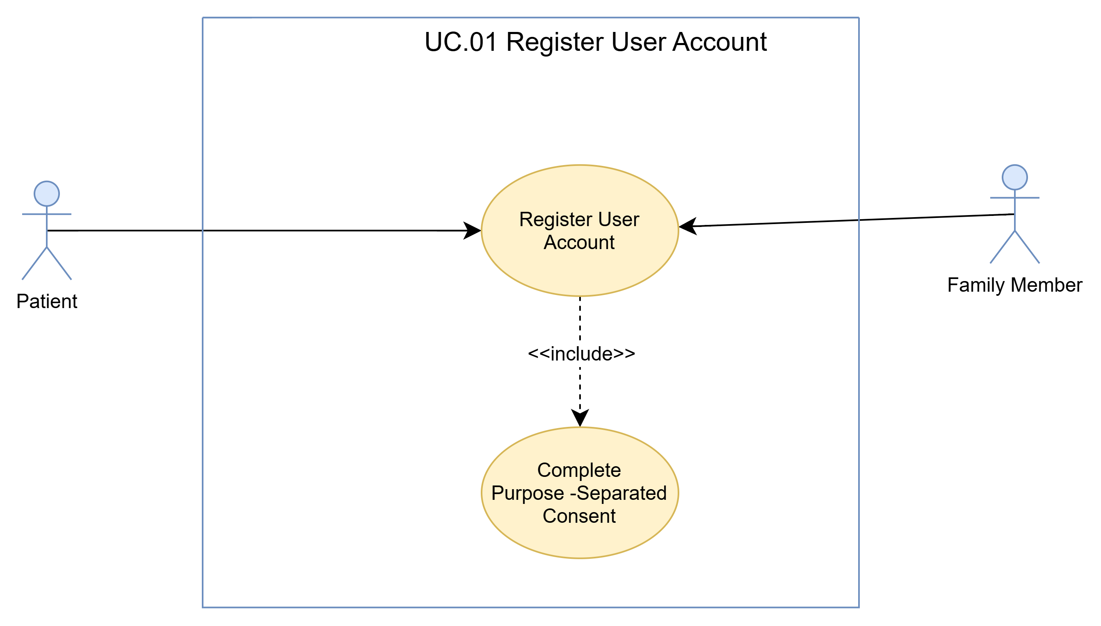
- Use Case Specìication
Use case ID | UC.01
Use case name | Register User Account
Create by | Viet Dang |  | Last updated by |  | Viet Dang, Bao Nguyen
Date created | September 16, 2026 |  | Date last updated |  | September , 2026
Actor | Patient, Family Member
Description | This use case allows a Patient or Family Member to register and activate a new DrugTime account using an Email address, Phone Number, or a supported third-party OAuth provider. During registration, the user selects an account type and must complete the Purpose-Separated Consent process before the account can be activated.
Goal | To create a DrugTime account for the selected user type and complete the required purpose-separated consent process.
Trigger | The user opens the DrugTime application for the first time and selects “Register Account” from the welcome screen.
Pre-condition | 1. The user can access the DrugTime mobile application.  2. An Internet connection is available, as required by the project assumptions.  3. The user has not completed the registration process yet.
Post-condition | 1. A DrugTime account is successfully registered for the selected user type.  2. Purpose-separated consent decisions have been recorded for the applicable data-processing purposes.  3. The user can proceed to the corresponding onboarding flow.  4. The account is available for subsequent DrugTime features according to the user's account type and granted consent.
Main Flow | Step | Actor Action |  | System Response
Main Flow | 1 | User chooses to register a new DrugTime account. |  | System displays the available account types for registration.
Main Flow | 2 | User selects Patient or Family Member. |  | System identifies the selected account type and displays the corresponding registration interface.
Main Flow | 3 | User provides the information required by the selected registration interface.
Main Flow | 4 | User submits the registration information. |  | System validates the submitted registration information.
Main Flow | 5 |  |  | System processes and creates the account for the selected account type.
Main Flow | 6 |  |  | System displays the purpose-separated consent interface.
Main Flow | 7 | User reviews the applicable data-processing purposes and provides the required consent decisions. |  | System records the consent decision separately for each applicable data-processing purpose.
Main Flow | 8 |  |  | System completes the registration process and makes the corresponding onboarding flow available.
Main Flow | 9 |  |  | System displays the onboarding flow corresponding to the selected account type.
Alternative Flow | Alternative Flow 1: User Changes Account Type Before Submission
Alternative Flow | Step | Actor Action |  | System Response
Alternative Flow | 1 | User chooses to change the selected account type. |  | System displays the available account types.
Alternative Flow | 2 | User selects another account type. |  | System displays the registration interface corresponding to the newly selected account type.
Alternative Flow | 3 | User provides the information required for the newly selected account type. |  | System validates the registration information.
Alternative Flow | Alternative Flow 2: User Reviews and Adjusts Consent Decisions Before Completion
Alternative Flow | Step | Actor Action |  | System Response
Alternative Flow | 1 | User reviews the applicable data-processing purposes. |  | System displays each applicable purpose separately.
Alternative Flow | 2 | User changes one or more consent decisions. |  | System updates the displayed consent selections.
Alternative Flow | 3 | User confirms the updated decisions. |  | System records the updated consent decisions separately for each applicable purpose.
Exceptions  Flow | Exception 1: Invalid Registration Information
Exceptions  Flow | Step | Actor Action |  | System Response
Exceptions  Flow | 1 | User submits invalid or incomplete registration information. |  | System rejects the registration request.
Exceptions  Flow | 2 |  |  | System identifies the information that needs to be corrected.
Exceptions  Flow | Exception 2: Registration Processing Failure
Exceptions  Flow | Step | Actor Action |  | System Response
Exceptions  Flow | 1 | User submits the registration information. |  | System encounters an error while processing the registration request.
Exceptions  Flow | 2 |  |  | System informs the user that registration cannot be completed at that time.
Exceptions  Flow | Exception 3: Internet Connection Unavailable
Exceptions  Flow | Step | Actor Action |  | System Response
Exceptions  Flow | 1 | User attempts to perform a registration operation without an Internet connection. |  | System cannot complete the registration request.
Exceptions  Flow | 2 |  |  | System informs the user that an Internet connection is required to continue.
Priority | High
Business rule | BR-01, BR-02, BR-06

- Prototype
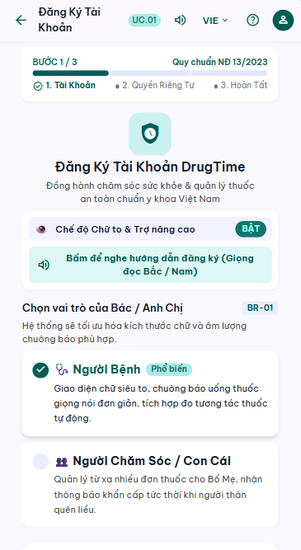

UC 02: Authenticate User
- Use Case Diagram
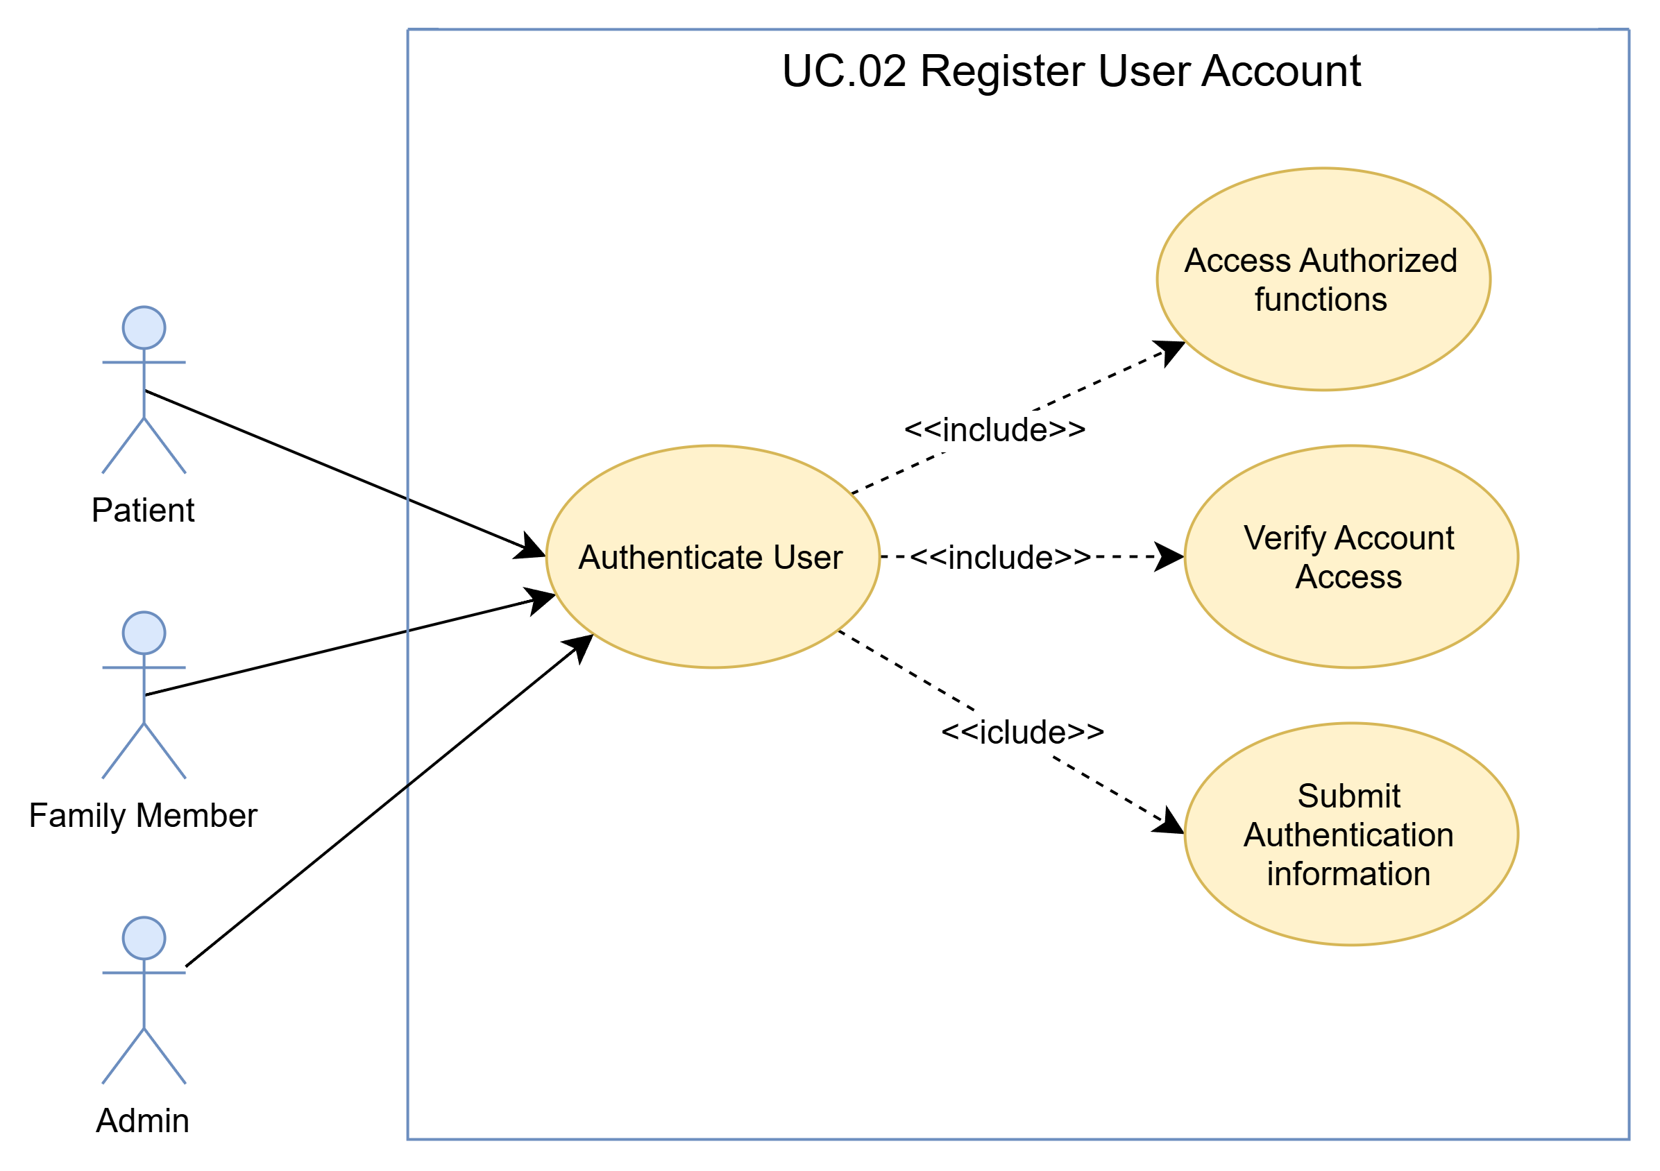
b) Use Case Specìication
Use case ID | UC.02
Use case name | Authenticate User
Create by | Viet Dang |  | Last updated by |  | Viet Dang
Date created | September 16, 2026 |  | Date last updated |  | September 16, 2026
Actor | Patient, Family Member, Admin
Description | This use case describes how a registered DrugTime user authenticates to the system and gains access according to the user's account type and applicable authorization.
Goal | To authenticate a registered DrugTime user and provide access to the functions authorized for the user's account type.
Trigger | The user chooses to log in to DrugTime.
Pre-condition | 1. The user has a registered DrugTime account.  2. The user can access the DrugTime application or Admin interface.  3. Network connectivity is available as required by the project assumptions.
Post-condition | 1. The user is successfully authenticated.  2. The system establishes an authenticated session for the user.  3. The system provides access according to the user's account type and applicable authorization.  4. The user can proceed to the corresponding DrugTime functions.
Main Flow | Step | Actor Action |  | System Response
Main Flow | 1 | User chooses Log In. |  | System displays the authentication interface.
Main Flow | 2 | User provides the required authentication information.
Main Flow | 3 | User submits the authentication request. |  | System validates the submitted authentication information.
Main Flow | 4 |  |  | System verifies the information and identifies that the account is eligible to access system
Main Flow | 5 |  |  | System establishes an authenticated session for the user.
Main Flow | 6 |  |  | System provides the interface and functions available to the authenticated user according to the user's account type and authorization.
Alternative Flow | Alternative Flow 1: User Revises Authentication Information
Alternative Flow | Step | Actor Action |  | System Response
Alternative Flow | 1 | User chooses to revise the authentication information. |  | System returns the user to the authentication information input step.
Alternative Flow | 2 | User modifies or re-enters the required authentication information. |  | System accepts the updated information.
Alternative Flow | 3 | User submits the authentication request. |  | System continues the authentication process.
Alternative Flow | Alternative Flow 2: Returns to the Previous Authentication Step User
Alternative Flow | Step | Actor Action |  | System Response
Alternative Flow | 1 | User chooses to return to the previous authentication step. |  | System returns the user to the previous step without establishing an authenticated session.
Alternative Flow | 2 | User chooses to continue authentication. |  | System displays the authentication interface.
Alternative Flow | 3 | User provides the required authentication information. |  | System accepts the provided information.
Alternative Flow | 4 |  |  | System continues the authentication process.
Exceptions  Flow | Exception 1: Invalid Authentication Information
Exceptions  Flow | Step | Actor Action |  | System Response
Exceptions  Flow | 1 | User submits invalid or incomplete registration information. |  | System cannot verify the provided authentication information.
Exceptions  Flow | 2 |  |  | System rejects the authentication request and informs the user that authentication was unsuccessful.
Exceptions  Flow | Exception 2: Account Not Eligible for Authentication
Exceptions  Flow | Step | Actor Action |  | System Response
Exceptions  Flow | 1 | User submits authentication information. |  | System determines that the associated account is not eligible for authentication.
Exceptions  Flow | 2 |  |  | System does not establish an authenticated session and informs the user that authentication cannot be completed.
Exceptions  Flow | Exception 3: Authentication Service Unavailable
Exceptions  Flow | Step | Actor Action |  | System Response
Exceptions  Flow | 1 | User submits an authentication request. |  | System cannot complete authentication because the required authentication service is unavailable.
Exceptions  Flow | 2 |  |  | System informs the user that authentication cannot currently be completed.
Exceptions  Flow | Exception 4: Authentication Service Unavailable
Exceptions  Flow | Step | Actor Action |  | System Response
Exceptions  Flow | 1 | User attempts to authenticate. |  | System cannot complete the authentication request because the required network connection is unavailable.
Exceptions  Flow | 2 |  |  | System informs the user that network connectivity is required to continue authentication.
Priority | High
Business rule | BR-01

c) Prototype
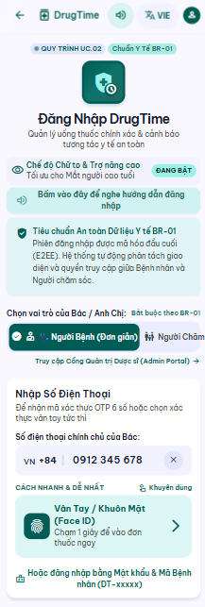

UC 03: Manage Purpose-Separated Consent
- Use Case Diagram
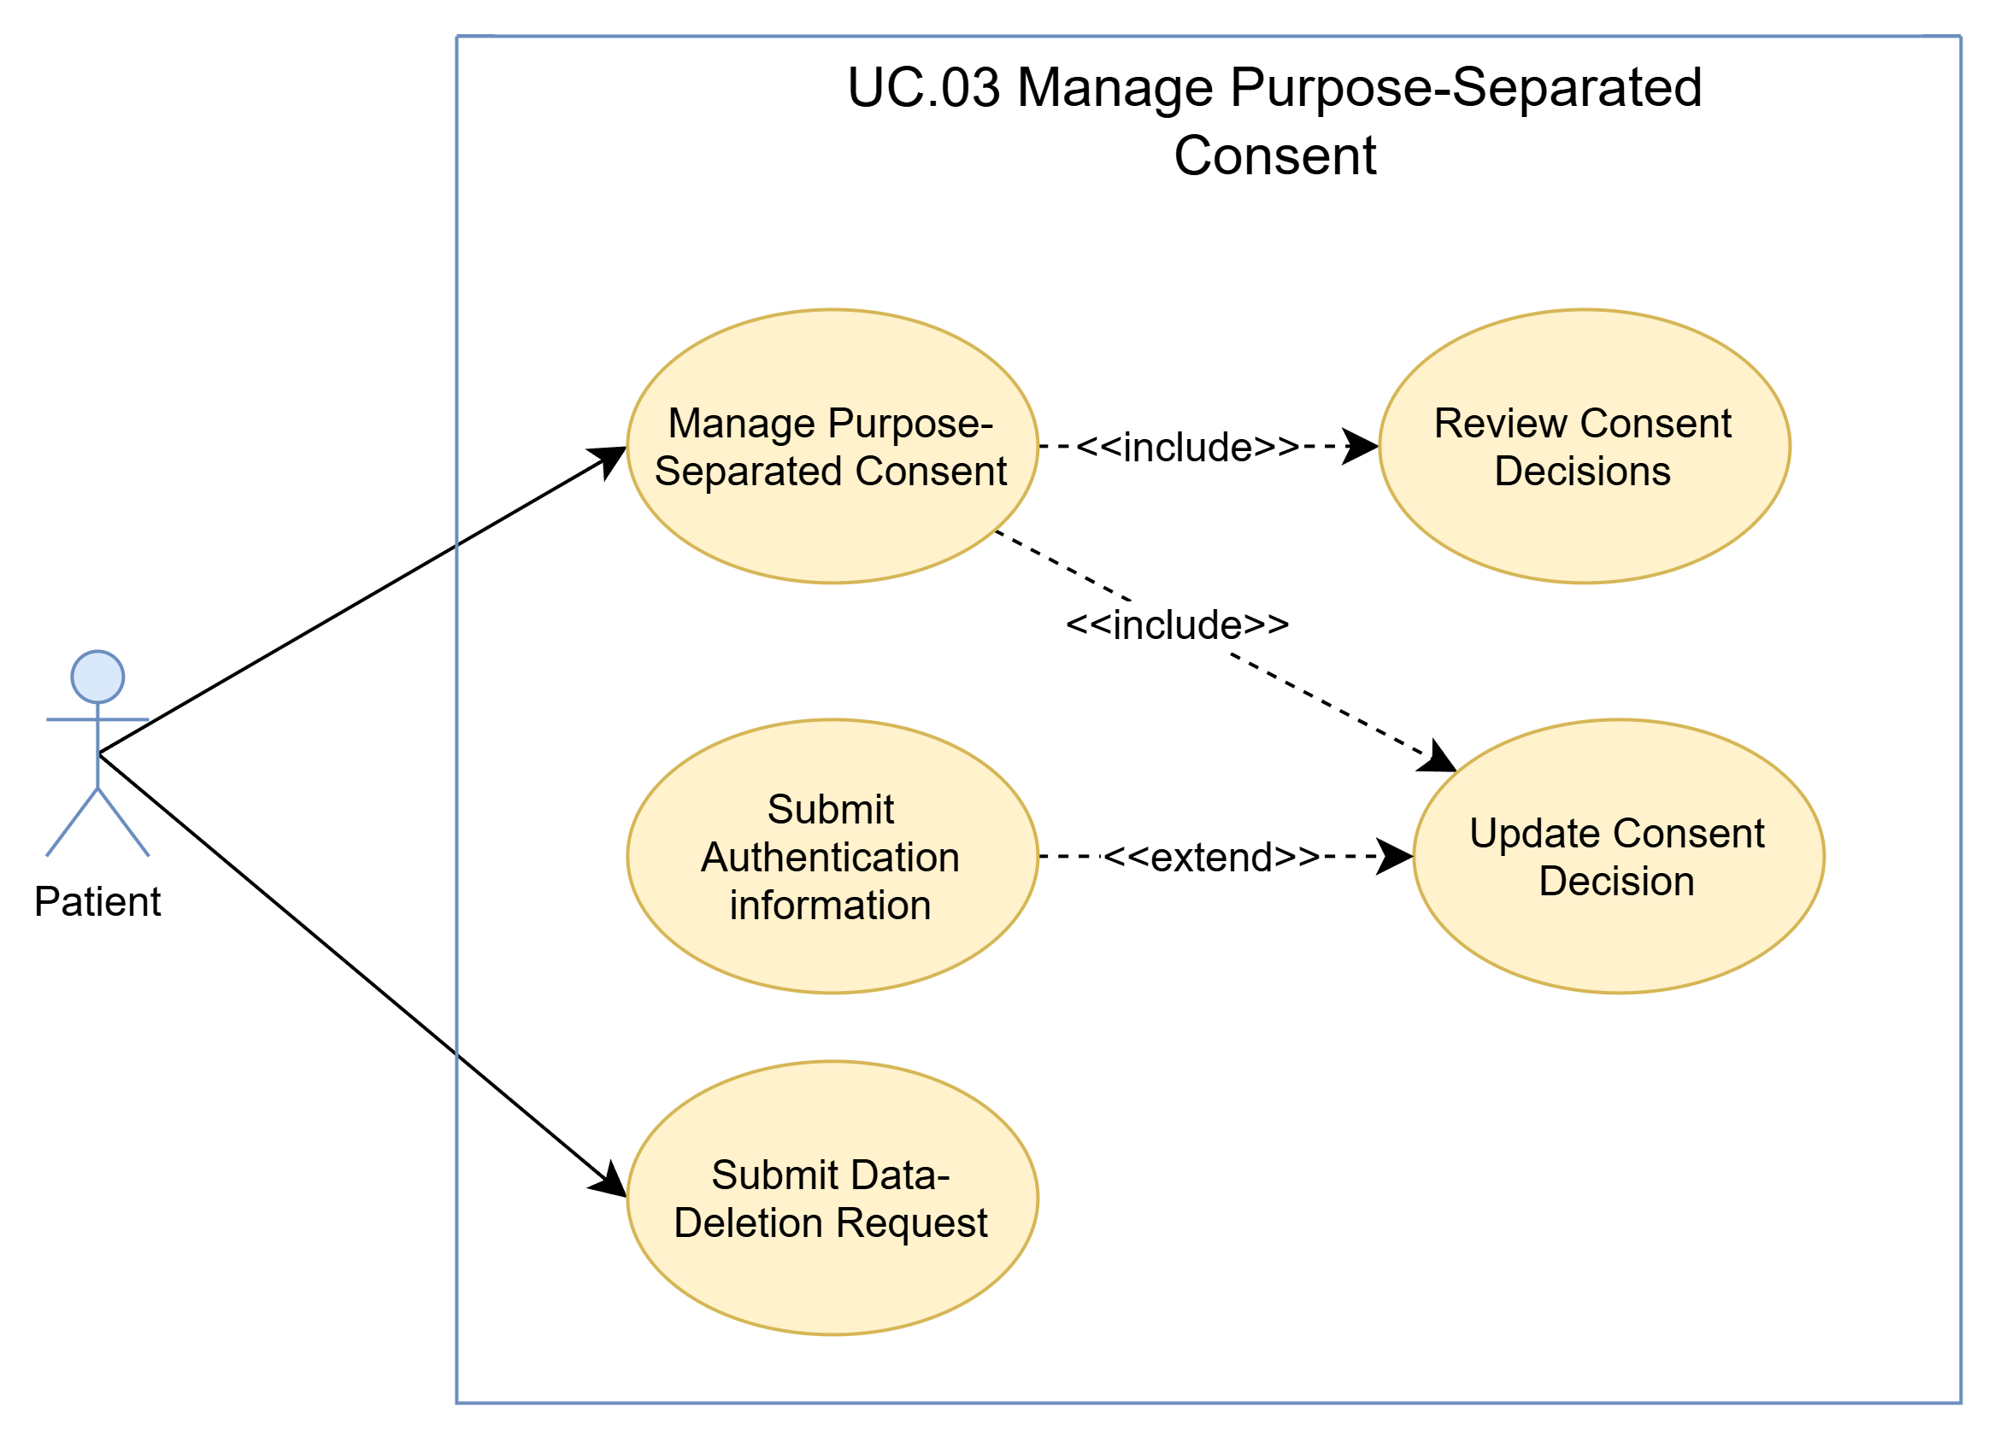
- Use Case Specification
Use case ID | UC.03
Use case name | Manage Purpose-Separated Consent
Create by | Viet Dang |  | Last updated by |  | Viet Dang
Date created | September 16, 2026 |  | Date last updated |  | September 16, 2026
Actor | Patient
Description | This use case describes how a Patient reviews and manages consent decisions for individual data-processing purposes, withdraws applicable consent through Account Settings, and submits a request for deletion of applicable personal and/or health data.
Goal | To allow the Patient to manage consent separately for each applicable data-processing purpose and exercise the supported consent withdrawal and data-deletion request rights.
Trigger | The Patient chooses to review or manage consent through the applicable DrugTime consent interface or Account Settings.
Pre-condition | 1. The Patient has a DrugTime account.  2. The Patient is authenticated.  3. The Patient can access the applicable consent or Account Settings interface.
Post-condition | 1. The Patient's consent decision for each affected processing purpose is recorded separately.  2. A withdrawn consent applies only to its corresponding processing purpose.  3. If the Patient submits a data-deletion request, the request is recorded for subsequent processing.  4. Subsequent processing of personal or health data remains subject to the applicable consent and data-protection requirements.
Main Flow | Main Flow 1: Review / Update Purpose-Separated Consent
Main Flow | Step | Actor Action |  | System Response
Main Flow | 1 | Patient opens the consent management interface or Account Settings. |  | System displays the Patient's applicable data-processing purposes and current consent decisions.
Main Flow | 2 | Patient reviews the applicable data-processing purposes and their corresponding consent decisions. |  | System presents each applicable purpose separately so that each consent decision can be managed independently.
Main Flow | 3 | Patient selects a data-processing purpose to manage. |  | System displays the current consent status and the available consent action for the selected purpose.
Main Flow | 4 | Patient provides the desired consent decision for the selected purpose. |  | System records the decision for that specific purpose independently from other purposes.
Main Flow | 5 |  |  | System preserves the separate consent decision for each affected purpose.
Main Flow | 6 | Patient completes the consent-management action. |  | System confirms the updated consent state and applies the decision to the corresponding processing purpose.
Main Flow | 7 |  |  | System makes subsequent processing subject to the applicable consent decisions and personal-data protection requirements.
Alternative Flow | Alternative Flow 1: Patient Revises a Consent Decision Before Completion
Alternative Flow | Step | Actor Action |  | System Response
Alternative Flow | 1 | Patient changes the consent decision for a selected processing purpose. |  | System updates the pending decision for that purpose.
Alternative Flow | 2 | Patient decides to revise the decision before completing the action. |  | System allows the Patient to return to the applicable consent decision.
Alternative Flow | 3 | Patient changes the consent decision again. |  | System updates the decision for the selected purpose without changing
Alternative Flow | 4 | Patient completes the consent-management action. |  | System records the final decision for the selected purpose separately.
Alternative Flow | Alternative Flow 2: Patient Withdraws Consent for a Specific Processing Purpose
Alternative Flow | Step | Actor Action |  | System Response
Alternative Flow | 1 | Patient selects a previously granted processing purpose. |  | System displays the current consent status for that purpose.
Alternative Flow | 2 | Patient chooses to withdraw consent for the selected purpose. |  | System updates the consent decision for that purpose to indicate withdrawal.
Alternative Flow | 3 | Patient completes the withdrawal action. |  | System does not treat the withdrawn consent as consent for other processing purposes.
Alternative Flow | 4 |  |  | System continues the authentication process.
Alternative Flow | Alternative Flow 3: Patient Submits a Data-Deletion Request
Alternative Flow | Step | Actor Action |  | System Response
Alternative Flow | 1 | Patient accesses the applicable data-management option in Account Settings. |  | System provides the supported option for submitting a data-deletion request.
Alternative Flow | 2 | Patient chooses to request deletion of applicable personal and/or health data. |  | System displays the applicable deletion-request information and allows the Patient to submit the request.
Alternative Flow | 3 | Patient submits the deletion request. |  | System records the deletion request for subsequent processing.
Alternative Flow | 4 |  |  | System confirms that the deletion request has been submitted.
Exceptions  Flow | Exception 1: Consent Decision Cannot Be Recorded
Exceptions  Flow | Step | Actor Action |  | System Response
Exceptions  Flow | 1 | Patient submits a consent decision. |  | System cannot record the consent decision.
Exceptions  Flow | 2 |  |  | System displays the applicable deletion-request information and allows the Patient to submit the request.
Exceptions  Flow | Exception 2: Data-Deletion Request Cannot Be Submitted
Exceptions  Flow | Step | Actor Action |  | System Response
Exceptions  Flow | 1 | Patient submits a data-deletion request. |  | System cannot record the request.
Exceptions  Flow | 2 |  |  | System informs the Patient that the deletion request could not be submitted.
Exceptions  Flow | Exception 3: Internet Connection Unavailable
Exceptions  Flow | Step | Actor Action |  | System Response
Exceptions  Flow | 1 | Patient attempts to submit a consent change or deletion request. |  | System cannot complete the operation because the required connection is unavailable.
Exceptions  Flow | 2 |  |  | System informs the Patient that the operation cannot currently be completed.
Priority | High
Business rule | BR-02, BR-03, BR-04, BR-05, BR-06, BR-25

- Prototype
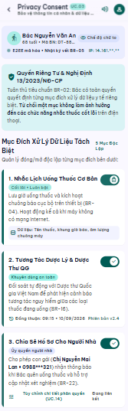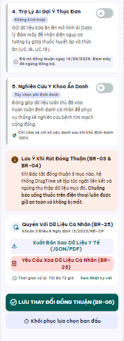

UC 04: Manage Patient Health Profile
- Use Case Diagram
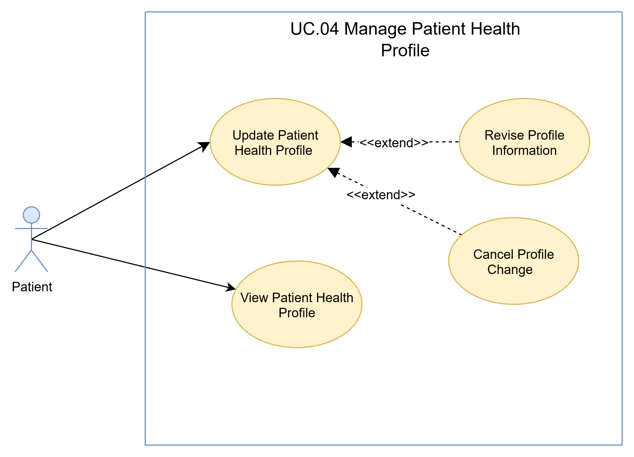
- Use Case Specification
Use case ID | UC.04
Use case name | Manage Patient Health Profile
Create by | Viet Dang |  | Last updated by |  | Viet Dang
Date created | September 16, 2026 |  | Date last updated |  | September 21, 2026
Actor | Patient
Description | This use case describes how a Patient views and updates the supported health-profile information maintained by DrugTime for medication-safety and personalization purposes.
Goal | To allow the Patient to review and maintain accurate health-profile information used by supported DrugTime functions.
Trigger | The Patient opens the Patient Health Profile function from the application.
Pre-condition | 1. The Patient is authenticated.  2. The Patient Health Profile function is available.  3. The Patient may only provide health-profile information required for an explicitly stated and approved processing purpose.
Post-condition | 1. The Patient can view the currently recorded health-profile information.  2. If the Patient confirms an update, the supported health-profile information is updated successfully.  3. Unconfirmed changes are not persisted.  4. The updated health-profile information becomes available to DrugTime functions that are authorized to use that information for the applicable processing purpose.
Main Flow | Main Flow 1: View Patient Health Profile
Main Flow | Step | Actor Action |  | System Response
Main Flow | 1 | Patient opens the health-profile function. |  | System displays the available Patient health-profile information.
Main Flow | 2 | Patient selects a profile section to review. |  | System displays the current information for the selected section.
Main Flow | 3 | Patient reviews the displayed information. |  | System keeps the recorded profile information unchanged.
Main Flow | 4 |  |  | System returns the Patient to the Patient Health Profile overview.
Main Flow | Main Flow 2: Update Patient Health Profile
Main Flow | Step | Actor Action |  | System Response
Main Flow | 1 | Patient chooses to edit the health profile. |  | System displays editable profile information.
Main Flow | 2 | Patient enters or changes supported information. |  | System validates the provided information.
Main Flow | 3 | Patient reviews the changes. |  | System displays the pending updated values.
Main Flow | 4 | Patient confirms the changes. |  | System saves the updated information.
Main Flow | 5 |  |  | System displays the updated profile.
 | Alternative Flow 1: Update a Specific Profile Section Only
 | Step | Actor Action |  | System Response
 | 1 | Patient selects a specific profile section to update. |  | System displays the editable information for that section.
 | 2 | Patient changes one or more supported information items. |  | System validates the provided information.
 | 3 | Patient reviews the updated information. |  | System displays the pending changes for confirmation.
 | 4 | Patient confirms the changes. |  | System saves the updated information for the selected profile section.
 | 5 |  |  | System displays the updated profile information.
 | Alternative Flow 2: Revise Profile Information Before Confirmation
 | Step | Actor Action |  | System Response
 | 1 | Patient reviews the pending profile changes and decides that further changes are required. |  | System keeps the unconfirmed changes available for revision.
 | 2 | Patient modifies one or more previously entered profile information items. |  | System validates the revised information.
 | 3 | Patient reviews the revised information. |  | System displays the latest pending values for confirmation.
 | 4 | Patient confirms the revised changes. |  | System saves the latest confirmed profile information.
 | 5 |  |  | System displays the updated Patient Health Profile.
 | Alternative Flow 3: Cancel Profile Changes
 | Step | Actor Action |  | System Response
 | 1 | Patient chooses to update the health profile. |  | System displays the editable profile information.
 | 2 | Patient changes one or more supported profile information items. |  | System validates and displays the pending changes.
 | 3 | Patient decides not to apply the changes and selects the cancel action. |  | System asks the Patient to confirm cancellation when required.
 | 4 | Patient confirms the cancellation. |  | System discards all unconfirmed changes.
 | 5 |  |  | System keeps the previously confirmed Patient Health Profile unchanged.
 | 6 |  |  | System returns the Patient to the current profile view.
Exceptions | Exception 1: Invalid Health-Profile Information
Exceptions | Step | Actor Action |  | System Response
Exceptions | 1 | Patient submits health-profile information that does not satisfy the applicable validation rules. |  | System detects the invalid information.
Exceptions | 2 |  |  | System rejects the update and does not persist the invalid data.
Exceptions | 3 |  |  | System identifies the invalid field or information item and displays an appropriate validation message.
Exceptions | 4 |  |  | Use Case ends unsuccessfully.
Exceptions | Exception 2: Health Profile Cannot Be Retrieved
Exceptions | Step | Actor Action |  | System Response
Exceptions | 1 | Patient opens the Patient Health Profile function. |  | System fails to retrieve the currently recorded health-profile information.
Exceptions | 2 |  |  | System does not display incomplete or unverified data as the confirmed Patient Health Profile.
Exceptions | 3 |  |  | System informs the Patient that the profile cannot currently be loaded.
Exceptions | 4 |  |  | Use Case ends unsuccessfully.
Exceptions | Exception 3: Health Profile Update Cannot Be Saved
Exceptions | Step | Actor Action |  | System Response
Exceptions | 1 | Patient confirms valid profile changes. |  | System encounters an error while saving the update.
Exceptions | 2 |  |  | System prevents a partial update and preserves the last successfully confirmed Patient Health Profile.
Exceptions | 3 |  |  | System informs the Patient that the profile update could not be completed.
Exceptions | 4 |  |  | Use Case ends unsuccessfully.
Exceptions | Exception 4: Authentication Is No Longer Valid
Exceptions | Step | Actor Action |  | System Response
Exceptions | 1 | Patient attempts to access the Patient Health Profile after the authenticated session is no longer valid. |  | System detects that authentication is no longer valid.
Exceptions | 2 |  |  | System blocks access to the protected health-profile data and does not apply pending changes.
Exceptions | 3 |  |  | System informs the Patient that authentication is required.
Exceptions | 4 |  |  | Use Case ends unsuccessfully.
Priority | High
Business rule | BR-06, BR-25

- Prototype
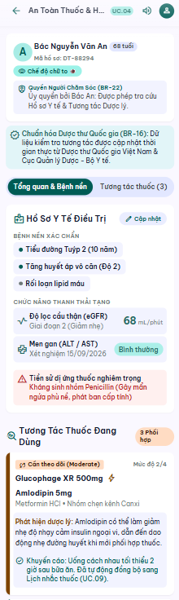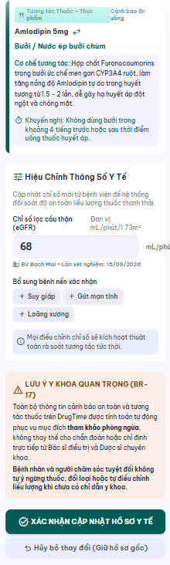

UC 05: Add Medication Manually
- Use Case Diagram
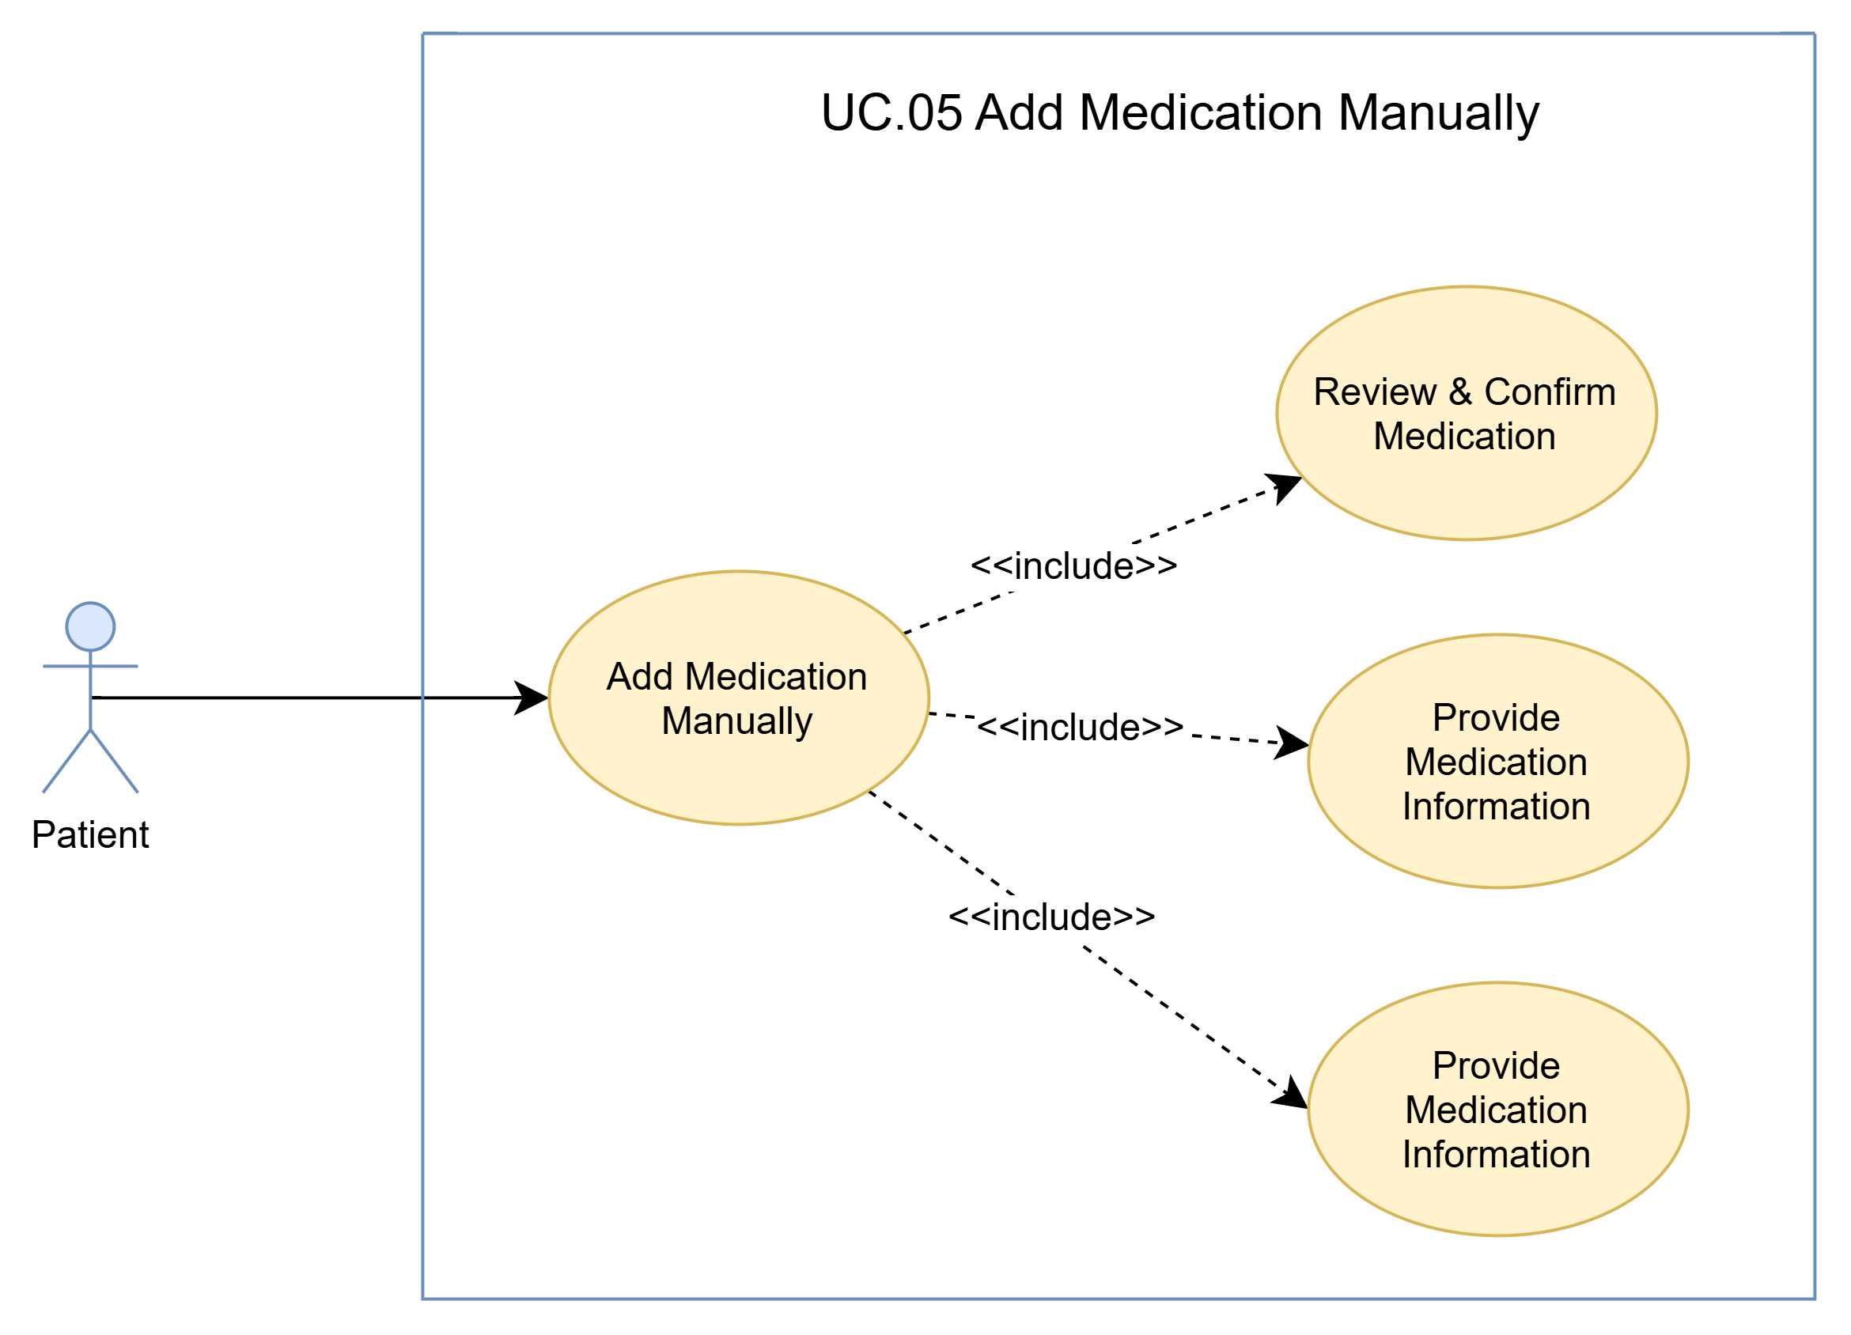
- Use Case Specification
Use case ID | UC.05
Use case name | Add Medication Manually
Create by | Viet Dang |  | Last updated by |  | Viet Dang, Bao Nguyen
Date created | September 16, 2026 |  | Date last updated |  | September 16, 2026
Actor | Patient
Description | This use case allows a Patient to add a medication to DrugTime through manual input by searching and selecting the intended medication from the available DrugTime medication catalogue, providing the required medication information, reviewing the completed medication information, and explicitly confirming the medication record before it is recorded. The manual medication-entry flow also serves as the supported fallback when a medication cannot be identified through the automated blister-pack recognition or catalogue-matching process.
Goal | To allow the Patient to accurately record an intended medication in DrugTime using the supported medication catalogue and required medication information, with the medication record being created only after the Patient has reviewed and explicitly confirmed it.
Trigger | The Patient opens the medication-management function and selects “Add Medication Manually” to record a medication through manual input.
Pre-condition | 1. The Patient has an authenticated DrugTime account.  2. The Patient can access the medication-management function.  3. The applicable DrugTime medication catalogue is available for medication search and selection.  4. An Internet connection is available, as required by the project assumptions.
Post-condition | 1. The intended medication is identified through the available medication catalogue.  2. The required medication information provided by the Patient has been reviewed and validated.  3. The Patient has explicitly confirmed the medication record.  4. The confirmed medication and required information are recorded in DrugTime.  5. The medication becomes available for subsequent medication-management functions.
Main Success Scenario: | Step | Actor Action |  | System Response
Main Success Scenario: | 1 | Patient selects “Add Medication Manually” from the medication-management function. |  | System displays the manual medication-entry interface and the available medication search function.
Main Success Scenario: | 2 | Patient searches for the intended medication. |  | System displays matching medication entries from the available catalogue.
Main Success Scenario: | 3 | Patient selects the intended medication. |  | System displays the selected medication and the fields required to complete the medication record.
Main Success Scenario: | 4 | Patient provides the required medication information. |  | System validates the entered information.
Main Success Scenario: | 5 |  |  | System displays the completed medication record for review and confirmation.
Main Success Scenario: | 6 | Patient reviews the completed medication record and selects Confirm. |  | System records the selected medication together with the confirmed required information.
Main Success Scenario: | 7 |  |  | System confirms successful recording and makes the medication available in the Patient's medication management.
Alternative Scenario | Alternative Flow 1: Multiple Catalogue Matches
Alternative Scenario | Step | Actor Action |  | System Response
Alternative Scenario | 1 | Patient selects “Add Medication Manually” from the medication-management function. |  | System displays the manual medication-entry interface and medication search function.
Alternative Scenario | 2 | Patient searches for the intended medication. |  | System displays matching medication entries from the available catalogue.
Alternative Scenario | 3 | Patient selects the intended medication. |  | System displays the selected medication and the fields required to complete the medication record.
Alternative Scenario | 4 | Patient provides the required medication information. |  | System validates the provided information.
Alternative Scenario | 5 |  |  | System displays the completed medication record for review and confirmation.
Alternative Scenario | 6 | Patient reviews the information and determines that the selected medication is not the intended medication. |  | System allows the Patient to return to the medication search and selection.
Alternative Scenario | 7 | Patient performs another search or selects another applicable medication entry. |  | Return to step 2
Alternative Scenario | Alternative Flow 2: Change Medication Selection Before Confirmation
Alternative Scenario | Step | Actor Action |  | System Response
Alternative Scenario | 1 | Patient determines that the selected medication is not the intended medication before confirming the medication record. |  | System allows the Patient to return to the medication search and selection step.
Alternative Scenario | 2 | Patient performs another search or selects another applicable medication entry. |  | System displays the newly selected medication information for review.
Alternative Scenario | 3 | Patient reviews the newly selected medication. |  | System keeps the newly selected medication available for completion of the medication record.
Alternative Scenario | 4 | Patient provides or revises the required medication information. |  | System validates the updated medication information.
Alternative Scenario | 5 | Patient reviews the completed medication information. |  | System displays the latest medication information for confirmation.
Alternative Scenario | 6 | Patient confirms the medication record. |  | System records the newly selected medication and the confirmed information.
Alternative Scenario | 7 |  |  | System confirms successful recording of the medication.
Alternative Scenario | Alternative Flow 3: Revise Medication Information Before Confirmation
Alternative Scenario | Step | Actor Action |  | System Response
Alternative Scenario | 1 | Patient reviews the medication information and decides that one or more entered items need to be changed. |  | System keeps the current unconfirmed medication information available for revision.
Alternative Scenario | 2 | Patient revises the applicable medication information. |  | System validates the revised information.
Alternative Scenario | 3 | Patient reviews the revised medication information. |  | System displays the latest information for confirmation.
Alternative Scenario | 4 | Patient confirms the revised medication record. |  | System records the latest confirmed medication information.
Alternative Scenario | 5 |  |  | System confirms successful recording of the medication.
Alternative Scenario | Alternative Flow 4: Cancel Medication Entry Before Confirmation
Alternative Scenario | Step | Actor Action |  | System Response
Alternative Scenario | 1 | Patient decides not to record the medication before confirming the medication record. |  | System allows the Patient to cancel the current medication-entry operation.
Alternative Scenario | 2 | Patient confirms the cancellation when required. |  | System discards the unconfirmed medication information.
Alternative Scenario | 3 |  |  | System keeps the previously recorded medication information unchanged.
Alternative Scenario | 4 |  |  | System returns the Patient to the applicable medication-management view.
Exceptions | Exception 1: No Catalogue Match
Exceptions | Step | Actor Action |  | System Response
Exceptions | 1 | Patient searches for the intended medication. |  | System determines that no applicable medication catalogue entry matches the provided search information.
Exceptions | 2 |  |  | System informs the Patient that no applicable catalogue entry was found.
Exceptions | Exception 2: Invalid or Incomplete Medication Information
Exceptions | Step | Actor Action |  | System Response
Exceptions | 1 | Patient submits the provided medication information for validation. |  | System identifies information that is missing, invalid, or requires correction.
Exceptions | 2 |  |  | System informs the Patient which medication information requires correction or completion and does not record the medication.
Exceptions | Exception 3: Medication Recording Failure
Exceptions | Step | Actor Action |  | System Response
Exceptions | 1 | Patient confirms the medication record. |  | System attempts to record the confirmed medication information.
Exceptions | 2 |  |  | System determines that the medication cannot be successfully recorded.
Exceptions | 3 |  |  | System informs the Patient that the medication could not be recorded and does not report the operation as successful.
Exceptions | Exception 4: Internet Connection Unavailable
Exceptions | Step | Actor Action |  | System Response
Exceptions | 1 | Patient attempts to perform a manual medication-entry operation without an available Internet connection. |  | System cannot complete the operation that requires the connection.
Exceptions | 2 |  |  | System informs the Patient that an Internet connection is required to continue.
Exceptions | 3 |  |  | System does not report the medication as successfully recorded and keeps the last valid recorded state unchanged.
Priority | High
Business rule | BR-11, BR-18, BR-29

- Prototype
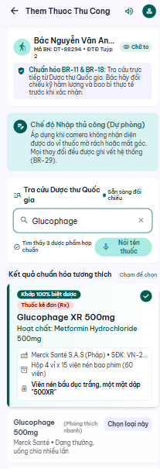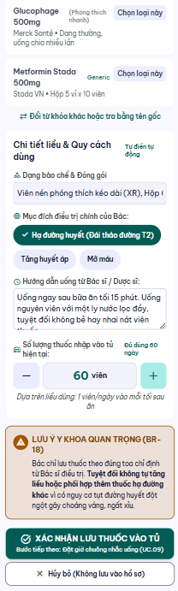

UC 06: Add Medication by Blister-Pack Scan
- Use Case Diagram
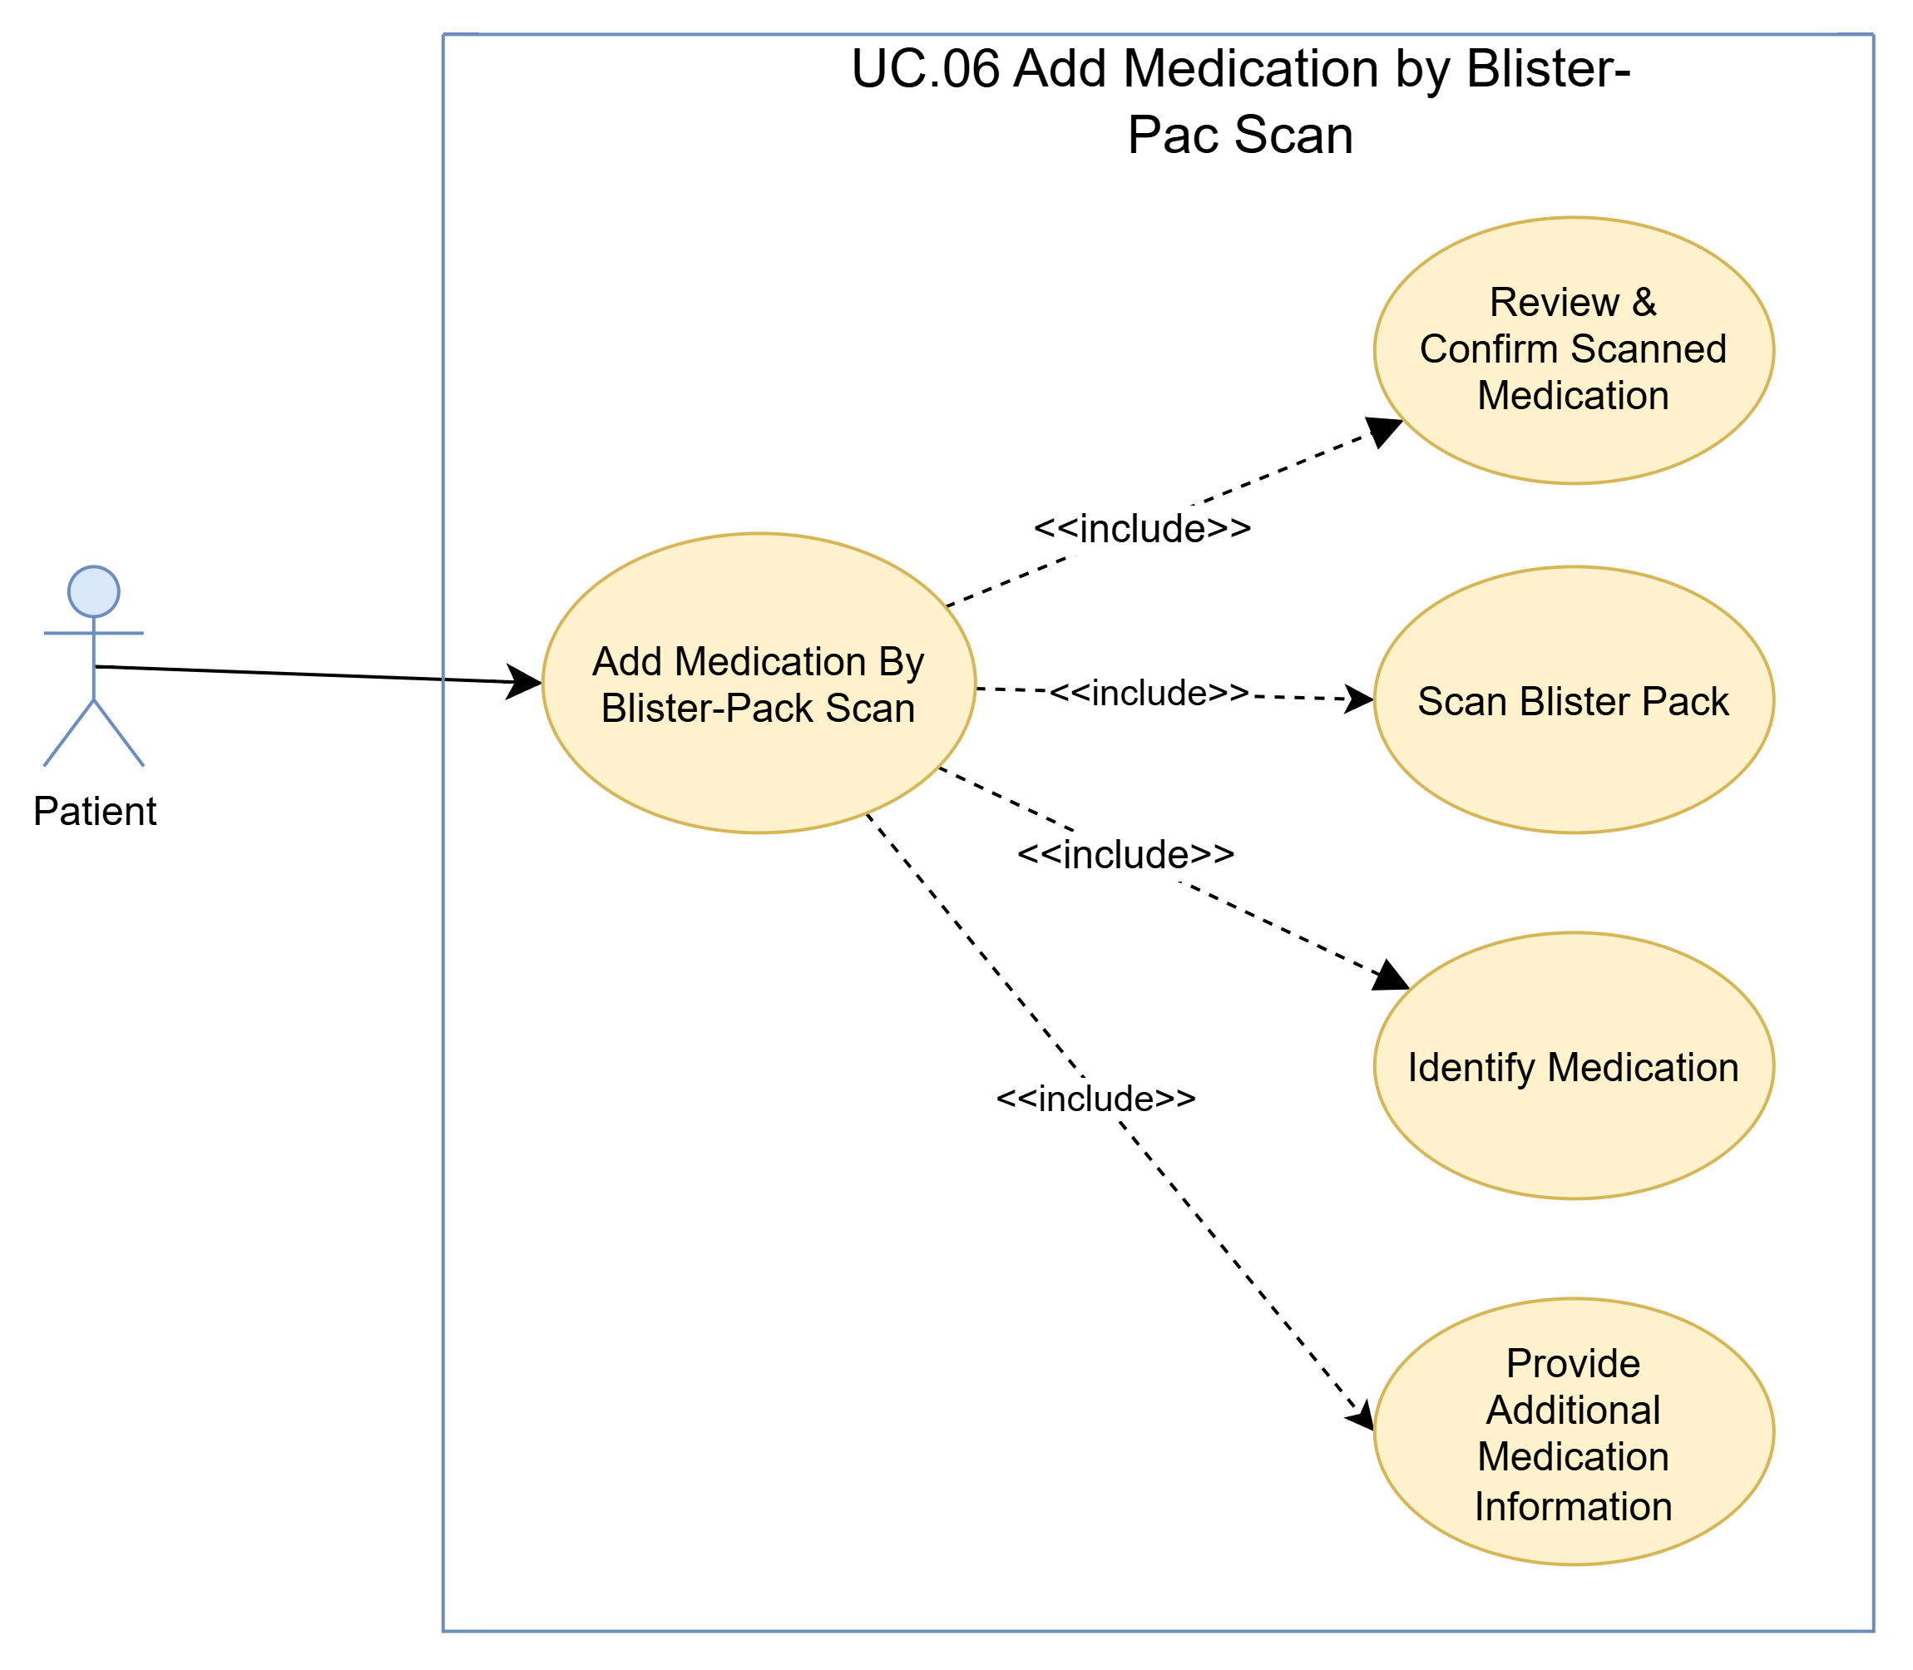
- Use Case Specification
Use case ID | UC.06
Use case name | Add Medication by Blister-Pack Scan
Create by | Viet Dang |  | Last updated by |  | Viet Dang, Bao Nguyen
Date created | September 16, 2026 |  | Date last updated |  | September 16, 2026
Actor | Patient
Description | This use case allows a Patient to add a medication to DrugTime by scanning the medication information displayed on a blister pack. DrugTime processes the captured information and attempts to identify the medication using the available medication catalogue. The Patient must review the identified medication information and explicitly confirm the information before the medication can be recorded. When the medication cannot be identified or matched to an applicable catalogue entry, DrugTime records the unmatched scan result for Admin review and provides the supported manual medication-entry flow as a fallback.
Goal | To reduce manual medication entry by allowing the Patient to identify a medication through blister-pack scanning while ensuring that the Patient manually reviews and explicitly confirms the medication information before the medication is recorded.
Trigger | The Patient opens the medication-management function and selects the option to add a medication by scanning a blister pack.
Pre-condition | - The Patient is authenticated and has access to medication-management functions.  - The Patient has selected the blister-pack scanning option.  - The device provides the scanning capability required to capture the blister-pack information.  - The applicable DrugTime medication catalogue is available for medication identification and matching.  - Internet connectivity is available as required by the project's system assumptions for the application.
Post-condition | - The scanned medication information has been processed and, when possible, matched to an applicable medication catalogue entry.  - The Patient has reviewed the identified medication information before it is recorded.  - The medication information has been explicitly confirmed by the Patient in accordance with the medication confirmation requirement.  - Any additional required medication information has been provided and validated.  - The confirmed medication is recorded and becomes available through the Patient's medication-management functions.  - If the medication cannot be identified, the unmatched scan result is recorded for Admin review and the Patient is provided with the supported manual medication-entry fallback.
Main Success Scenario: | Step | Actor Action |  | System Response
Main Success Scenario: | 1 | Patient selects Add Medication by Blister-Pack Scan. |  | System activates the blister-pack scanning flow and provides the scanning function.
Main Success Scenario: | 2 | Patient captures the medication information from the blister pack using the scanning function. |  | System processes the captured information and attempts to identify the medication using the available medication catalogue.
Main Success Scenario: | 3 |  |  | System displays the identified medication information and applicable catalogue match for Patient review.
Main Success Scenario: | 4 | Patient reviews the identified medication and selects the intended medication when applicable. |  | System displays the selected medication information and prepares it for Patient confirmation.
Main Success Scenario: | 5 | Patient provides any additional required medication information. |  | System validates the provided medication information.
Main Success Scenario: | 6 |  |  | System displays the completed medication information for final review and confirmation.
Main Success Scenario: | 7 | Patient reviews the completed medication information and confirms the medication record. |  | System records the confirmed medication and associated required information.
Main Success Scenario: | 8 |  |  | System confirms that the medication has been successfully recorded and makes the medication available through the Patient's medication-management functions.
Alternative Scenario: | Alternative Flow 1: Revise Medication Selection Before Confirmation
Alternative Scenario: | Step | Actor Action |  | System Response
Alternative Scenario: | 1 | Patient reviews the medication information identified from the blister-pack scan |  | System displays the identified medication information for review.
Alternative Scenario: | 2 | Patient determines that one or more editable medication information fields are incorrect or incomplete. |  | System keeps the medication record unconfirmed and allows the applicable information to be edited.
Alternative Scenario: | 3 | Patient manually revises the applicable medication information. |  | System validates the revised information.
Alternative Scenario: | 4 |  |  | System displays the revised medication information for final review and confirmation
Alternative Scenario: | 5 | Patient reviews and explicitly confirms the revised medication information |  | System records the confirmed medication and associated information
Alternative Scenario: | 6 |  |  | System confirms successful recording
Alternative Scenario: | Alternative Flow 2: Revise Additional Medication Information Before Final Confirmation
Alternative Scenario: | Step | Actor Action |  | System Response
Alternative Scenario: | 1 | Patient determines during final review that one or more items of the additional medication information need to be changed. |  | System keeps the current medication record unconfirmed and makes the applicable information available for revision.
Alternative Scenario: | 2 | Patient revises the applicable medication information. |  | System validates the revised information.
Alternative Scenario: | Alternative Flow 3: Cancel Medication Entry Before Final Confirmation
Alternative Scenario: | Step | Actor Action |  | System Resposne
Alternative Scenario: | 1 | Patient chooses to cancel the current scan-based medication-entry operation before final confirmation. |  | System allows the Patient to cancel the current medication-entry process.
Alternative Scenario: | 2 | Patient confirms the cancellation when required. |  | System discards the unconfirmed medication information and does not record the medication.
Alternative Scenario: | 3 |  |  | System returns the Patient to the applicable medication-management view without changing previously recorded medication information.
Exceptions | Exception 1: Camera or Scanning Capability Unavailable
Exceptions | Step | Actor Action |  | System Response
Exceptions | 1 | Patient selects the blister-pack scanning function. |  | System determines that the required camera or scanning capability is unavailable.
Exceptions | 2 |  |  | System informs the Patient that blister-pack scanning cannot be performed under the current condition.
Exceptions | Exception 2: Medication Cannot Be Identified or Matched
Exceptions | Step | Actor Action |  | System Response
Exceptions | 1 | Patient completes the blister-pack scan. |  | System cannot identify the medication or cannot find an applicable medication catalogue match.
Exceptions | 2 |  |  | System records the unmatched scan result for Admin review and catalogue-management activities.
Exceptions | 3 |  |  | System informs the Patient that the medication could not be identified through the scanning flow and provides the supported manual medication-entry fallback.
Exceptions | Exception 3: Patient Does Not Confirm Scanned Medication Information
Exceptions | Step | Actor Action |  | System Response
Exceptions | 1 | Patient reviews the identified medication information but does not explicitly confirm it. |  | System does not treat the scanned medication information as confirmed.
Exceptions | 2 | Patient attempts to continue without completing the required confirmation. |  | System prevents the medication from being recorded as a confirmed medication and informs the Patient that confirmation is required.
Exceptions | Exception 4: Additional Medication Information Is Invalid or Incomplete
Exceptions | Step | Actor Action |  | System Response
Exceptions | 1 | Patient submits the additional required medication information. |  | System identifies information that is missing or does not satisfy the applicable medication-entry requirements.
Exceptions | 2 |  |  | System informs the Patient which information must be corrected or completed and does not proceed with recording the incomplete medication information.
Exceptions | Exception 5: Medication Recording Failure
Exceptions | Step | Actor Action |  | System Response
Exceptions | 1 | Patient confirms the completed medication record. |  | System attempts to record the confirmed medication.
Exceptions | 2 |  |  | System determines that the medication cannot be recorded successfully.
Exceptions | 3 |  |  | System informs the Patient that the medication could not be recorded and does not indicate that the medication was successfully added.
Priority | High
Business rule | BR-10, BR-11, BR-12, BR-18

- Prototype
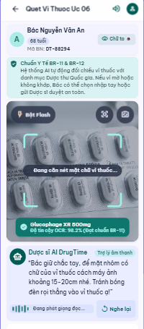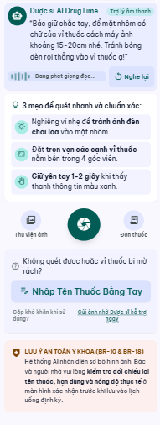

UC 07: Review and Confirm Scanned Medication
- Use Case Diagram
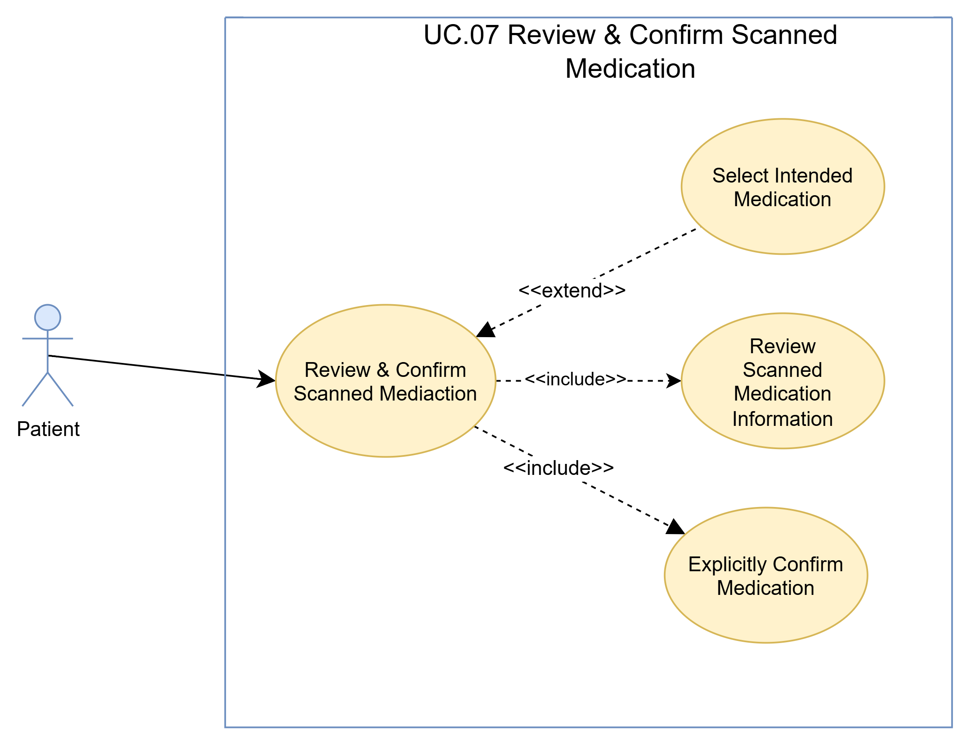
- Use Case Specification
Use case ID | UC.07
Use case name | Review and Confirm Scanned Medication
Create by | Viet Dang |  | Last updated by |  | Viet Dang, Bao Nguyen
Date created | September 16, 2026 |  | Date last updated |  | September 16, 2026
Actor | Patient
Description | This use case allows a Patient to review medication information produced by the supported blister-pack scanning process before the information is used to complete the medication-entry process. The Patient reviews the identified medication information against the intended medication, selects the intended medication when multiple candidate matches are available, and must explicitly confirm the medication information before it can proceed to the recording step. If the Patient does not confirm the information or determines that the identified medication is incorrect, the medication remains unconfirmed and the Patient may revise the selection, return to the supported medication-entry flow, or cancel the process.
Goal | To ensure that medication information obtained through blister-pack scanning is reviewed and explicitly confirmed by the Patient before the information can be used to complete the medication-entry process.
Trigger | A medication candidate or identified medication result produced by the blister-pack scanning process is available and is presented to the Patient for review and confirmation.
Pre-condition | - The Patient is authenticated and has access to the medication-management functions.  - A blister-pack scan has been processed through the supported scanning flow.  - Medication information or one or more candidate medication matches are available for Patient review.  - The identified medication information is available for the Patient to compare and verify.  - The Patient has not yet confirmed the scanned medication information.
Post-condition | - The Patient has reviewed the identified medication information.  - When multiple candidate matches are available, the Patient has selected the intended medication before confirmation.  - The Patient has explicitly confirmed the intended medication information.  - The confirmed medication information is made available to the calling medication-entry flow for continuation toward recording.  - If the Patient does not confirm the medication information, the medication remains unconfirmed and is not treated as a confirmed medication record.
Main Success Scenario: | Step | Actor Action |  | System Response
Main Success Scenario: | 1 |  |  | System displays the medication information identified from the blister-pack scan for Patient review
Main Success Scenario: | 2 | Patient reviews and compares the displayed medication information with the intended medication on the blister pack. |  | System keeps the identified medication information available for confirmation.
Main Success Scenario: | 3 | Patient explicitly confirms that the displayed medication information represents the intended medication. |  | System marks the medication information as Patient-confirmed.
Main Success Scenario: | 4 |  |  | System returns the Patient-confirmed medication information to the medication-entry flow so that the remaining required medication information and recording process can continue.
Alternative Scenario | Alternative Flow 1: Multiple Catalogue Matches
Alternative Scenario | Step | Actor Action |  | System Response
Alternative Scenario | 1 |  |  | System determines that multiple candidate medication matches are available from the blister-pack scanning process.
Alternative Scenario | 2 |  |  | System displays the candidate medication matches together with the available information required to distinguish them.
Alternative Scenario | 3 | Patient reviews the candidate medication matches and selects the intended medication. |  | System keeps the selected medication information available for confirmation.
Alternative Scenario | Alternative Flow 2: Cancel Review and Confirmation
Alternative Scenario | Step | Actor Action |  | System Response
Alternative Scenario | 1 | Patient decides not to continue with the current scanned medication before confirming it. |  | System allows the Patient to cancel the current review and confirmation process.
Alternative Scenario | 2 | Patient confirms the cancellation when required. |  | System does not treat the scanned medication information as confirmed and exits the current review process.
Alternative Scenario | 3 |  |  | System returns the Patient to the applicable medication-management context without recording the unconfirmed medication as a confirmed medication.
Exceptions | Exception 1: Patient Attempts to Continue Without Confirmation
Exceptions | Step | Actor Action |  | System Response
Exceptions | 1 | Patient reviews the scanned medication information but does not explicitly confirm it. |  | System cannot identify the medication or cannot find an applicable medication catalogue match.
Exceptions | 2 | Patient attempts to continue the medication-entry process without providing the required confirmation. |  | System records the unmatched scan result for Admin review and catalogue-management activities.
Exceptions | Exception 2: Confirmation Processing Failure
Exceptions | Step | Actor Action |  | System Response
Exceptions | 1 | Patient explicitly confirms the medication information. |  | System attempts to process the Patient's confirmation.
Exceptions | 2 |  |  | System determines that the confirmation cannot be successfully processed.
Exceptions | 3 |  |  | System informs the Patient that the medication confirmation could not be completed and does not treat the medication information as confirmed.
Priority | High
Business rule | BR-10

- Prototype
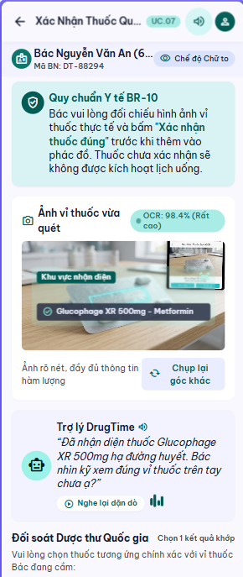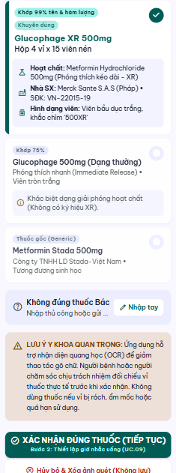

UC 08: Manage Recorded Medication
- Use Case Diagram

- Use Case Specification
Use case ID | UC.08
Use case name | Manage Recorded Medication
Create by | Viet Dang |  | Last updated by |  | Viet Dang
Date created | September 16, 2026 |  | Date last updated |  | September 16, 2026
Actor | Patient
Description | This use case allows a Patient to review and manage a medication that has previously been recorded in DrugTime. The Patient can review the recorded medication information, update supported medication information, or remove the medication from the active medication list. Any update or removal must be explicitly confirmed by the Patient before the change is applied.
Goal | To allow the Patient to keep the recorded medication list accurate and current by reviewing, updating, or removing recorded medication information.
Trigger | The Patient wants to review or manage a previously recorded medication.
Pre-condition | - The Patient is authenticated and has access to medication-management functions.  - At least one medication has previously been recorded for the Patient.  - The recorded medication is available for review or management.  - The supported medication-management functions are available to the Patient.
Post-condition | - If an update is completed, the confirmed revised medication information is recorded.  - If a removal is completed, the confirmed medication is removed from the active medication list.  - The Patient's medication list reflects the completed management action.
Main Success Scenario: | Step | Actor Action |  | System Response
Main Success Scenario: | 1 | Patient opens the recorded medication list. |  | System displays the medications currently recorded for the Patient.
Main Success Scenario: | 2 | Patient selects the medication to manage. |  | System displays the selected medication information and the supported management actions.
Main Success Scenario: | 3 | Patient chooses to update the selected medication information. |  | System displays the currently recorded medication information and allows the Patient to revise the supported information.
Main Success Scenario: | 4 | Patient revises the applicable medication information and submits the changes. |  | System validates the revised medication information.
Main Success Scenario: | 5 |  |  | System displays the validated revised medication information for Patient review and confirmation.
Main Success Scenario: | 6 | Patient reviews and explicitly confirms the revised medication information. |  | System records the confirmed medication changes.
Main Success Scenario: | 7 |  |  | System confirms that the medication information has been updated and displays the current medication list.
Alternative Scenario | Alternative Flow 1: Remove Recorded Medication
Alternative Scenario | Step | Actor Action |  | System Response
Alternative Scenario | 1 | Patient chooses the supported removal action for the selected medication. |  | System displays the selected medication information and requests confirmation before removal.
Alternative Scenario | 2 | Patient reviews the selected medication and confirms that it should be removed. |  | System removes the medication from the active medication list.
Alternative Scenario | 3 |  |  | System confirms that the medication has been removed and displays the current medication list without the removed medication.
Alternative Scenario | Alternative Flow 2: Review Recorded Medication Without Making Changes
Alternative Scenario | Step | Actor Action |  | System Response
Alternative Scenario | 1 | Patient reviews the displayed medication information and decides not to update or remove it. |  | System keeps the recorded medication information unchanged.
Alternative Scenario | 2 | Patient chooses to return to the recorded medication list. |  | System displays the current recorded medication list.
Alternative Scenario | Alternative Flow 3: Revise Medication Information Before Confirmation
Alternative Scenario | Step | Actor Action |  | System Response
Alternative Scenario | 1 | Patient reviews the revised medication information and determines that further changes are required before confirmation. |  | System keeps the current revision unconfirmed and allows the Patient to continue editing the supported information.
Alternative Scenario | 2 | Patient makes the required changes and submits the revised information. |  | System validates the revised medication information.
Alternative Scenario | Alternative Flow 4: Cancel Medication Changes Before Confirmation
Alternative Scenario | Step | Actor Action |  | System Response
Alternative Scenario | 1 | Patient decides not to continue with the medication changes before confirming them. |  | System allows the Patient to cancel the current update operation.
Alternative Scenario | 2 | Patient confirms the cancellation when required. |  | System discards the unconfirmed changes and keeps the previously recorded medication information unchanged.
Alternative Scenario | 3 |  |  | System returns the Patient to the recorded medication information or medication list.
Alternative Scenario | Alternative Flow 5: Cancel Medication Removal Before Confirmation
Alternative Scenario | Step | Actor Action |  | System Response
Alternative Scenario |  | Patient selects the removal action but decides not to remove the medication before confirming it. |  | System keeps the selected medication in the active medication list and allows the Patient to cancel the removal operation.
Alternative Scenario |  | Patient cancels the removal operation. |  | System does not remove the medication and keeps the existing medication information unchanged.
Alternative Scenario |  |  |  | System returns the Patient to the selected medication information and supported management actions.
Exceptions | Exception 1: Scanned Medication Information Cannot Be Reviewed
Exceptions | Step | Actor Action |  | System Response
Exceptions | 1 |  |  | System determines that the selected medication is no longer available for the requested management action.
Exceptions | 2 |  |  | System informs the Patient that the selected medication cannot currently be managed.
Exceptions | 3 |  |  | System refreshes and displays the medications currently available for management.
Exceptions | Exception 2: Updated Medication Information Is Invalid or Incomplete
Exceptions | Step | Actor Action |  | System Response
Exceptions | 1 |  |  | System determines that the revised medication information is invalid or missing required information.
Exceptions | 2 |  |  | System informs the Patient of the information that must be corrected or completed and does not record the invalid revision.
Exceptions | 3 | Patient corrects or completes the indicated medication information and resubmits the changes. |  | System validates the corrected medication information.
Exceptions | Exception 3: Update or Removal Operation Fails
Exceptions | Step | Actor Action |  | System Response
Exceptions | 1 |  |  | System determines that the confirmed update or removal operation cannot be completed successfully.
Exceptions | 2 |  |  | System informs the Patient that the requested medication-management action could not be completed and does not report the action as successful.
Exceptions | 3 |  |  | System keeps the last successfully recorded medication state unchanged.
Exceptions | Exception 4: Internet Connection Unavailable
Exceptions | Step | Actor Action |  | System Response
Exceptions | 1 |  |  | System detects that the required Internet connection is unavailable.
Exceptions | 2 |  |  | System informs the Patient that the affected medication-management operation cannot be completed while the connection is unavailable.
Exceptions | 3 |  |  | System informs the Patient that the affected medication-management operation cannot be completed while the connection is unavailable.
Priority | High
Business rule | BR-06, BR-18

- Prototype
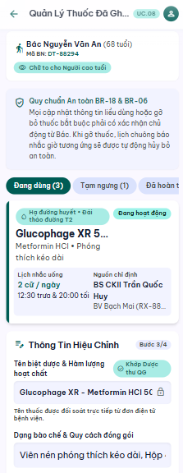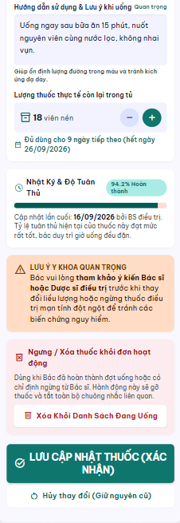

UC 09: Manage Medication Schedule
- Use Case Diagram
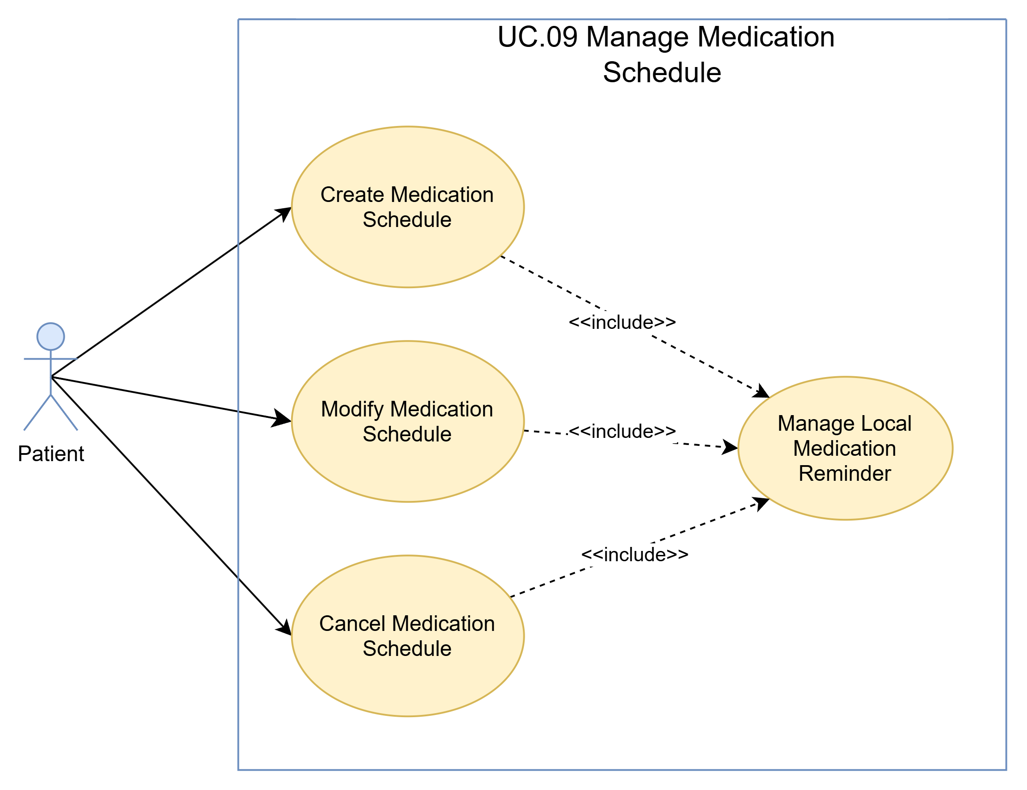
- Use Case Specification
Use case ID | UC.09
Use case name | Manage Medication Schedule
Create by | Viet Dang |  | Last updated by |  | Viet Dang
Date created | September 16, 2026 |  | Date last updated |  | September 16, 2026
Actor | Patient
Description | This use case allows a Patient to create, modify, or cancel a medication schedule for a recorded medication. The Patient provides or revises the supported schedule information, reviews the resulting schedule, and explicitly confirms the requested action before it is applied. When a schedule is created or modified, DrugTime creates or updates the corresponding supported local medication reminder. When a schedule is cancelled, the corresponding local medication reminder is cancelled.
Goal | To allow the Patient to maintain an accurate medication schedule and ensure that the corresponding local medication reminder reflects the Patient-confirmed schedule.
Trigger | The Patient wants to manage the medication schedule of a recorded medication.
Pre-condition | - The Patient is authenticated and has access to medication-management functions.  - The target medication has been recorded for the Patient.  - The Patient has access to the medication schedule-management function.  - For modification or cancellation, an existing medication schedule is available for the selected medication.  - The supported local reminder function is available.
Post-condition | - A new medication schedule is created, an existing medication schedule is modified, or an existing medication schedule is cancelled according to the Patient-confirmed action.  - For a created or modified schedule, the resulting schedule reflects the valid information confirmed by the Patient.  - The corresponding local medication reminder reflects the resulting medication schedule.
Main Success Scenario: | Main Flow 1: Create Medication Schedule
Main Success Scenario: | Step | Actor Action |  | System Response
Main Success Scenario: | 1 | Patient selects a recorded medication and chooses to create a schedule. |  | System displays the schedule-entry function.
Main Success Scenario: | 2 | Patient provides the supported schedule information and submits it. |  | System validates the provided schedule information.
Main Success Scenario: | 3 |  |  | System displays the validated proposed medication schedule for review and confirmation.
Main Success Scenario: | 4 | Patient reviews and explicitly confirms the proposed medication schedule. |  | System creates the confirmed medication schedule.
Main Success Scenario: | 5 |  |  | System creates the corresponding local medication reminder for the confirmed schedule.
Main Success Scenario: | 6 |  |  | System confirms that the medication schedule has been created successfully and displays the resulting schedule.
Alternative Scenario | Alternative Flow 1: Modify Existing Medication Schedule
Alternative Scenario | Step | Actor Action |  | System Response
Alternative Scenario | 1 | Patient selects an existing medication schedule and chooses to modify it. |  | System and makes the supported schedule information available for modification.
Alternative Scenario | 2 | Patient modifies the applicable schedule information and submits the changes. |  | System validates the modified schedule information.
Alternative Scenario | 3 |  |  | System displays the validated modified schedule for review and confirmation.
Alternative Scenario | 4 | Patient reviews and explicitly confirms the modified schedule. |  | System applies the confirmed changes to the medication schedule.
Alternative Scenario | 5 |  |  | System updates the corresponding local medication reminder to reflect the confirmed schedule.
Alternative Scenario | 6 |  |  | System confirms that the medication schedule has been modified successfully and displays the resulting schedule.
Alternative Scenario | Alternative Flow 2: Cancel Existing Medication Schedule
Alternative Scenario | Step | Actor Action |  | System Response
Alternative Scenario | 1 | Patient selects an existing medication schedule and chooses to cancel it. |  | System displays the selected schedule and requests confirmation of the cancellation.
Alternative Scenario | 2 | Patient reviews the selected schedule and explicitly confirms the cancellation. |  | System cancels the confirmed medication schedule.
Alternative Scenario | 3 |  |  | System cancels the corresponding local medication reminder.
Alternative Scenario | 4 |  |  | System confirms that the medication schedule has been cancelled and displays the resulting schedule status.
Alternative Scenario | Alternative Flow 3: Revise Proposed Schedule Before Confirmation
Alternative Scenario | Step | Actor Action |  | System Response
Alternative Scenario | 1 | Patient reviews the proposed schedule and determines that further changes are required before confirmation. |  | System keeps the proposed schedule unconfirmed and allows the Patient to revise the supported schedule information.
Alternative Scenario | 2 | Patient revises the applicable schedule information and resubmits it. |  | System validates the revised schedule information.
Exception Flow | Exception 1: Schedule Operation Fails
Exception Flow | Step | Actor Action |  | System Response
Exception Flow | 1 | Patient confirms the schedule creation, modification, or cancellation. |  | System determines that the confirmed schedule creation, modification, or cancellation cannot be completed successfully.
Exception Flow | 2 |  |  | System informs the Patient that the requested schedule operation could not be completed.
Exception Flow | 3 |  |  | System does not report the requested schedule operation as successfully completed.
Exception Flow | Exception 2: Local Reminder Cannot Be Updated
Exception Flow | Step | Actor Action |  | System Response
Exception Flow | 1 | Patient reviews and explicitly confirms the proposed medication schedule. |  | System applies the confirmed changes to the medication schedule.
Exception Flow | 2 |  |  | System determines that the corresponding local medication reminder cannot be created, updated, or cancelled as required.
Exception Flow | 3 |  |  | System informs the Patient that the schedule operation and its corresponding local reminder were not fully applied.
Exception Flow | 4 |  |  | System does not report the overall schedule-management operation as fully completed.
Exception Flow | Exception 3: Existing Schedule Is No Longer Available
Exception Flow | Step | Actor Action |  | System Response
Exception Flow | 1 | Patient selects an existing medication schedule and chooses to modify it. |  | System displays the current schedule and makes the supported schedule information available for modification.
Exception Flow | 2 |  |  | System determines that the selected medication schedule is no longer available for the requested management action.
Exception Flow | 3 |  |  | System informs the Patient that the selected schedule cannot currently be managed.
Exception Flow | 4 |  |  | System refreshes the available medication schedule information and does not apply the requested action to another schedule.
Priority | High
Business rule | BR-06

- Prototype
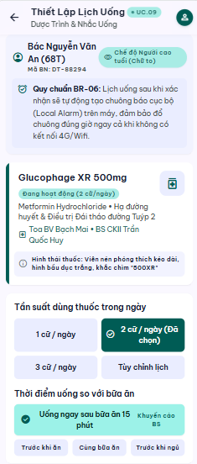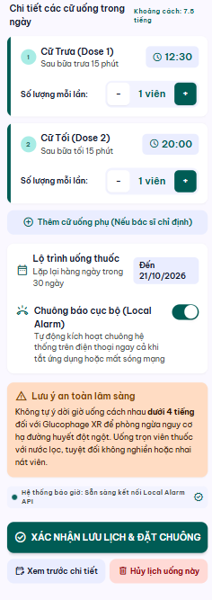

UC 10: Receive Medication Dose Reminder
- Use Case Diagram
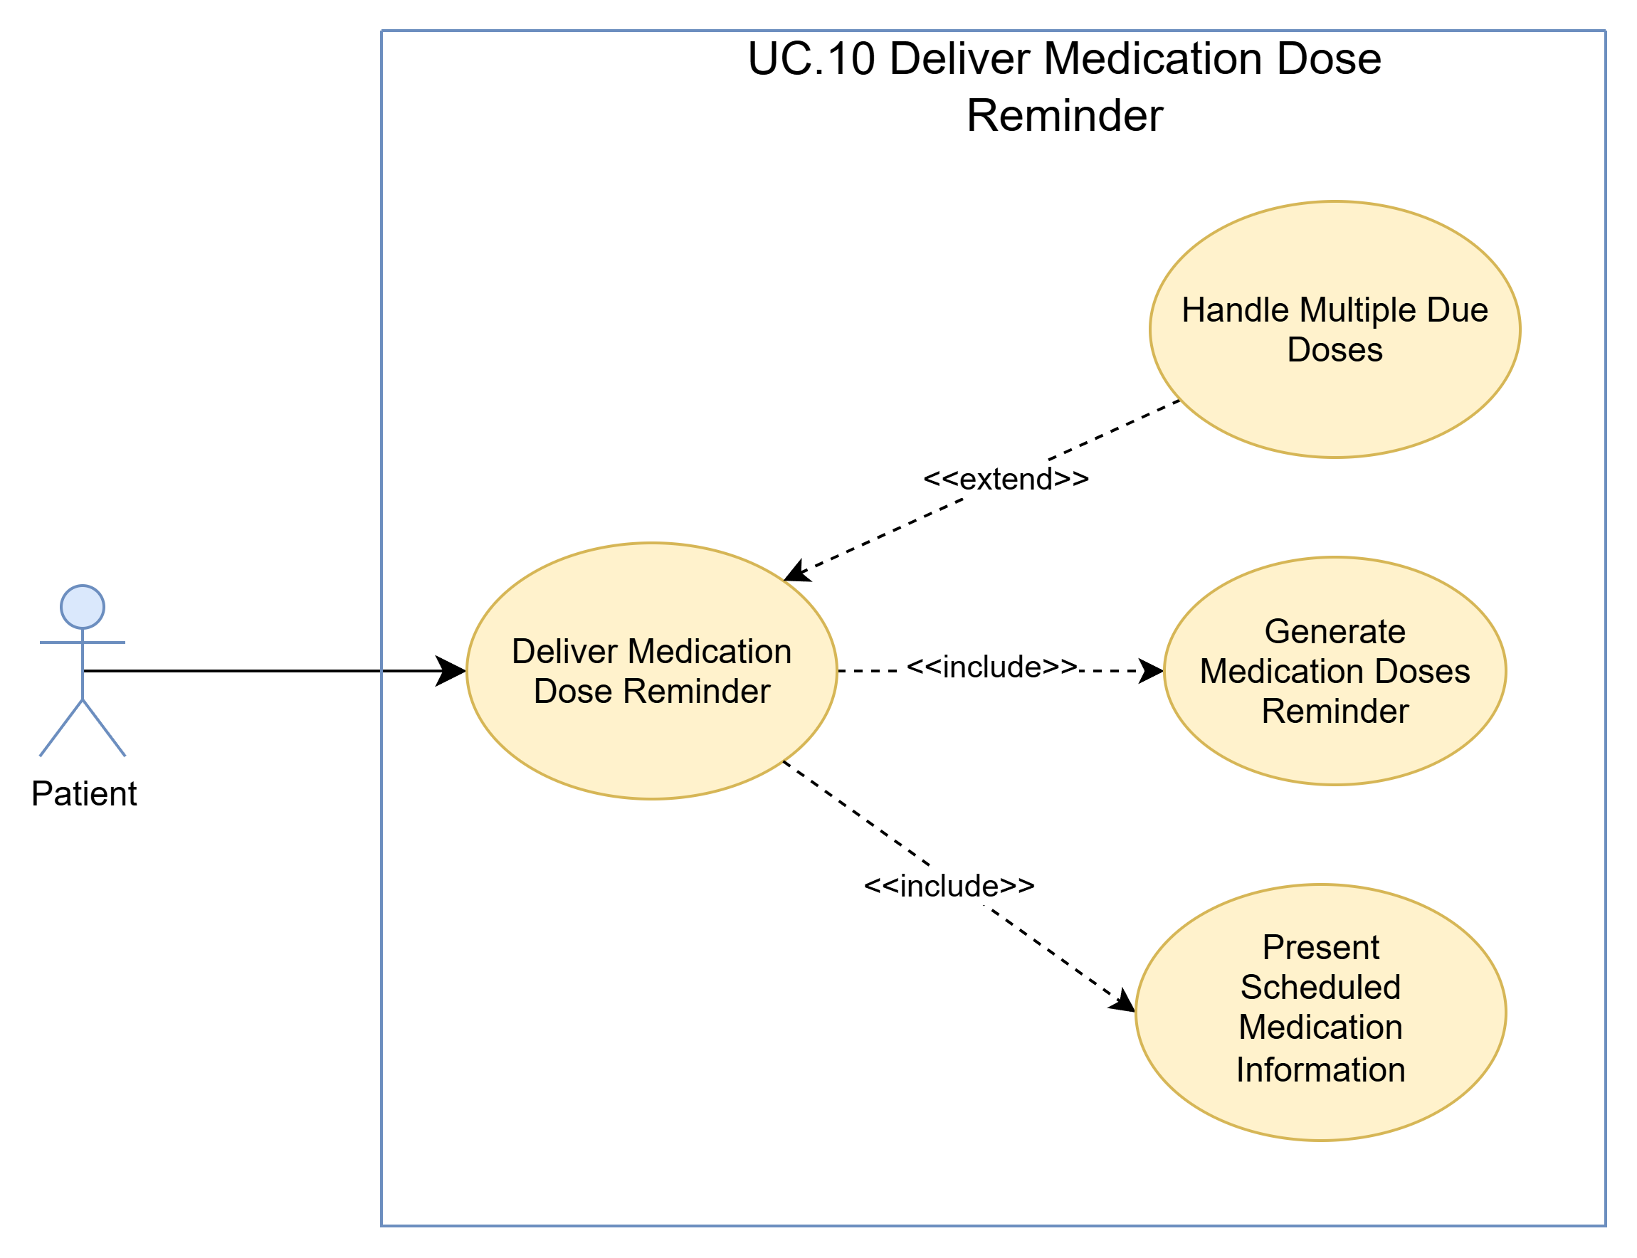
- Use Case Specification
Use case ID | UC.10
Use case name | Receive Medication Dose Reminder
Create by | Viet Dang |  | Last updated by |  | Viet Dang
Date created | September 16, 2026 |  | Date last updated |  | September 16, 2026
Actor | Patient
Description | This use case describes how DrugTime delivers a local medication dose reminder when an active medication schedule reaches its configured reminder time. The system generates and presents the corresponding on-device notification containing the relevant scheduled medication information. Delivery or viewing of the reminder does not by itself confirm that the Patient has taken the medication.
Goal | To notify the Patient when a scheduled medication dose is due so that the Patient is aware of the scheduled medication intake.
Trigger | A valid medication schedule reaches its configured reminder time.
Pre-condition | - The Patient has a recorded medication with an active medication schedule.  - The medication schedule contains valid reminder information.  - The corresponding local medication reminder has been configured.  - The Patient's device supports the required local-notification capability.
Post-condition | - The local medication dose reminder is generated for the scheduled dose at its configured reminder time.  - The reminder is delivered to the Patient's device and presents the relevant scheduled medication information.  - The scheduled dose remains unconfirmed until the Patient performs the supported dose-confirmation action.
Main Flow | Step | Actor Action |  | System Response
Main Flow | 1 |  |  | System detects that an active medication schedule has reached its configured reminder time.
Main Flow | 2 |  |  | System identifies the scheduled medication dose associated with the reminder.
Main Flow | 3 |  |  | System generates the corresponding local medication dose reminder containing the relevant scheduled medication information.
Main Flow | 4 |  |  | System delivers the local medication dose reminder to the Patient's device.
Main Flow | 5 |  |  | System presents the relevant scheduled medication information in the local notification.
Main Flow | 6 |  |  | System keeps the scheduled medication dose unconfirmed until the Patient performs the supported dose-confirmation action.
Alternative Scenario | Alternative Flow 1: Multiple Scheduled Doses Are Due
Alternative Scenario | Step | Actor Action |  | System Response
Alternative Scenario | 1 | Patient receives a reminder when more than one scheduled medication dose is due at the same time. |  | System determines that more than one scheduled medication dose is due at the same reminder time.
Alternative Scenario | 2 |  |  | System identifies the applicable scheduled medication information for each due dose.
Alternative Scenario | 3 |  |  | System prepares the applicable reminder information so that the Patient can distinguish the due medication doses.
Alternative Scenario | Alternative Flow 2: Patient Views the Reminder Later
Alternative Scenario | Step | Actor Action |  | System Response
Alternative Scenario | 1 | Patient does not immediately view the delivered reminder. |  | System displays the available reminder information for the scheduled medication dose.
Alternative Scenario | 2 | Patient later accesses the available reminder. |  | System provides the scheduled medication information associated with the reminder.
Alternative Scenario | 3 | Patient views the reminder information. |  | System keeps the scheduled medication dose unconfirmed until the supported dose-confirmation action is performed.
Exception Flow | Exception 1: Reminder Configuration Is Unavailable
Exception Flow | Step | Actor Action |  | System Response
Exception Flow | 1 |  |  | System determines that the required local reminder configuration for the scheduled medication dose is unavailable or cannot be used.
Exception Flow | 2 |  |  | System does not generate a misleading or incomplete medication reminder.
Exception Flow | 3 |  |  | System does not modify the underlying medication schedule.
Exception Flow | Exception 2: Local Reminder Delivery Fails
Exception Flow | Step | Actor Action |  | System Response
Exception Flow | 1 |  |  | System determines that the generated local medication dose reminder cannot be delivered successfully to the Patient's device.
Exception Flow | 2 |  |  | System does not represent the affected reminder as successfully delivered.
Exception Flow | 3 |  |  | System keeps the underlying medication schedule unchanged.
Priority | High
Business rule | BR-06

- Prototype
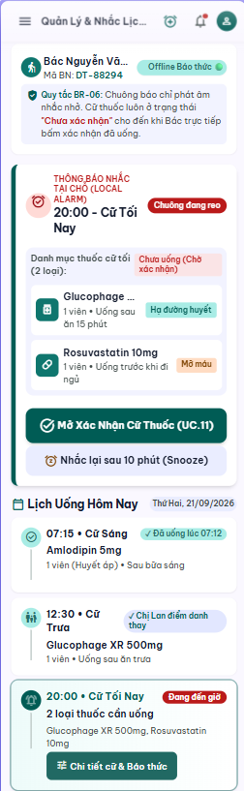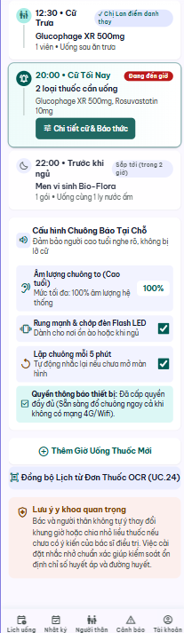

UC 11: Confirm Medication Dose Intake
- Use Case Diagram
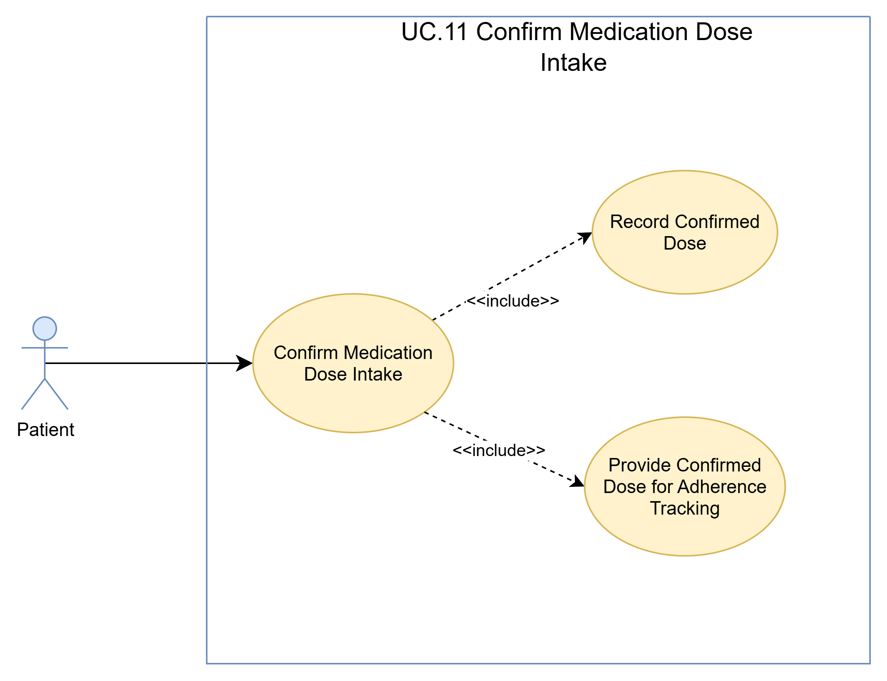
- Use Case Specification
Use case ID | UC.11
Use case name | Confirm Medication Dose Intake
Create by | Viet Dang |  | Last updated by |  | Viet Dang
Date created | September 16, 2026 |  | Date last updated |  | September 16, 2026
Actor | Patient
Description | This use case allows a Patient to explicitly confirm an applicable scheduled medication dose using the supported dose-confirmation action. DrugTime validates that the selected dose can be confirmed, records the confirmed dose, and makes the confirmed dose available for medication adherence tracking. Receiving or viewing a medication reminder alone does not confirm the dose.
Goal | To record a scheduled medication dose as confirmed only after the Patient explicitly performs the supported dose-confirmation action.
Trigger | The Patient chooses to confirm an applicable scheduled medication dose.
Pre-condition | - The Patient is authenticated and has access to the applicable medication information.  - The Patient has a recorded medication with an applicable scheduled dose.  - The scheduled dose is available for confirmation.  - The supported dose-confirmation action is available to the Patient.
Post-condition | - The selected scheduled medication dose is recorded as confirmed.  - The confirmed dose is made available for medication adherence tracking.  - The dose is no longer treated as unconfirmed.  - The Patient is shown the updated dose-confirmation status.
Main Flow | Step | Actor Action |  | System Response
Main Flow | 1 | Patient opens an applicable scheduled dose from the medication reminder. |  | System displays the scheduled dose information and the supported dose-confirmation action.
Main Flow | 2 | Patient performs the supported explicit dose-confirmation action. |  | System validates that the selected scheduled dose is available for confirmation.
Main Flow | 3 |  |  | System records the selected scheduled dose as confirmed.
Main Flow | 4 |  |  | System makes the confirmed dose available for medication adherence tracking.
Main Flow | 5 |  |  | System displays the updated dose-confirmation status to the Patient.
Alternative Scenario | Alternative Flow 1: Confirm Dose from Medication Schedule
Alternative Scenario | Step | Actor Action |  | System Response
Alternative Scenario | 1 | Patient opens the medication schedule and selects an applicable scheduled dose instead of confirming it from the reminder. |  | System displays the selected dose and the supported dose-confirmation action.
Alternative Scenario | 2 | Patient performs the supported explicit dose-confirmation action. |  | System validates that the selected dose is available for confirmation.
Alternative Scenario | 3 |  |  | System records the selected dose as confirmed.
Alternative Scenario | 4 |  |  | System makes the confirmed dose available for adherence tracking and displays the updated confirmation status.
Alternative Scenario | Alternative Flow 2: Cancel Dose Confirmation Before Confirmation
Alternative Scenario | Step | Actor Action |  | System Response
Alternative Scenario | 1 | Patient decides not to perform the dose-confirmation action. |  | System keeps the scheduled dose in its current valid state.
Alternative Scenario | 2 | Patient leaves the confirmation process. |  | System returns the Patient to the applicable medication or reminder context without recording the dose as confirmed.
Exception Flow | Exception 1: Dose No Longer Confirmable
Exception Flow | Step | Actor Action |  | System Response
Exception Flow | 1 | Patient attempts to confirm a scheduled dose that is no longer available for confirmation. |  | System determines that the selected scheduled dose is no longer available for confirmation in its current state.
Exception Flow | 2 |  |  | System does not record the scheduled dose as confirmed and preserves its current valid state.
Exception Flow | 3 |  |  | System informs the Patient that the selected dose cannot be confirmed and does not report a successful confirmation.
Exception Flow | Exception 2: Confirmation Processing Failure
Exception Flow | Step | Actor Action |  | System Response
Exception Flow | 1 | Patient performs the supported dose-confirmation action. |  | System attempts to record the dose confirmation.
Exception Flow | 2 |  |  | System does not report the selected dose as successfully confirmed.
Exception Flow | 3 |  |  | System preserves the last valid dose state.
Exception Flow | 4 |  |  | System informs the Patient that the dose confirmation could not be completed.
Priority | High
Business rule | BR-13, BR-14

- Prototype
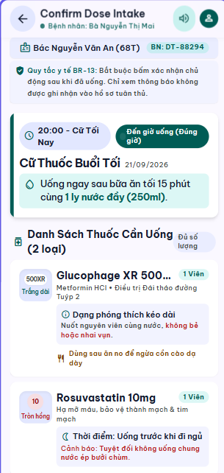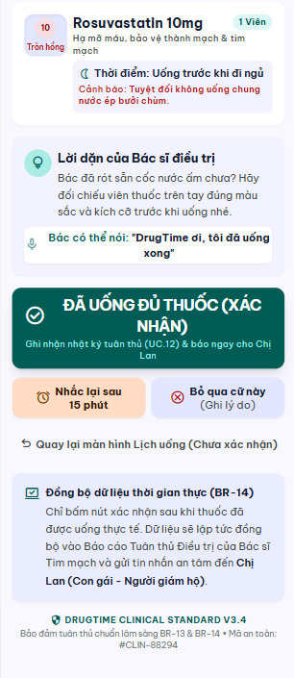

UC 12: Track Medication Adherence History
- Use Case Diagram
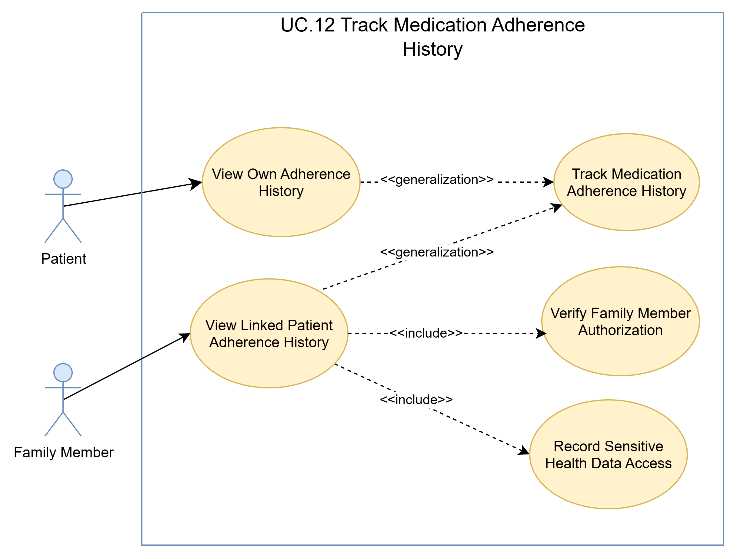
- Use Case Specification
Use case ID | UC.12
Use case name | Track Medication Adherence History
Create by | Viet Dang |  | Last updated by |  | Viet Dang
Date created | September 16, 2026 |  | Date last updated |  | September 16, 2026
Actor | Patient, Family Member
Description | This use case allows a Patient to review their medication adherence history and allows an authorized Family Member to review the basic adherence history of a linked Patient within the data-sharing scope authorized by that Patient. The adherence history contains available medication dose events that have been confirmed or classified as missed.
Goal | To provide the Patient and authorized Family Members with a reviewable history of confirmed and missed medication doses within the applicable access scope.
Trigger | The Patient or an authorized Family Member chooses to view medication adherence history.
Pre-condition | - The Actor is authenticated.  - Medication adherence-history functionality is available.  - When the Actor is a Family Member:  - the Family Member has an active link to the selected Patient; and  - access to the applicable adherence information is within the Patient-authorized data-sharing scope.  - The selected Patient context is available when the Actor is a Family Member.
Post-condition | - The applicable medication adherence history is displayed to the Actor.  - The displayed history contains only information within the Actor's authorized access scope.  - Available confirmed and missed medication dose events are presented as part of the adherence history.  - When a Family Member accesses a Patient's adherence history, the access is auditable as required by the applicable sensitive-health-data access rule.
Main Flow | Step | Actor Action |  | System Response
Main Flow | 1 | Patient chooses to view medication adherence history. |  | System identifies the Patient's own adherence-history context.
Main Flow | 2 |  |  | System retrieves the available medication adherence history for the Patient.
Main Flow | 3 |  |  | System displays the available confirmed and missed medication dose events.
Main Flow | 4 | Patient reviews the displayed medication adherence history. |  | System keeps the Patient within their own adherence-history context.
Alternative Scenario | Alternative Flow 1: Family Member Views Linked Patient's Adherence History
Alternative Scenario | Step | Actor Action |  | System Response
Alternative Scenario | 1 | Family Member selects another linked Patient for whom access has been explicitly authorized. |  | System verifies the Family Member's authorization for the selected Patient.
Alternative Scenario | 2 |  |  | System displays the adherence history available within the authorized scope for the selected Patient.
Alternative Scenario | 3 |  |  | System retrieves the adherence history available within the authorized scope for the selected Patient.
Alternative Scenario | 4 |  |  | System displays the available confirmed and missed medication dose events within the authorized scope.
Alternative Scenario | 5 | Family Member reviews the displayed adherence history. |  | System keeps the Family Member within the selected Patient's authorized data scope and records the sensitive-health-data access as required.
Alternative Scenario | Alternative Flow 2: Family Member Views Another Authorized Linked Patient
Alternative Scenario | Step | Actor Action |  | System Response
Alternative Scenario | 1 | Family Member selects another linked Patient. |  | System verifies authorization and the applicable data-sharing scope for the newly selected Patient.
Alternative Scenario | 2 |  |  | System retrieves and displays only the adherence history available within the authorized scope for the newly selected Patient.
Alternative Scenario | 3 | Family Member reviews the displayed adherence history. |  | System keeps the Family Member within the newly selected Patient's authorized data scope and records the applicable sensitive-health-data access.
Exception Flow | Exception 1: Family Member Is Not Authorized to Access Selected Patient's History
Exception Flow | Step | Actor Action |  | System Response
Exception Flow | 1 |  |  | System determines that the Family Member is not authorized to access the selected Patient's adherence history within the current data-sharing scope.
Exception Flow | 2 |  |  | System denies access to the restricted adherence history.
Exception Flow | 3 |  |  | System does not disclose the restricted adherence history or other protected Patient health information.
Exception Flow | 4 |  |  | System informs the Family Member that the requested adherence history is not available within the current authorization scope.
Exception Flow | Exception 2: No Adherence History Available
Exception Flow | Step | Actor Action |  | System Response
Exception Flow | 1 | Patient or Family Member requests adherence history for an authorized Patient. |  | System determines that no confirmed or missed dose history is available.
Exception Flow | 2 |  |  | System informs the Actor that no adherence history is currently available.
Exception Flow | 3 |  |  | System displays an empty history state without presenting fabricated or unrelated dose events.
Exception Flow | Exception 3: Adherence History Cannot Be Retrieved
Exception Flow | Step | Actor Action |  | System Response
Exception Flow | 1 | Patient or Family Member requests adherence history. |  | System cannot retrieve the applicable adherence history.
Exception Flow | 2 |  |  | System informs the Actor that the adherence history cannot be displayed at this time.
Exception Flow | 3 |  |  | System does not display incomplete or misleading adherence information.
Priority | High
Business rule | BR-08, BR-14, BR-28

- Prototype
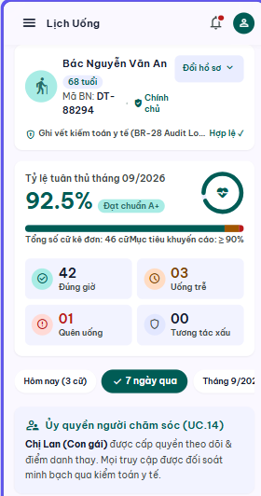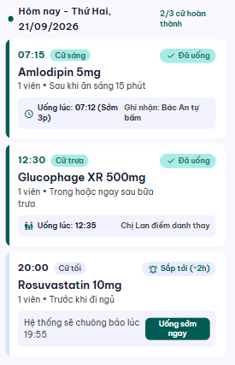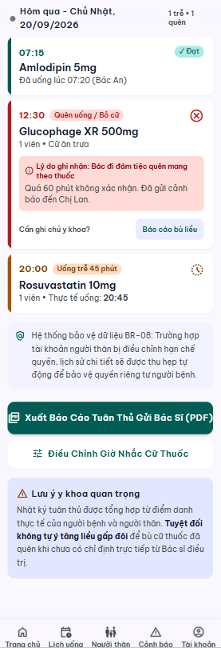

UC 13: Link Family Caregiver Account
- Use Case Diagram
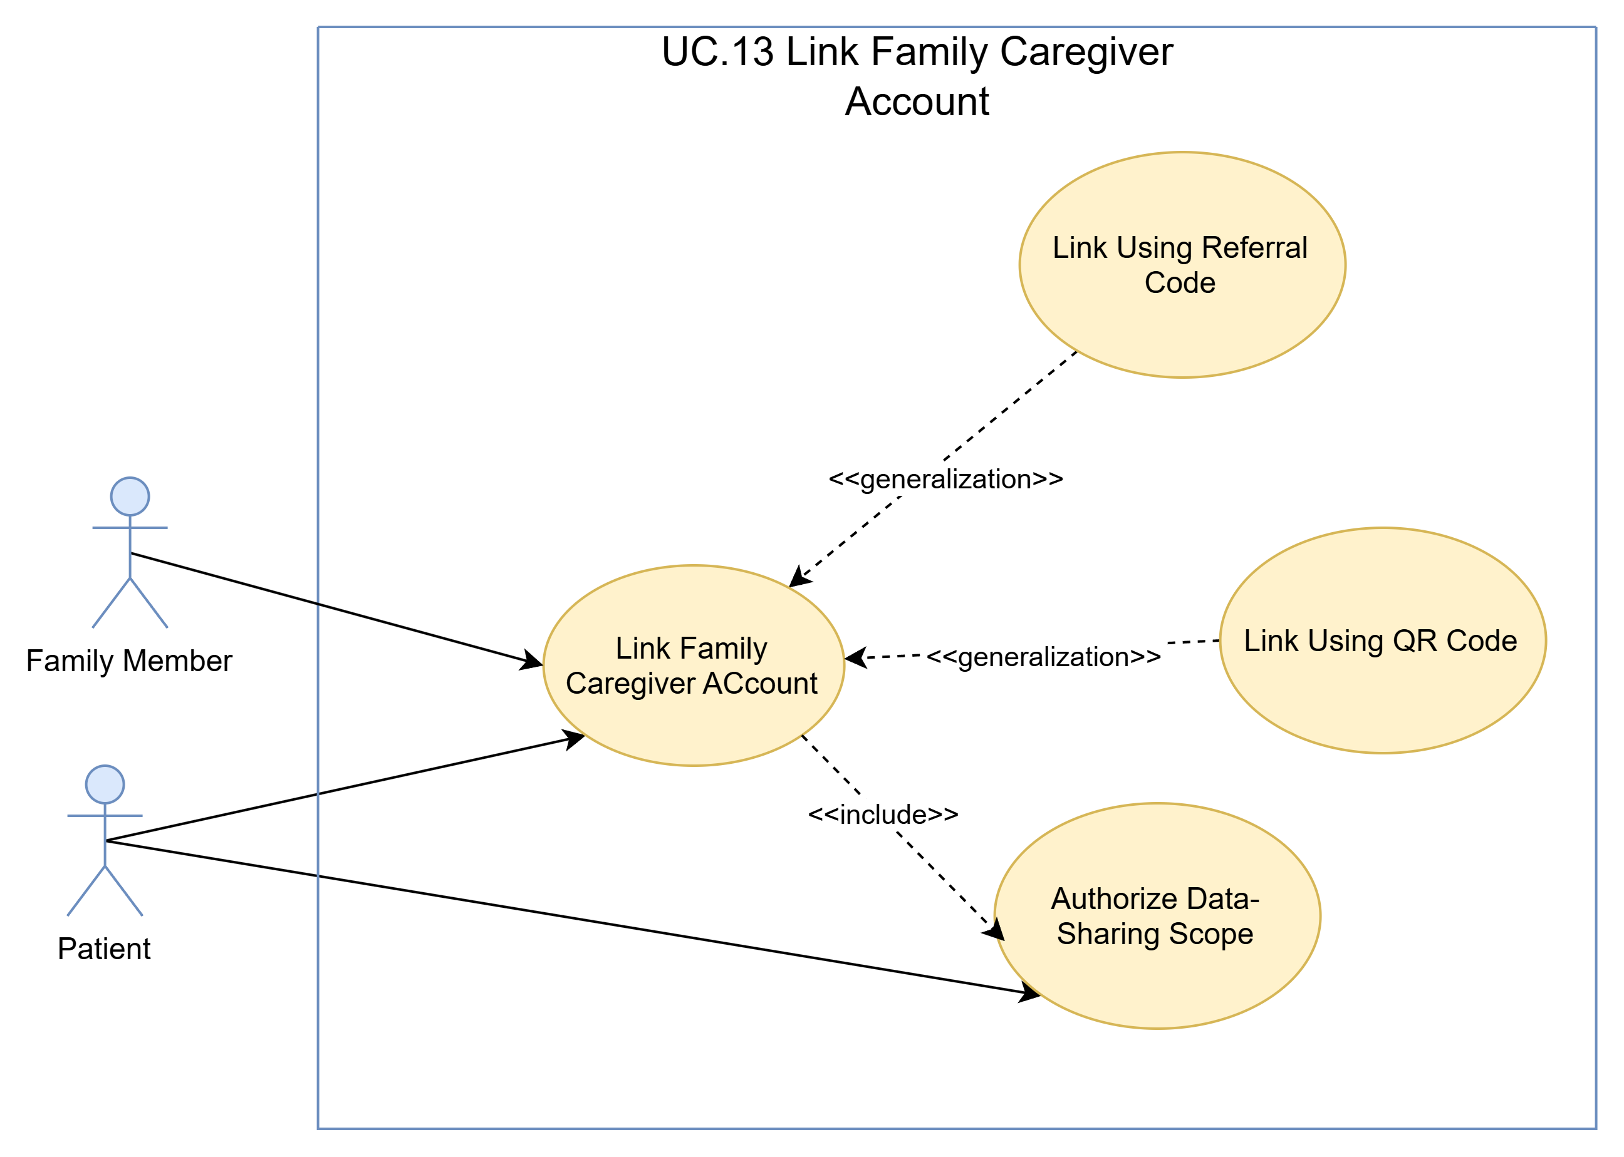
- Use Case Specification
Use case ID | UC.13
Use case name | Link Family Caregiver Account
Create by | Viet Dang |  | Last updated by |  | Viet Dang
Date created | September 16, 2026 |  | Date last updated |  | September 16, 2026
Actor | Patient, Family Member
Description | This use case describes how a Patient and Family Member establish a supported caregiver relationship using a QR code or referral code. The Patient explicitly authorizes the applicable data-sharing scope before Family Member access to Patient data becomes available.
Goal | To establish a valid caregiver relationship between a Patient and Family Member and apply only the data-sharing scope explicitly authorized by the Patient.
Trigger | The Patient chooses to link a Family Member, or a Family Member chooses to link to a Patient using the supported family-linking function.
Pre-condition | - The Patient has a valid DrugTime account.  - The Family Member has a valid DrugTime account.  - Both users are authenticated and can access the applicable family-linking function.  - No duplicate active caregiver relationship exists between the same Patient and Family Member for the requested link.
Post-condition | - A caregiver relationship is established between the Patient and Family Member.  - The Patient's applicable data-sharing authorization is recorded for the relationship.  - The Family Member can access only the capabilities and Patient data permitted by the Patient-authorized scope.
Main Flow | Step | Actor Action |  | System Response
Main Flow | 1 | Patient chooses to link a Family Member. |  | System displays the supported family-linking options.
Main Flow | 2 | Patient chooses QR-code linking. |  | System generates and displays the applicable linking QR code.
Main Flow | 3 | Family Member chooses to link to a Patient and scans the Patient's QR code. |  | System validates the QR code and identifies the applicable Patient–Family Member linking context.
Main Flow | 4 | Family Member submits the linking request. |  | System presents the linking request and applicable data-sharing authorization context to the Patient.
Main Flow | 5 | Patient reviews the linking request and explicitly authorizes the applicable data-sharing scope. |  | System validates and records the Patient's authorization decision.
Main Flow | 6 |  |  | System establishes the caregiver relationship between the Patient and Family Member.
Main Flow | 7 |  |  | System applies Family Member access only within the Patient-authorized data-sharing scope.
Main Flow | 8 |  |  | System confirms that the caregiver relationship has been established and displays the applicable authorized capabilities.
Alternative Scenario | Alternative Flow 1: Link Using Referral Code
Alternative Scenario | Step | Actor Action |  | System Response
Alternative Scenario | 1 | Patient chooses referral-code linking. |  | System generates and displays the applicable referral code.
Alternative Scenario | 2 | Family Member chooses to link to a Patient and enters the Patient's referral code. |  | System validates the referral code and identifies the applicable Patient–Family Member linking context.
Alternative Scenario | Alternative Flow 2: Patient Does Not Authorize Data Sharing
Alternative Scenario | Step | Actor Action |  | System Response
Alternative Scenario | 1 | Patient reviews the linking request and chooses not to authorize the applicable data-sharing scope. |  | System records that the required authorization was not granted for the current linking attempt.
Alternative Scenario | 2 |  |  | System does not grant the Family Member access to the Patient's protected health or adherence data.
Alternative Scenario | 3 |  |  | System informs the applicable users that the requested authorized caregiver access was not established.
Exception Flow | Exception 1: Family Member Is Not Authorized to Access Selected Patient's History
Exception Flow | Step | Actor Action |  | System Response
Exception Flow | 1 |  |  | System determines that the submitted QR code or referral code is invalid or cannot be used for the requested linking operation.
Exception Flow | 2 |  |  | System rejects the current linking request and does not establish a caregiver relationship from the invalid linking information.
Exception Flow | 3 |  |  | System informs the Family Member that the linking information cannot be used.
Exception Flow | Exception 2: Linking Cannot Be Completed
Exception Flow | Step | Actor Action |  | System Response
Exception Flow | 1 | Patient or Family Member requests adherence history for an authorized Patient. |  | System determines that no confirmed or missed dose history is available.
Exception Flow | 2 |  |  | System determines that the authorized caregiver relationship cannot be established successfully.
Exception Flow | 3 |  |  | System does not report the caregiver relationship as successfully established.
Exception Flow | 4 |  |  | System informs the applicable users that the linking operation could not be completed.
Priority | High
Business rule | BR-07, BR-08, BR-21

- Prototype
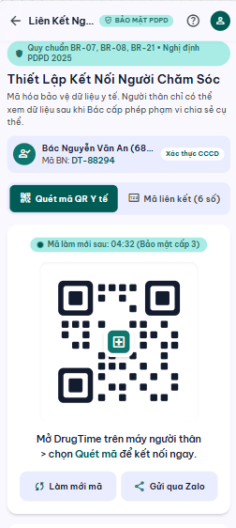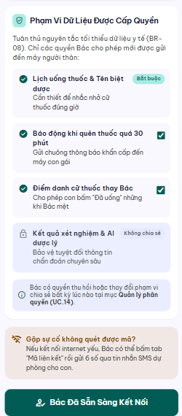

UC 14: Manage Caregiver Permissions
- Use Case Diagram
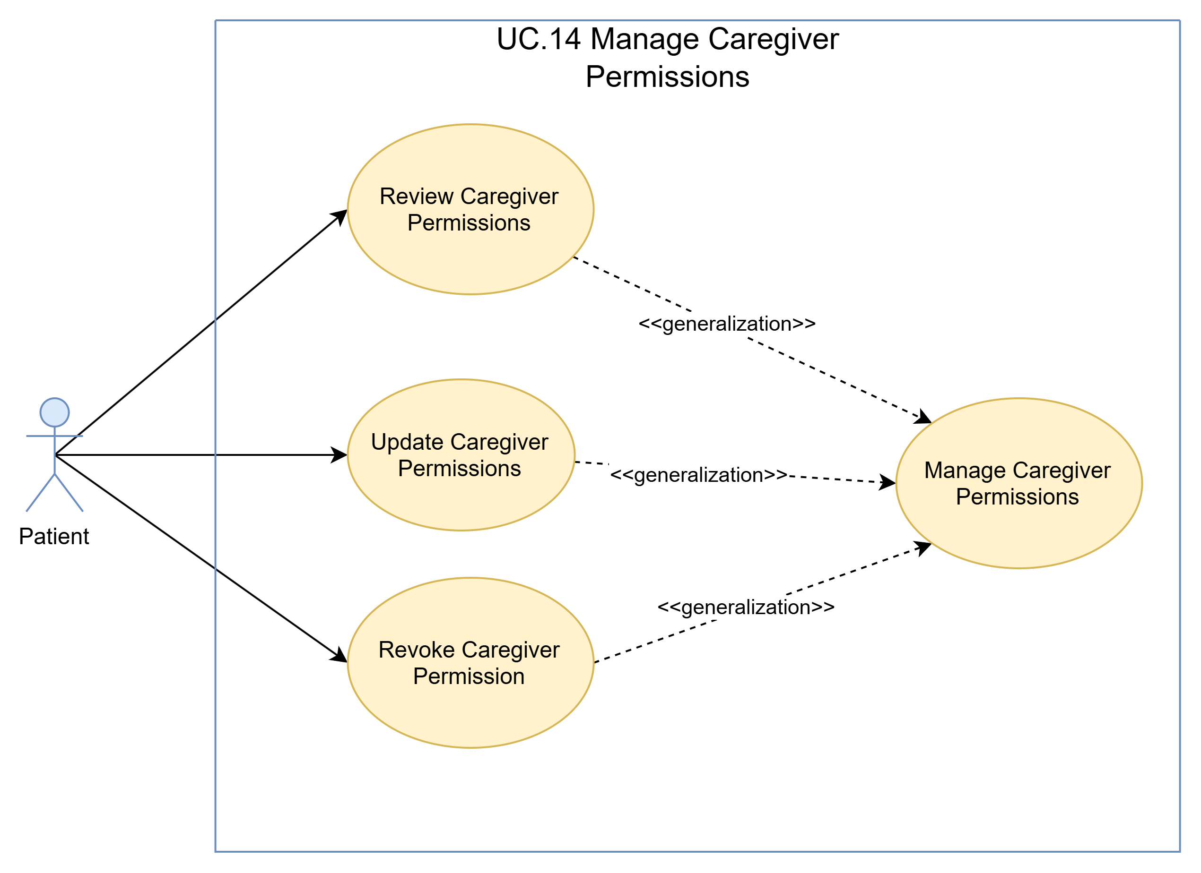
- Use Case Specification
Use case ID | UC.14
Use case name | Manage Caregiver Permissions
Create by | Viet Dang |  | Last updated by |  | Viet Dang
Date created | September 16, 2026 |  | Date last updated |  | September 16, 2026
Actor | Patient
Description | This use case allows a Patient to review and manage the data-sharing permissions of a linked Family Member. The Patient may update the authorized data-sharing scope or revoke previously granted permission so that subsequent Family Member access remains limited to the Patient-authorized scope.
Goal | To keep a linked Family Member's access aligned with the data-sharing scope explicitly authorized by the Patient.
Trigger | The Patient opens caregiver permission management.
Pre-condition | - The Patient is authenticated and has access to caregiver permission management.  - An applicable active Patient–Family Member relationship exists.  - The selected Family Member has an applicable authorization state that can be reviewed or managed.
Post-condition | - The selected Family Member's data-sharing permission is updated or revoked according to the Patient's confirmed action.  - Subsequent Family Member access is limited to the resulting Patient-authorized scope.  - Any revoked scope is no longer authorized for subsequent Family Member access.  - The updated authorization state is available to the Patient.
Main Flow | Step | Actor Action |  | System Response
Main Flow | 1 | Patient opens caregiver permission management. |  | System displays the linked Family Members and their applicable access status.
Main Flow | 2 | Patient selects a Family Member to manage. |  | System displays the Family Member's currently authorized data-sharing scope and the supported permission-management actions.
Main Flow | 3 | Patient chooses to update the Family Member's permission scope. |  | System allows the Patient to revise the applicable data-sharing scope.
Main Flow | 4 | Patient revises and submits the proposed data-sharing scope. |  | System validates the proposed authorization scope and displays the resulting scope for review.
Main Flow | 5 | Patient reviews and explicitly confirms the proposed authorization scope. |  | System applies the confirmed authorization scope to the selected Family Member relationship.
Main Flow | 6 |  |  | System displays the updated authorization state to the Patient.
Alternative Scenario | Alternative Flow 1: Link Using Referral Code
Alternative Scenario | Step | Actor Action |  | System Response
Alternative Scenario | 1 | Patient chooses to revoke previously granted data-sharing permission for the selected Family Member. |  | System displays the applicable currently authorized scope and requests confirmation of the revocation.
Alternative Scenario | 2 | Patient reviews and explicitly confirms the revocation. |  | System revokes the applicable data-sharing permission.
Alternative Scenario | 3 |  |  | System ensures that the revoked scope is no longer authorized for subsequent Family Member access.
Alternative Scenario | Alternative Flow 2: Keep Existing Permission
Alternative Scenario | Step | Actor Action |  | System Response
Alternative Scenario | 1 | Patient reviews the Family Member's current authorization and chooses not to make a change. |  | System retains the existing data-sharing authorization unchanged.
Exception Flow | Exception 1: Family Member Relationship Is No Longer Available
Exception Flow | Step | Actor Action |  | System Response
Exception Flow | 1 |  |  | System determines that the selected Family Member relationship is no longer available for permission management.
Exception Flow | 2 |  |  | System does not modify another Family Member relationship as a substitute.
Exception Flow | 3 |  |  | System informs the Patient that the selected relationship is no longer available and refreshes the available linked Family Members.
Exception Flow | Exception 2: Invalid Permission Scope
Exception Flow | Step | Actor Action |  | System Response
Exception Flow | 1 |  |  | System determines that the proposed authorization scope is not valid for the requested permission update.
Exception Flow | 2 |  |  | System does not apply the invalid authorization change and informs the Patient that the proposed scope must be revised.
Priority | High
Business rule | BR-07, BR-08, BR-09

- Prototype
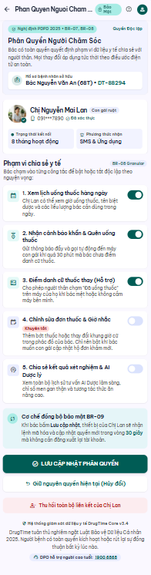

UC 15: Manage Multiple Linked Patients
- Use Case Diagram
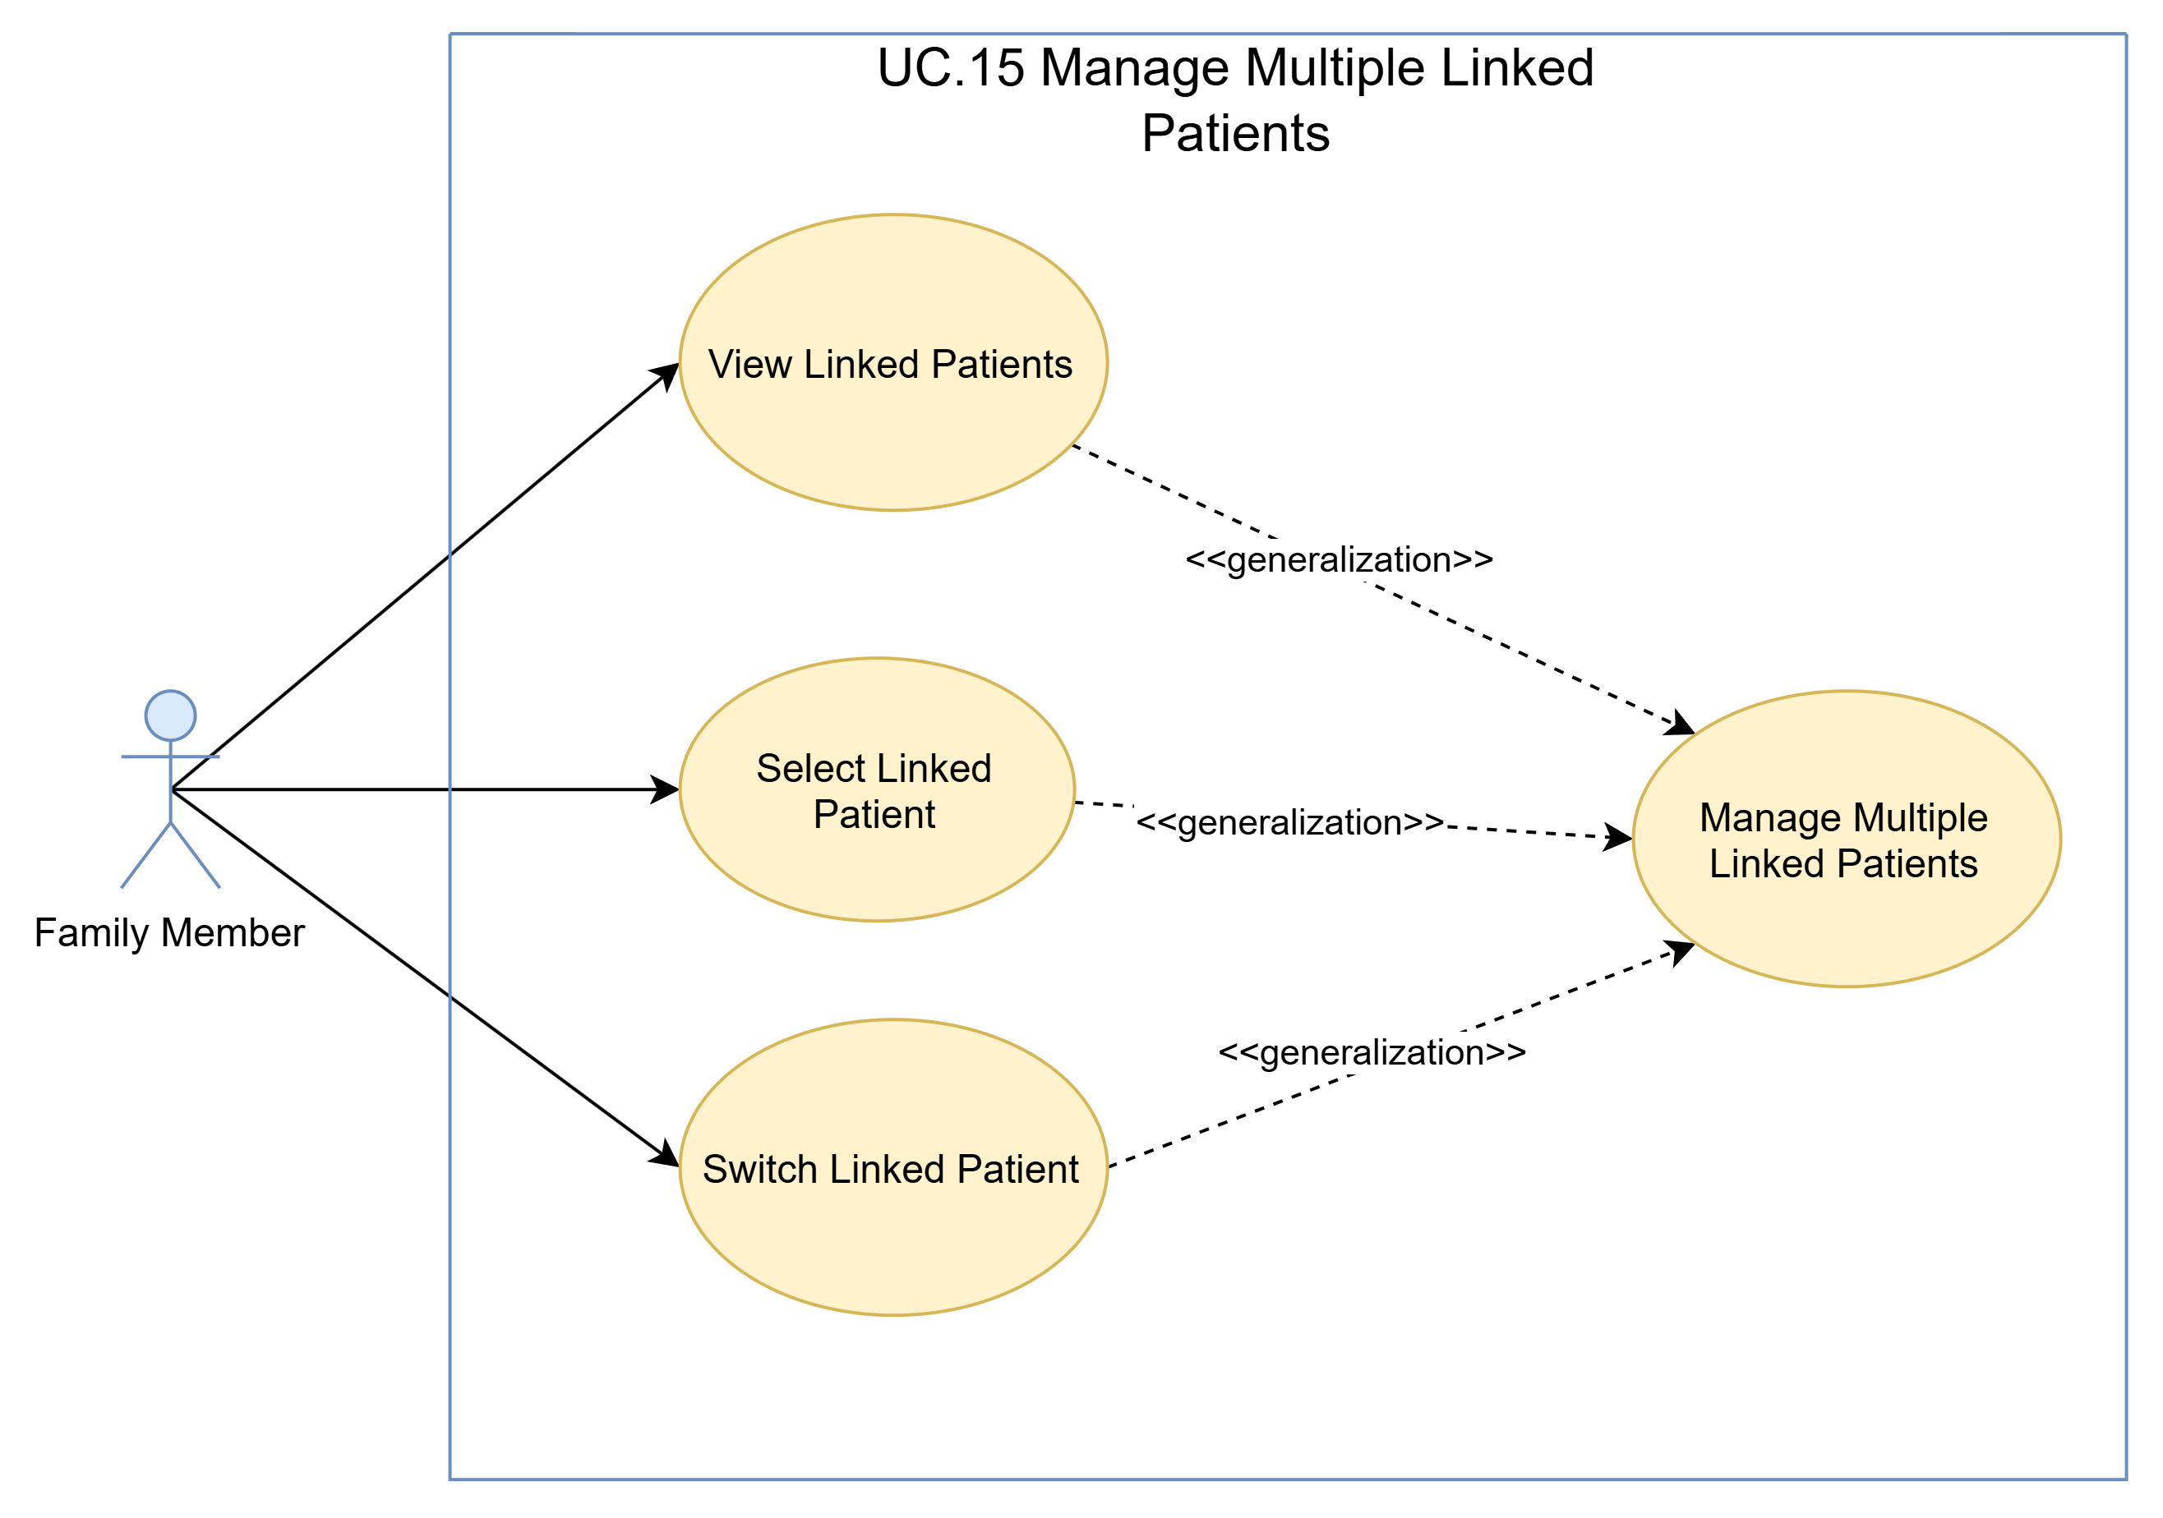
- Use Case Specification
Use case ID | UC.15
Use case name | Manage Multiple Linked Patients
Create by | Viet Dang |  | Last updated by |  | Viet Dang
Date created | September 16, 2026 |  | Date last updated |  | September 16, 2026
Actor | Family Member
Description | This use case allows a Family Member to review available linked Patient relationships and select or switch the active Patient context. For each selected Patient, DrugTime determines the authorization granted by that individual Patient so that subsequent supported functions operate only within the applicable authorized scope.
Goal | To allow a Family Member to manage and switch among multiple linked Patient contexts while preserving the authorization independently granted by each Patient.
Trigger | The Family Member opens linked-patient management.
Pre-condition | - The Family Member is authenticated.  - At least one applicable Patient–Family Member relationship exists.  - The Family Member can access the linked-patient management function.
Post-condition | - The selected linked Patient becomes the active Patient context.  - The applicable authorization scope for the selected Patient context is established.  - Subsequent supported functions are limited to the authorization granted by the selected Patient.
Main Flow | Step | Actor Action |  | System Response
Main Flow | 1 | Family Member opens linked-patient management. |  | System displays the available linked Patient relationships.
Main Flow | 2 | Family Member selects a linked Patient. |  | System verifies that the Patient–Family Member relationship is valid and determines the applicable authorization scope for the selected Patient.
Main Flow | 3 |  |  | System activates the selected Patient as the current Patient context.
Main Flow | 4 |  |  | System makes the selected Patient context available only with the capabilities permitted by that Patient's applicable authorization scope.
Main Flow | 5 |  |  | System displays the active Patient context and its available supported functions to the Family Member.
Alternative | Alternative Flow 1: Switch to Another Linked Patient
Alternative | Step | Actor Action |  | System Response
Alternative | 1 | Family Member chooses to switch from the current Patient to another linked Patient. |  | System displays the available linked Patient relationships.
Alternative | 2 | Family Member selects another linked Patient. |  | System clears the current selection for the requested switch and proceeds to validate the newly selected Patient context.
Alternative | Alternative Flow 2: Keep Existing Permission
Alternative | Step | Actor Action |  | System Response
Alternative | 1 | Patient reviews the Family Member's current authorization and chooses not to make a change. |  | System retains the existing data-sharing authorization unchanged.
Exception | Exception 1: Family Member Relationship Is No Longer Available
Exception | Step | Actor Action |  | System Response
Exception | 1 |  |  | System determines that the selected Family Member relationship is no longer available for permission management.
Exception | 2 |  |  | System does not modify another Family Member relationship as a substitute.
Exception | 3 |  |  | System informs the Patient that the selected relationship is no longer available and refreshes the available linked Family Members.
Exception | Exception 2: Invalid Permission Scope
Exception | Step | Actor Action |  | System Response
Exception | 1 |  |  | System determines that the proposed authorization scope is not valid for the requested permission update.
Exception | 2 |  |  | System does not apply the invalid authorization change and informs the Patient that the proposed scope must be revised.
Priority | High
Business rule | BR-07, BR-08, BR-09

- Prototype
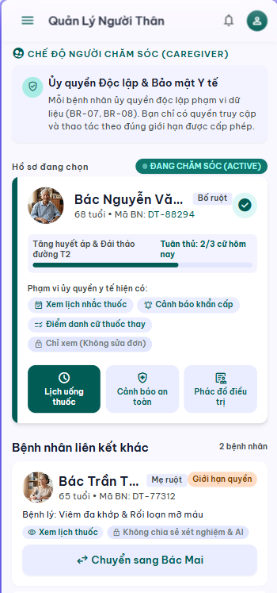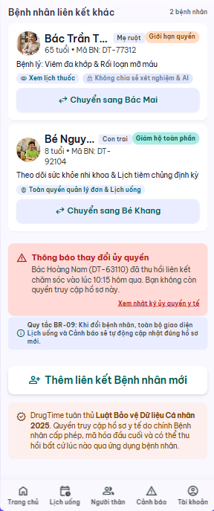

UC 16: Look Up Drug Information
- Use Case Diagram
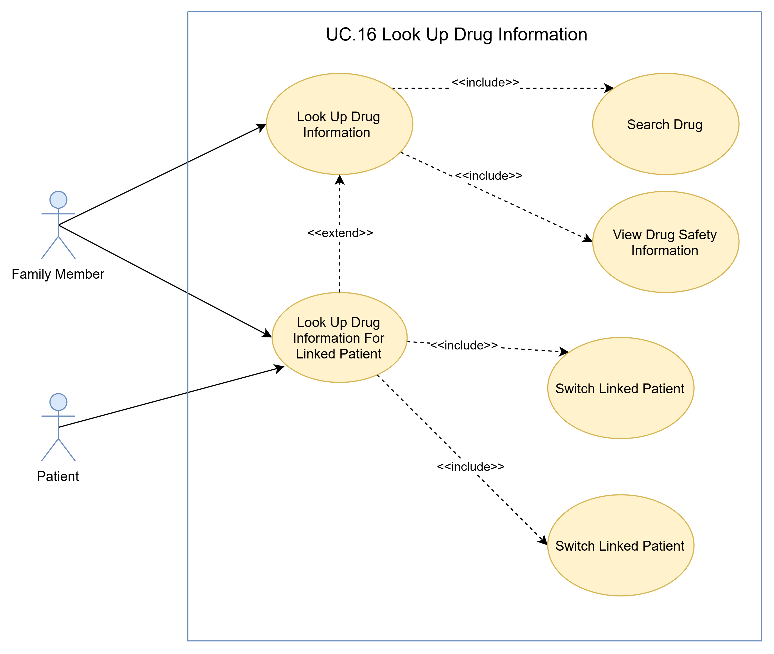
- Use Case Specification
Use Case ID | UC.16
Use Case Name | Look Up Drug Information
Created by | Bao Nguyen |  | Last updated by |  | Bao Nguyen
Date Created | Sep 20, 2026 |  | Date last updated |  | Sep 20, 2026
Actors | Patient, Family Member
Brief Description | This use case describes how a patient or an authorized family member looks up drug safety information based on authoritative reference sources in Vietnam.
Goal | Provide users with accurate reference information on drug safety, accompanied by a clear medical disclaimer.
Trigger | User opens the app and selects the drug information lookup function.
Pre-conditions | - User has logged into the system.  - User has access to the drug safety lookup function.  - Authoritative drug catalog data available
Post-conditions | - Drug information is displayed.  - Access logs for sensitive data are recorded when a family member performs a lookup on behalf of a patient.
Main Flow | Step | Actor Action |  | System Response
Main Flow | 1 | User selects the "Drug Information Lookup" function |  | Search interface display system
Main Flow | 2 | User enters the drug name as a keyword. |  | Query Pharmacopoeia / Drug List
Main Flow | 3 | The user selects the medicinal product they wish to view from the list of results. |  | System for searching and retrieving detailed drug data
Main Flow | 4 |  |  | System for displaying drug information, safety warnings, and mandatory medical disclaimers.
Alternative Flow | Alternative 1: Family members can look up medication information for linked patients.
Alternative Flow | Step | Actor Action |  | System Response
Alternative Flow | 1 | The family member selects the linked patient and requests a medication information lookup. |  | System for verifying data-sharing permissions granted by patients
Alternative Flow | 2 |  |  | System for displaying medication information within authorized limits and logging access to sensitive data.
Alternative Flow | Alternative 2: No authoritative reference data found.
Alternative Flow | Step | Actor Action |  | System Response
Alternative Flow | 1 | User enters the drug name as a keyword. |  | The system attempts to query but detect no information matching with the user's information
Alternative Flow | 2 |  |  | The notification system cannot complete the lookup due to a the absence of data; it does not display incorrect information.
Exception Flow | Exception 1: Hệ thống mất kết nối với cơ sở dữ liệu
Exception Flow | Step | Actor Action |  | System Response
Exception Flow | 1 | User enters the drug name as a keyword. |  | The system attempts to query data but fail
Exception Flow | 2 |  |  | The notification system cannot complete the lookup due to a connection loss
Exception Flow | Exception 2: Family members do not have the right to share the data.
Exception Flow | Step | Actor Action |  | System Response
Exception Flow | 1 | The family member selects the linked patient and requests a medication information lookup. |  | The system refuses to provide information related to the patient.
Exception Flow | 2 |  |  | The system notifies family members about access limitations.
Priority | High
Business Rule | BR-16, BR-17, BR-18, BR-22, BR-29

- Prototype
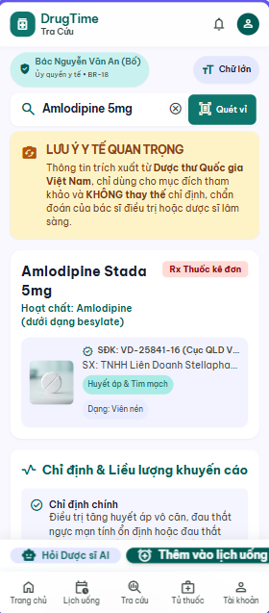

UC 17: Check Drug-Drug Interaction
- Use Case Diagram
- Use Case Specification
Use Case ID | UC.17
Use Case Name | Check Drug-Drug Interaction
Created by | Bao Nguyen |  | Last updated by |  | Bao Nguyen
Date Created | Sep 20, 2026 |  | Date last updated |  | Sep 20, 2026
Actors | Patient, Family member
Brief Description | Check for and display alerts regarding drug-drug interactions for medications the user is currently taking or has selected for lookup, based on the clinical contraindication list in Decision 5948/QĐ-BYT.
Goal | Timely detection of drug-drug interactions to minimize the risk of adverse medical events.
Trigger | The patient or family member selects the list of medications to check for drug-drug interactions.
Pre-conditions | - Logged-in user  - At least two types of medication have been selected or imported.  - The drug interaction database has been synchronized.
Post-conditions | The drug-drug interaction alert level (if applicable) is clearly displayed, accompanied by a medical disclaimer.
Main Flow | Step | Actor Action |  | System Response
Main Flow | 1 | The user selects the Check Drug-Drug function |  | The system displays the suitable interface
Main Flow | 2 | The user selects the list of medications to check for interactions. |  | System for receiving lists of active ingredients/drugs
Main Flow | 3 | The user clicks the "Check interaction" button. |  | System for cross-referencing drug pairs against the interaction list from Decision 5948/QĐ-BYT and the DrugTime database.
Main Flow | 4 |  |  | The system returns the alert level (Contraindication, Serious interaction, Caution advised).
Main Flow | 5 | Users view details regarding alert levels and recommendations. |  | Warning display system with mandatory disclaimer: "Information is for reference only; consult a doctor or pharmacist"
Alternative Flow | Alternative 1: Automatic check when the patient adds a new medication to the list.
Alternative Flow | Step | Actor Action |  | System Response
Alternative Flow | 1 | The patient adds a new medication to the list. |  | The system automatically runs interaction checks for all medications currently listed in the prescription.
Alternative Flow | 2 |  |  | If a dangerous interaction occurs, the system immediately displays a prominent warning screen.
Exception Flow | Exception 1: The system has lost the Internet Connection
Exception Flow | Step | Actor Action |  | System Response
Exception Flow | 1 | The user selects the list of medications to check for interactions. |  | System for receiving lists of active ingredients/drugs
Exception Flow | 2 | The user clicks the "Check interaction" button. |  | The system attempts to process the request but fail due to lose connection
Exception Flow | 3 |  |  | The system displays the notification: "Unable to check for interactions at this time. Please check your Internet connection and try again."
Priority | High
Business Rule | BR-16, BR-17, BR-18, BR-22, BR-29

- Prototype
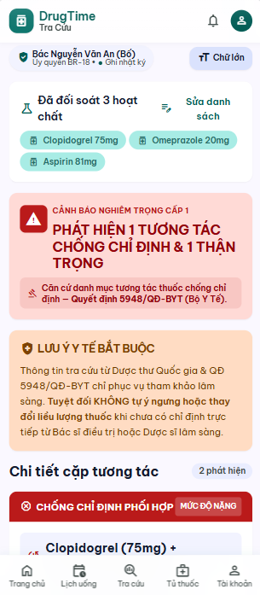

UC 18: Check Drug-Food Interaction
- Use Case Diagram
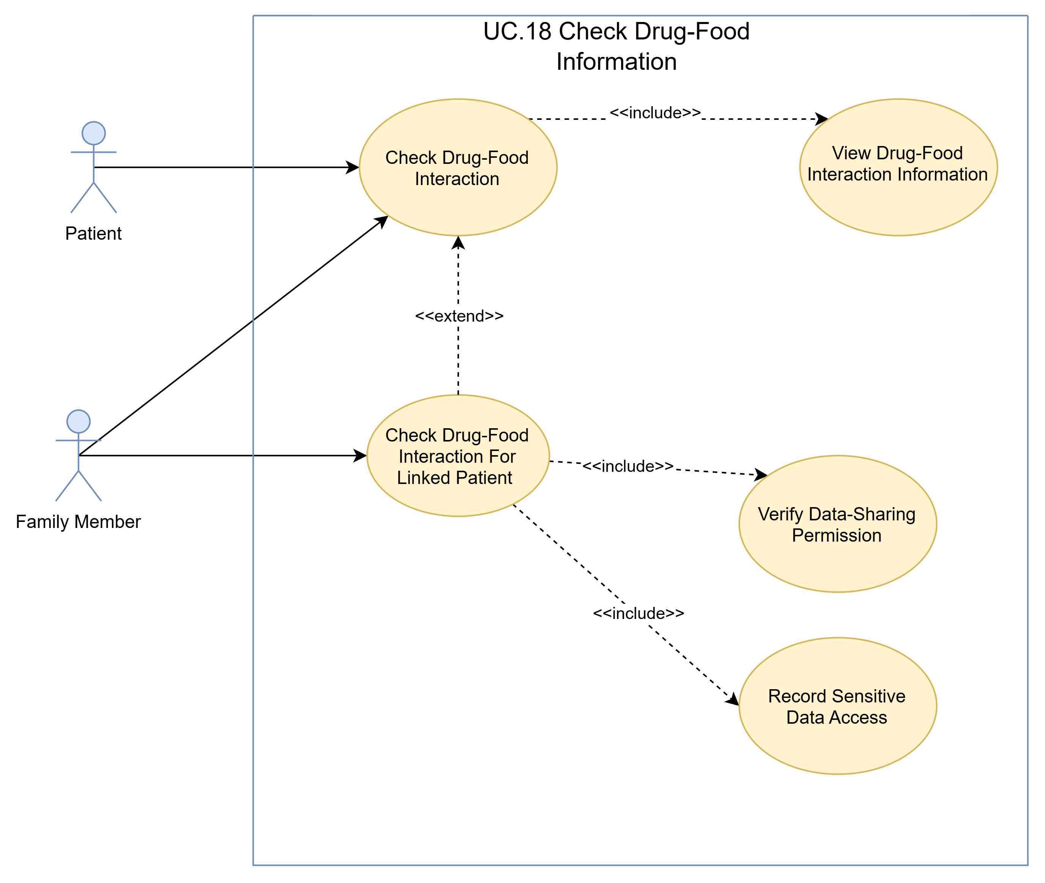
- Use Case Specification
Use Case ID | UC.18
Use Case Name | Check Drug-Food Interaction
Created by | Bao Nguyen |  | Last updated by |  | Bao Nguyen
Date Created | Sep 20, 2026 |  | Date last updated |  | Sep 20, 2026
Actors | Patient, Family Member
Brief Description | Check for interactions or contraindications between medications and food, beverages, or dietary supplements, based on the 2022 Vietnam National Formulary.
Goal | Help users understand when to take medication (before or after meals) and avoid foods that reduce efficacy or increase toxicity.
Trigger | The user requests a check for food-drug interactions for the selected medication.
Pre-conditions | - Logged-in user  - Selected the drug for which a food interaction check is required.
Post-conditions | A complete list of foods and beverages to be mindful of or avoided is displayed.
Main Flow | Step | Actor Action |  | System Response
Main Flow | 1 | The user selects the Check Drug-Food function |  | The system displays the suitable interface
Main Flow | 2 | The user selects a specific medication and requests a "food interaction check." |  | Drug-food interaction database query system
Main Flow | 3 |  |  | The system retrieves reference data from the National Pharmacopoeia of Vietnam.
Main Flow | 4 | Users should review dietary precautions related to the medication. |  | The system displays foods to avoid (e.g., alcohol, beer, pomelo, milk, etc.) and the optimal time to take the medication, accompanied by a medical disclaimer.
Alternative Flow | Alternative 1: Family members reviewing the patient's food-drug interactions.
Alternative Flow | Step | Actor Action |  | System Response
Alternative Flow | 1 | Family members access the medication safety section of the linked patient's record. |  | System confirming that the patient has granted permission to share health data
Alternative Flow | 2 |  |  | The system returns food interaction information and logs sensitive access activities.
Exception Flow | Exception 1: The system has lost the Internet Connection
Exception Flow | Step | Actor Action |  | System Response
Exception Flow | 1 | The user selects the Check Drug-Drug function |  | The system displays the suitable interface
Exception Flow | 2 | The user selects a specific medication and requests a "food interaction check." |  | The system attempts to query the data from database but fail due to the lost connection
Exception Flow | 3 |  |  | The system displays the notification: "Unable to check for interactions at this time. Please check your Internet connection and try again."
Priority | High
Business Rule | BR-16, BR-17, BR-18, BR-22, BR-29

- Prototype
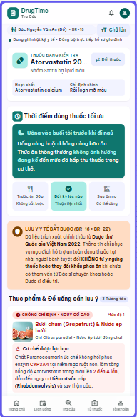

UC 19: Generate AI Meal Suggestion
- Use Case Diagram
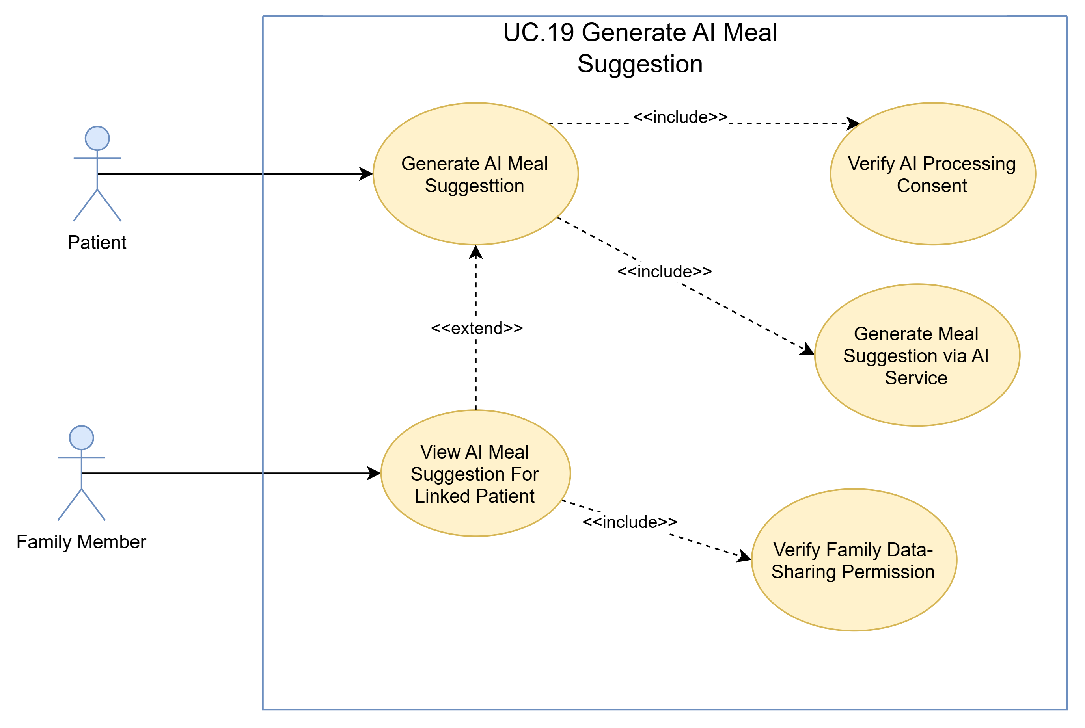
- Use Case Specification
Use Case ID | UC.19
Use Case Name | Generate AI Meal Suggestion
Created by | Bao Nguyen |  | Last updated by |  | Bao Nguyen
Date Created | Sep 20, 2026 |  | Date last updated |  | Sep 20, 2026
Actors | Patient, Family Member
Brief Description | The system gathers the patient's medication list and schedule, then sends this context to an AI LLM API service to generate meal suggestions accompanied by detailed explanations, ensuring safety regarding drug-food interactions.
Goal | Provide suggested meal plans suitable for patients with dietary restrictions while taking medication.
Trigger | Users select "Generate AI meal suggestions" from the main interface or the medication schedule.
Pre-conditions | - Logged-in user  - The patient has completed the separate consent (Purpose-Separated Consent) for the processing of data for AI meal recommendations.  - Internet connection is active.
Post-conditions | Suggested menu with safety explanations displayed to the user, accompanied by a medical disclaimer.
Main Flow | Step | Actor Action |  | System Response
Main Flow | 1 | The patient selects the "Generate AI meal suggestions" option. |  | The system displays suitable interface
Main Flow | 2 |  |  | The system checks the approval status for processing Patient data for purpose AI
Main Flow | 3 |  |  | Context synthesis system: list of current medications, medication schedule, and dietary interaction guidelines.
Main Flow | 4 |  |  | The system sends requests to the external AI LLM API service.
Main Flow | 5 |  |  | The AI LLM API service returns meal suggestions accompanied by explanations.
Main Flow | 6 | The patient reviews the suggested menu and the explanation regarding safety. |  | The system saves suggested results to the database and displays the information alongside a medical disclaimer
Alternative Flow | Alternative 1: Family members view AI-generated meal suggestions for the linked patient.
Alternative Flow | Step | Actor Action |  | System Response
Alternative Flow | 1 | Family members access the linked patient's meal suggestions. |  | The system confirms that the patient has enabled data sharing with family members and consented to the AI feature.
Alternative Flow | 2 |  |  | System displaying meal suggestions for family members
Exception Flow | Exception 1: Patient withdrew consent for data processing for AI
Exception Flow | Step | Actor Action |  | System Response
Exception Flow | 1 | The patient selects the "Generate AI meal suggestions" option. |  | The system displays suitable interface
Exception Flow | 2 |  |  | The system checks the approval status for processing Patient data for purpose AI and detects patient withdrew consent
Exception Flow | 3 |  |  | The system rejects the AI API call and notifies the patient that they need to re-enable consent in their account settings if they wish to use the feature.
Exception Flow | Alternative 2: AI LLM API service encounters an error or lost network connection.
Exception Flow | Step | Actor Action |  | System Response
Exception Flow | 1 | The patient selects the "Generate AI meal suggestions" option. |  | The system displays suitable interface
Exception Flow | 2 |  |  | The system checks the approval status for processing Patient data for purpose AI
Exception Flow | 3 |  |  | Context synthesis system: list of current medications, medication schedule, and dietary interaction guidelines.
Exception Flow | 4 |  |  | The system attempts to send request to external AI LLM API but fail due to lost connection or encounter failure
Exception Flow | 5 |  |  | The system reports that it cannot generate meal suggestions at this time and does not provide unverified information.
Priority | High
Business Rule | BR-16, BR-17, BR-18, BR-22

- Prototype
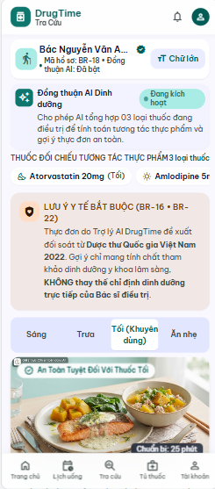

UC 20: Configure Simple Mode Display
- Use Case Diagram
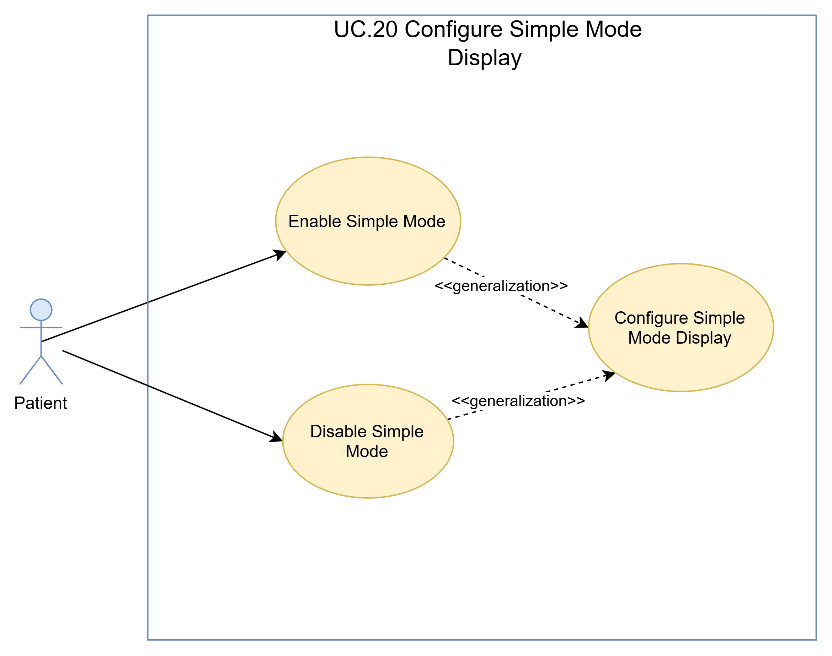
- Use Case Specification
Use Case ID | UC.20
Use Case Name | Configure Simple Mode Display
Created by | Bao Nguyen |  | Last updated by |  | Bao Nguyen
Date Created | Sep 20, 2026 |  | Date last updated |  | Sep 20, 2026
Actors | Patient
Brief Description | Allows patients (especially the elderly or those with poor vision) to switch between the standard interface and "Simple Mode," which features high contrast, large fonts, and a minimal number of buttons.
Goal | Improve accessibility and ease of use for elderly patients when confirming medication intake.
Trigger | The patient selects "Turn Simple Mode On/Off" in the app's Settings menu.
Pre-conditions | The patient is opening the DrugTime mobile app.
Post-conditions | The application switches the entire display layout to Simple Mode
Main Flow | Step | Actor Action |  | System Response
Main Flow | 1 | The patient goes to Settings and selects "Switch to Simple Mode." |  | The system records requests for interface changes.
Main Flow | 2 |  |  | Interface adjustment system: increase contrast, enlarge text, hide secondary features, display large buttons.
Main Flow | 3 | The patient operates using the Simple Mode interface. |  | The system saves this display preference to local application storage.
Alternative Flow | Alternative 1: Patient turns off Simple Mode to return to the Standard Interface
Alternative Flow | Step | Actor Action |  | System Response
Alternative Flow | 1 | The patient presses the "Turn off Simple Mode" button on the screen. |  | The system restores the standard interface layout.
Exception Flow | Exception 1: Error saving application configuration
Exception Flow | Step | Actor Action |  | System Response
Exception Flow | 1 | The patient goes to Settings and selects "Switch to Simple Mode." |  | The system attempts to record request for interface changes but fail
Exception Flow | 2 |  |  | The system is temporarily displaying Simple Mode for the current session and is reporting an error when saving settings.
Priority | High
Business Rule

- Prototype
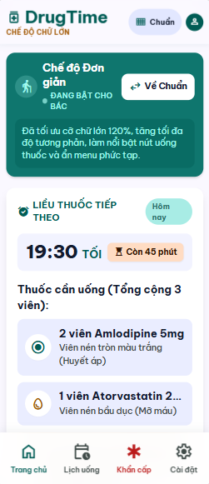

UC 21: Manage Medication Catalogue
- Use Case Diagram
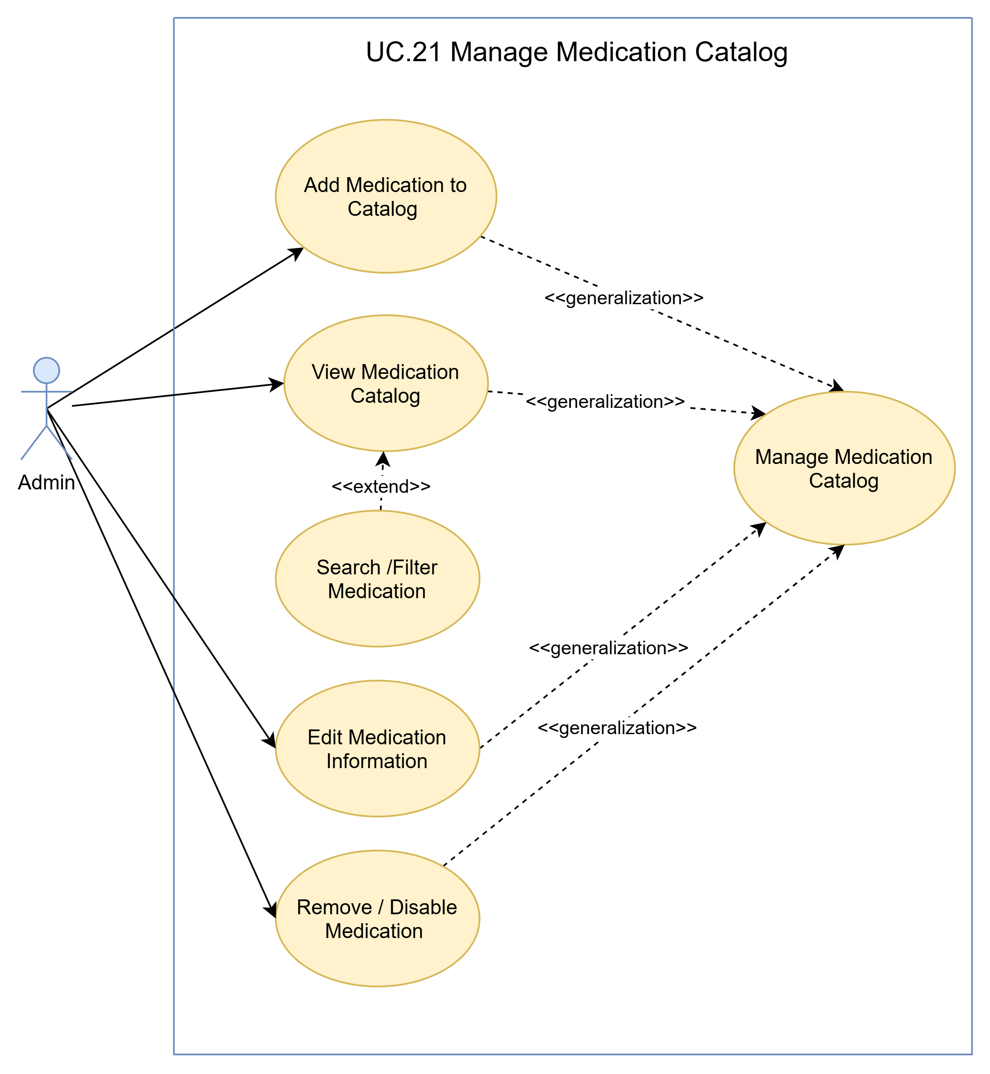
- Use Case Specification
Use Case ID | UC.21
Use Case Name | Manage Medication Catalog
Created by | Bao Nguyen |  | Last updated by |  | Bao Nguyen
Date Created | Sep 20, 2026 |  | Date last updated |  | Sep 20, 2026
Actors | Admin
Brief Description | Users (Administrators) can view the list, add new entries, edit, and delete or disable medication information within the system's standard drug catalog via the Admin Web Dashboard.
Goal | Enables the management of the entire portfolio of medicines authorized for circulation in Vietnam to facilitate lookup, matching of blister pack identification data, and safety checks.
Pre-conditions | - The administrator has logged into the Admin Web Dashboard.  - Administrators have access to manage the medication catalog.
Post-conditions | - The drug catalog data is accurately updated in the database.  - The new list of medicines accurately reflects the service status of the mobile application.
Main Flow A | A. View the list of drug categories  Trigger: The admin selects the "Drug Categories" tab on the Admin Web Dashboard.  Result: Display a full or filtered list of available medications..
Main Flow A | Step | Actor Action |  | System Response
Main Flow A | 1 | Navigate to the "Drug Category Management" page from the Admin dashboard. |  | Display the medication category management interface, including the current list and function buttons: Add New, Edit, and Delete.
Main Flow A | 2 | Search for or filter medicines by brand name, active ingredient name, marketing authorization code, or disease group. |  | Display the list of medicines matching the search/filter criteria.
Main Flow B | B. Add new drug to the list  Trigger: The admin clicks the "Add New Medication" button.  Result: The new drug has been successfully developed and added to the list.
Main Flow B | Step | Actor Action |  | System Response
Main Flow B | 1 | Click the "Add New" button on the medication list interface. |  | Display the form for adding a medication, including: Drug name, Active ingredient, Strength, Unit of measure, Registration code, Manufacturer, Disease group...
Main Flow B | 2 | Enter the full medication details into the form. |  | Validate data upon entry (e.g., drug registration codes must be unique; mandatory fields cannot be left blank).
Main Flow B | 3 | Click the "Save" button. |  | Confirm all valid cases
Main Flow B | 4 |  |  | Save the new medication information to the database. Display the message "New medication successfully added to the catalog."
Main Flow B | 5 |  |  | Update the medication display list
Main Flow C | C. Edit drug information in the catalog  Trigger: The admin clicks the "Edit" button or double-clicks the medication record.  Result: Drug information successfully updated.
Main Flow C | Step | Actor Action |  | System Response
Main Flow C | 1 | Select the medication you wish to edit from the list and click the "Edit" button. |  | Display the medication details form for editing.
Main Flow C | 2 | Modify the information requiring updates (e.g., adding active ingredients, changing disease categories, etc.). |  | Validate the edited data.
Main Flow C | 3 | Click the "Update" button. |  | Confirm the validity of the modified information.
Main Flow C | 4 |  |  | Save the updated information to the database. Display the message "Drug information updated successfully."
Main Flow C | 5 |  |  | Update the medication list on the interface.
Main Flow D | D Remove/Disable medication from the list  Trigger: The admin selects the medication and clicks the "Delete" button.  Result: The drug is removed from the list or its status is changed to "discontinued from circulation."
Main Flow D | Step | Actor Action |  | System Response
Main Flow D | 1 | Select the medication record to be deleted and click "Delete". |  | Display the delete confirmation dialog box.
Main Flow D | 2 | Click "Agree" in the confirmation dialog box. |  | Check whether the medication is linked to the patient's prescription or the interaction database.
Main Flow D | 3 |  |  | If deletion or hiding is possible, the system updates the status in the database and displays the notification "Medication successfully removed from the list."
Main Flow D | 4 |  |  | Update the medication list so that deleted records are no longer displayed.
Alternative Flow | Alternative 1: The administrator left a required field blank or entered a duplicate registration code.
Alternative Flow | Step | Actor Action |  | System Response
Alternative Flow | 1 | Click the "Add New" button on the medication list interface. |  | Display the form for adding a medication, including: Drug name, Active ingredient, Strength, Unit of measure, Registration code, Manufacturer, Disease group...
Alternative Flow | 2 | Failure to fill in all mandatory fields or entering data in the wrong format. |  | Display error messages below the invalid fields and retain the form for the admin to modify.
Alternative Flow | 3 | Sửa lại thông tin theo yêu cầu và tiếp tục lưu hồ sơ
Alternative Flow | Alternative 2: Admin cancels the add or edit operation.
Alternative Flow | Step | Actor Action |  | System Response
Alternative Flow | 1 | The admin clicks the "Cancel" button. |  | The system displays a cancellation confirmation.
Alternative Flow | 2 | The admin confirms the cancellation. |  | The system closes the form without saving any changes.
Exception Flow | Exception 1: The system has lost connection to the database.
Exception Flow | Step | Actor Action |  | System Response
Exception Flow | 1 | (Add, edit, or delete records) |  | The system cannot save data to Supabase.
Exception Flow | 2 |  |  | Display the message "Unable to connect to the database. Please try again later."
Priority | High
Business Rule | BR-29, BR-30

- Prototype
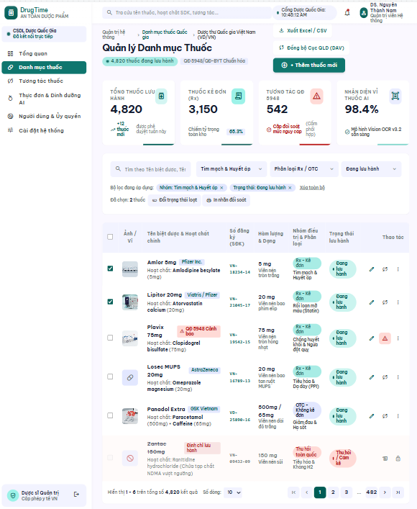

UC 22: Manage Interaction Catalogue
- Use Case Diagram
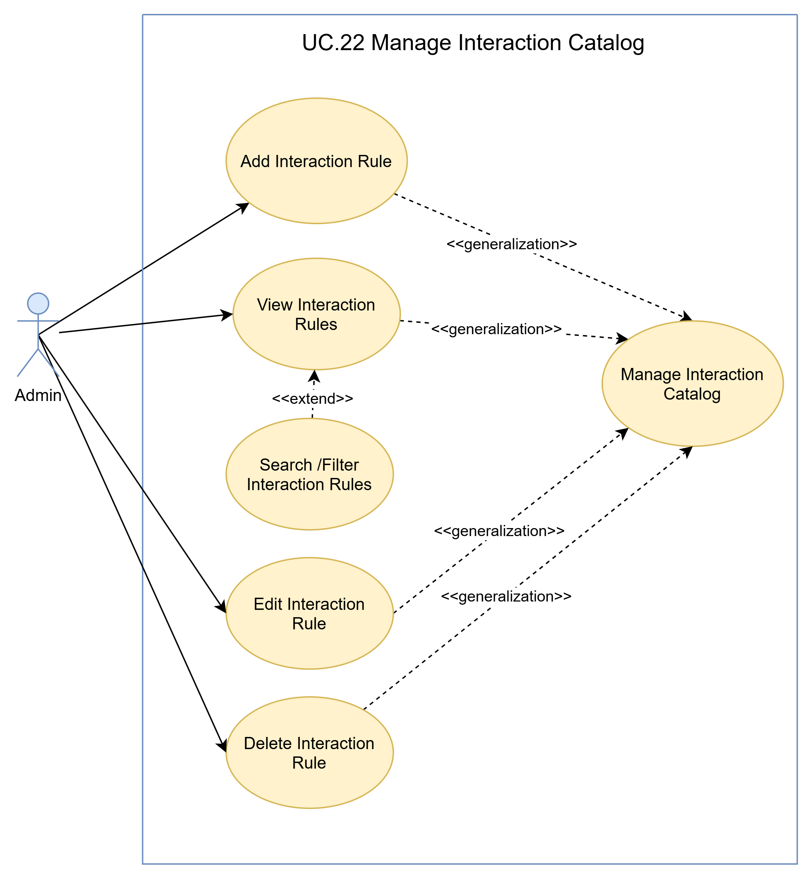
- Use Case Specification
Use Case ID | UC.22
Use Case Name | Manage Interaction Catalog
Created by | Bao Nguyen |  | Last updated by |  | Bao Nguyen
Date Created | Sep 20, 2026 |  | Date last updated |  | Sep 20, 2026
Actors | Admin
Brief Description | Admins can view, add, edit, and delete drug-drug and drug-food interaction rules on the Admin Web Dashboard.
Goal | Maintain an accurate drug interaction database, updated in accordance with Decision 5948/QĐ-BYT and the National Pharmacopoeia of Vietnam.
Pre-conditions | The administrator has logged into the Admin Web Dashboard with category management privileges
Post-conditions | Interaction rule data is updated in the database and immediately applied to drug safety check functions.
Main Flow A | A. View the list of interaction rules  Trigger: The admin selects the "Interaction Categories" tab.  Result: Display a list of drug-drug and drug-food interaction pairs.
Main Flow A | Step | Actor Action |  | System Response
Main Flow A | 1 | Open the "Interactive Category Management" page. |  | Display the interactive category management interface with filtering tools based on interaction type.
Main Flow A | 2 | Filter by interaction type (Drug-Drug / Drug-Food) or search by active ingredient or food name. |  | Display interaction rules that meet the filtering criteria.
Main Flow B | B. Add new interaction rule  Trigger: The admin clicks the "Add interaction rule" button.  Result: The new interaction rule has been saved to the database.
Main Flow B | Step | Actor Action |  | System Response
Main Flow B | 1 | Click "Add new interaction" |  | Display the interaction configuration form, including: Active Substance/Drug (or Active Substance–Food) pair, alert level, interaction mechanism, recommendations, disclaimer...
Main Flow B | 2 | Select two interacting objects and enter the warning description. |  | Check whether this interaction pair already exists in the database.
Main Flow B | 3 | Click the "Save" button. |  | Confirm valid information
Main Flow B | 4 |  |  | Record the new interaction rule in the database. Display the notification "Interaction rule added successfully."
Main Flow B | 5 |  |  | Update the display list
Main Flow C | C. Modify interaction rules  Trigger: The admin selects an interaction rule and clicks "Edit".  Result: Warning content/interaction level successfully updated.
Main Flow C | Step | Actor Action |  | System Response
Main Flow C | 1 | Select the interaction rule you want to edit and click "Edit". |  | Display the form containing the current interactive data.
Main Flow C | 2 | Adjust the alert level or guidance content. |  | Validate input data
Main Flow C | 3 | Click the "Update" button. |  | Confirm the validity of the modified information.
Main Flow C | 4 |  |  | Save the modified information to the database. Display the message "Interaction updated successfully."
Main Flow C | 5 |  |  | Update the display list
Main Flow D | D Delete interaction rule  Trigger: The admin selects the interaction rule and clicks "Delete".  Result: Interaction rule removed from the database.
Main Flow D | Step | Actor Action |  | System Response
Main Flow D | 1 | Select the interaction rule you want to delete and click "Delete". |  | Display the delete confirmation dialog box..
Main Flow D | 2 | Click "Agree" in the confirmation dialog box. |  | Delete the interaction rule from the database. Display the message "Interaction deleted successfully" and update the list.
Alternative Flow | Alternative 1: Import duplicate interaction pairs that already exist.
Alternative Flow | Step | Actor Action |  | System Response
Alternative Flow | 1 | Click "Add new interaction" |  | Display the interaction configuration form, including: Active Substance/Drug (or Active Substance–Food) pair, alert level, interaction mechanism, recommendations, disclaimer...
Alternative Flow | 2 | Select two interacting objects and enter the warning description. |  | Check and notice this interaction pair already exists in the database.
Alternative Flow | 3 |  |  | Display an message: "Please re-enter the information"
Exception Flow | Exception 1: The system has lost connection to the database.
Exception Flow | Step | Actor Action |  | System Response
Exception Flow | 1 | (Add, edit, or delete records) |  | The system cannot save data to Supabase.
Exception Flow | 2 |  |  | Display the message "Unable to connect to the database. Please try again later."
Priority | High
Business Rule | BR-29, BR-30

- Prototype
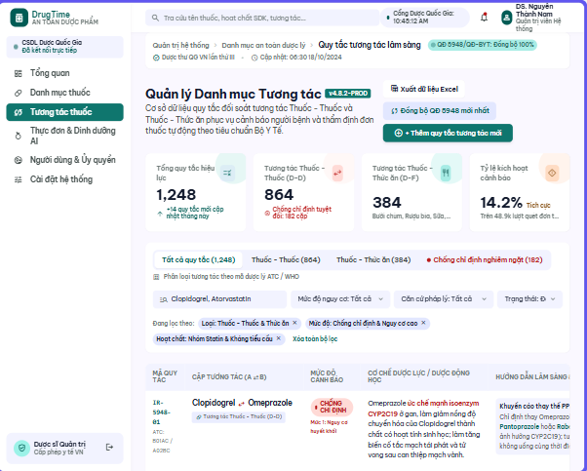

UC 23: Synchronize Regulatory Drug Data
- Use Case Diagram

- Use Case Specification
Use Case ID | UC.23
Use Case Name | Synchronize Regulatory Drug Data
Created by | Bao Nguyen |  | Last updated by |  | Bao Nguyen
Date Created | Sep 20, 2026 |  | Date last updated |  | Sep 20, 2026
Actors | Admin
Brief Description | It allows the administrator to initiate the synchronization of drug catalog and interaction data—sourced from Vietnamese pharmaceutical data sources within the system's scope—into the DrugTime catalog. The system also supports periodic synchronization via background jobs.
Goal | Update DrugTime's medication and interaction catalogues using the Vietnamese pharmaceutical data sources defined in the system.
Trigger | The admin clicks the "Synchronize Data" button on the Admin Dashboard, or the background job schedule triggers.
Pre-conditions | - For the flow initiated by the Admin, the Admin is logged in and has permission to manage the catalogue.  - The data source to be synchronized is configured and accessible..
Post-conditions | - New medication/interaction records updated in Supabase.  - The sync log process is complete.
Main Flow | Step | Actor Action |  | System Response
Main Flow | 1 | The admin requests the synchronization of regulatory drug data. |  | Synchronous request reception system.
Main Flow | 2 |  |  | System for initiating data synchronization tasks.
Main Flow | 3 |  |  | The system retrieves data from the corresponding Vietnamese Drug Regulatory Data Source.
Main Flow | 4 |  |  | The system receives and processes the incoming data.
Main Flow | 5 |  |  | The system updates valid data into the corresponding medication catalogue and/or interaction catalogue.
Main Flow | 6 |  |  | The system completes the synchronization process and notifies the Admin of the result.
Alternative Flow | Alternative 1: The synchronization process runs automatically in the background without administrator intervention.
Alternative Flow | Step | Actor Action |  | System Response
Alternative Flow | 1 |  |  | Scheduled time for triggering the Background Worker
Alternative Flow | 2 |  |  | The system retrieves data from the corresponding Vietnamese Drug Regulatory Data Source.
Alternative Flow | 3 |  |  | Continues to step 4 in Main Flow
Exception Flow | Exception 1: Regulatory Data Source Unavailable
Exception Flow | Step | Actor Action |  | System Response
Exception Flow | 1 | The admin requests the synchronization of regulatory drug data. |  | Synchronous request reception system.
Exception Flow | 2 |  |  | System for initiating data synchronization tasks.
Exception Flow | 3 |  |  | The system attempts to retrieve data from the corresponding Vietnamese Drug Regulatory Data Source but fail
Exception Flow | 5 |  |  | The system stops the synchronization process for that source.
Exception Flow | 6 |  |  | The system notifies the administrator of the synchronization failure.
Priority | High
Business Rule | BR-29, BR-30

- Prototype
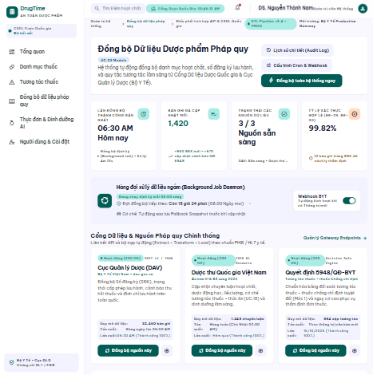

UC 24: Review Unmatched Medication Scan Results
- Use Case Diagram
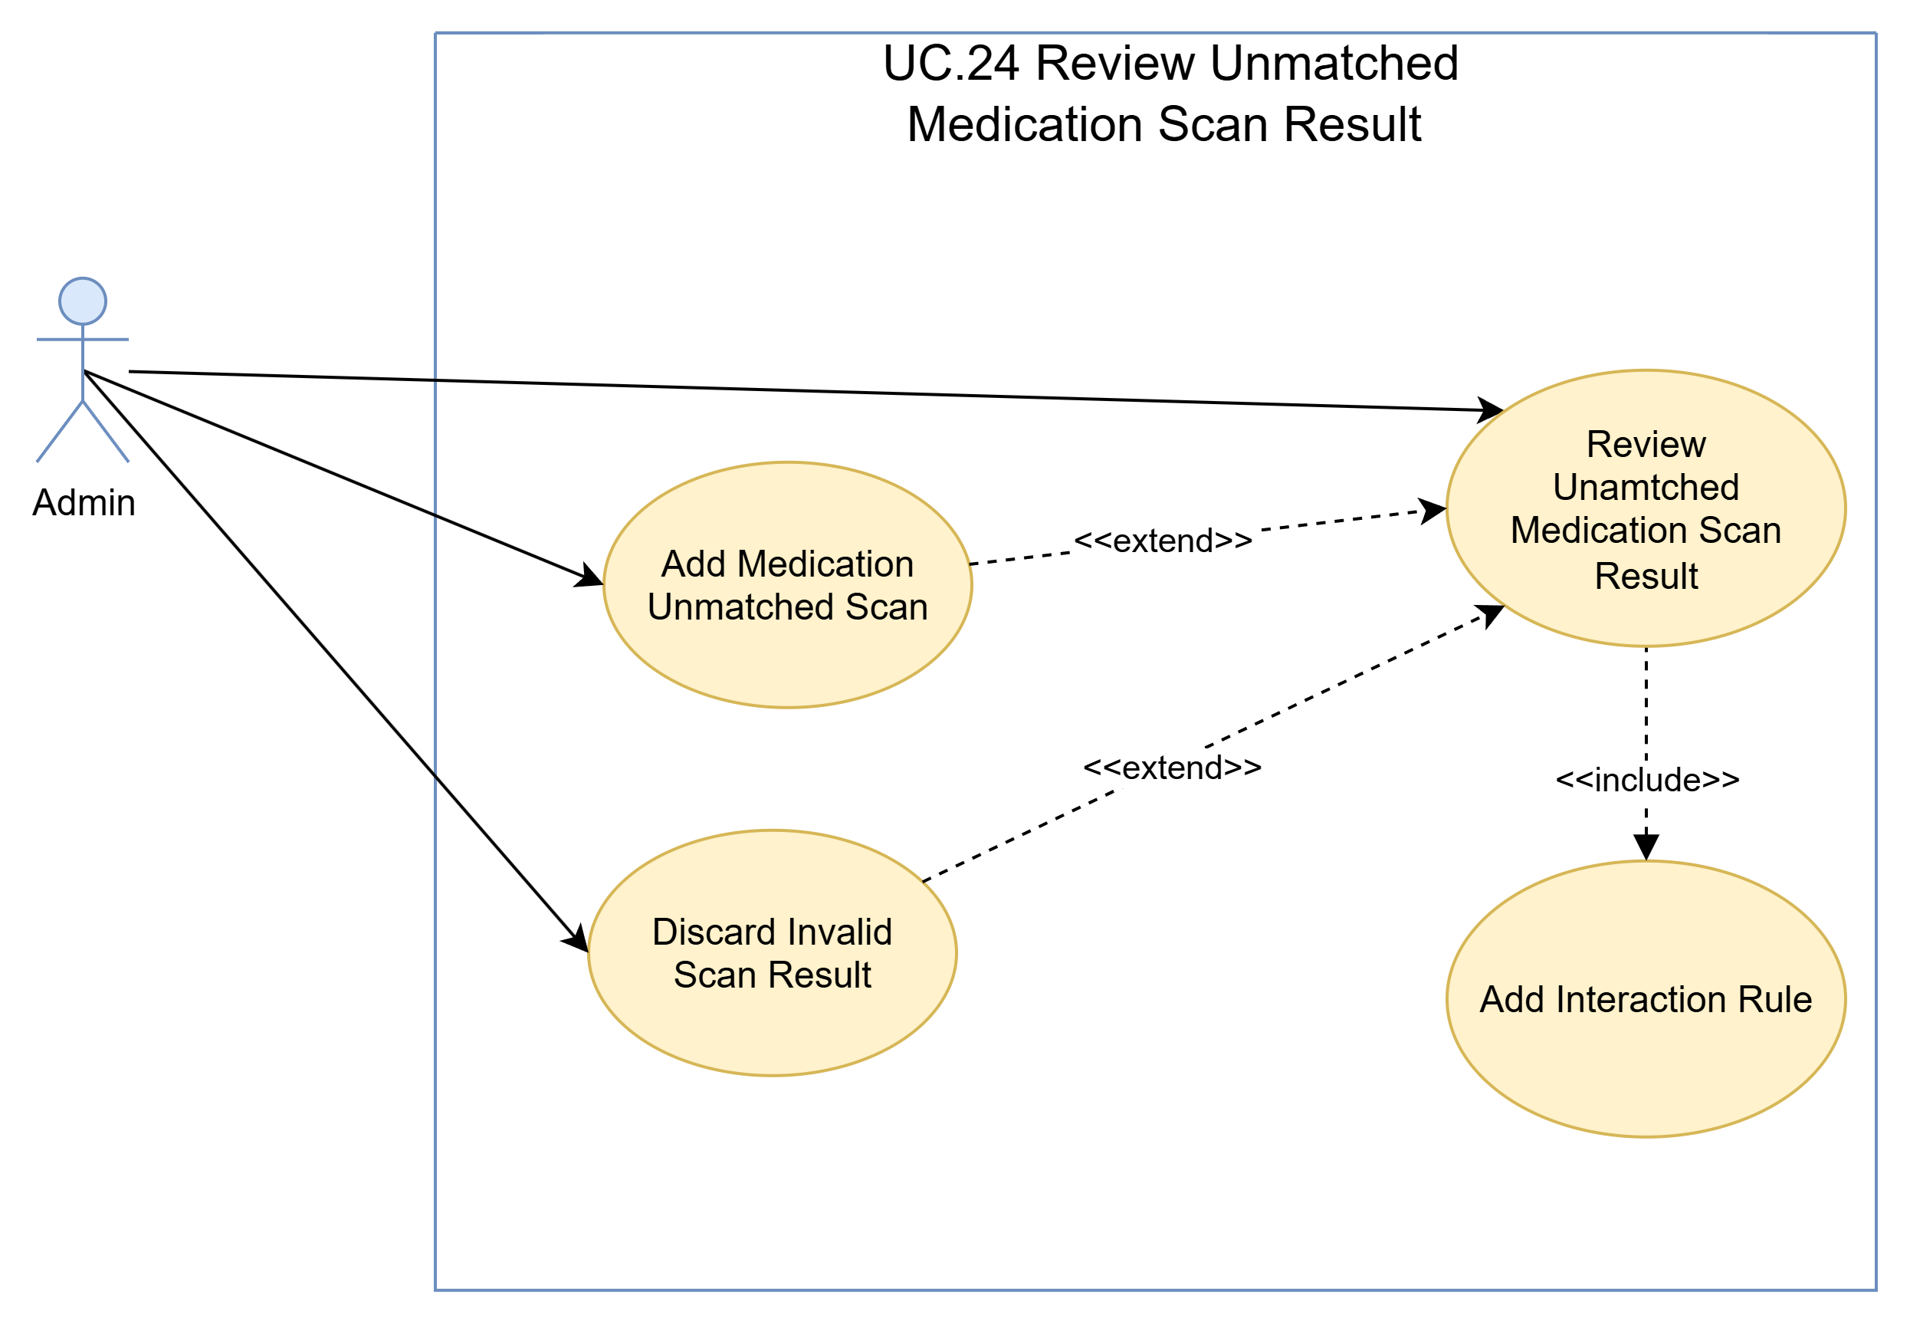
- Use Case Specification
Use Case ID | UC.24
Use Case Name | Review Unmatched Medication Scan Results
Created by | Bao Nguyen |  | Last updated by |  | Bao Nguyen
Date Created | Sep 20, 2026 |  | Date last updated |  | Sep 20, 2026
Actors | Admin
Brief Description | Allows administrators to review text records from blister packs—scanned via OCR/ML Kit on the mobile app—that the system could not automatically match with the existing medication catalog. This enables administrators to add new medications to the catalog or refine the matching data.
Goal | Monitor failed blister pack scans to continuously expand and refine the medication catalog.
Trigger | The admin opens the "Review Mismatched Scan Results" screen on the Admin Web Dashboard.
Pre-conditions | - The admin has successfully logged in.  - Mismatched blister pack scan records have been received from the patient device.
Post-conditions | Non-matching records are marked as "Processed," and new medications (if any) are added to the master list.
Main Flow | Step | Actor Action |  | System Response
Main Flow | 1 | The admin accesses the list of mismatched blister pack scan records. |  | The system displays a list of scanned OCR text strings, along with the scan time and frequency of occurrence.
Main Flow | 2 | The admin selects an unprocessed record to view its details. |  | System for displaying details of recognized text
Main Flow | 3 | The admin verifies the medication information and selects "Add this medication to the Standard List." |  | The system opens the "add new medication" form with OCR-extracted text information pre-filled.
Main Flow | 4 | The admin fills in the missing fields and clicks "Confirm Add." |  | System for creating new drug records in the catalog and updating the status of mismatched scan records to "Processed."
Alternative Flow | Alternative 1: The admin ignores or deletes the error scan record caused by an invalid scan image.
Alternative Flow | Step | Actor Action |  | System Response
Alternative Flow | 1 | The admin selects an unprocessed record to view its details. |  | System for displaying details of recognized text
Alternative Flow | 2 | The administrator checks the scanned document and detects noise or errors—specifically, information that is not a drug name.
Alternative Flow | 3 | The admin clicks "Mark as ignored." |  | The record status is set to "Discarded."
Exception Flow | Exception 1: List of mismatched scan records is empty.
Exception Flow | Step | Actor Action |  | System Response
Exception Flow | 1 | The admin accesses the list of mismatched blister pack scan records. |  | The system displays the message "No mismatched scan records to review."
Priority | High
Business Rule | BR-11, BR-12

- Prototype
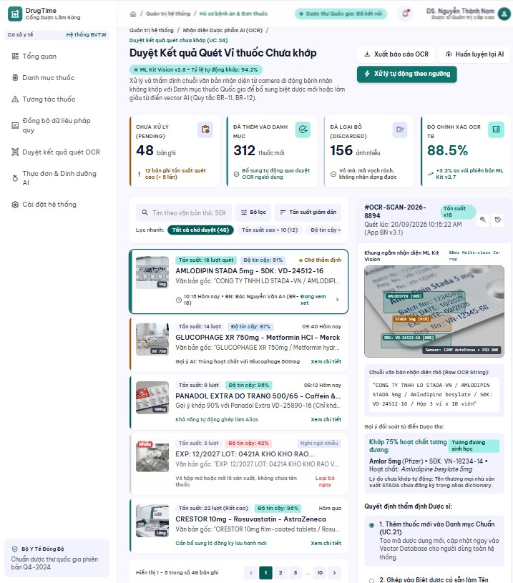

UC 25: Submit Data-Deletion Request
- Use Case Diagram
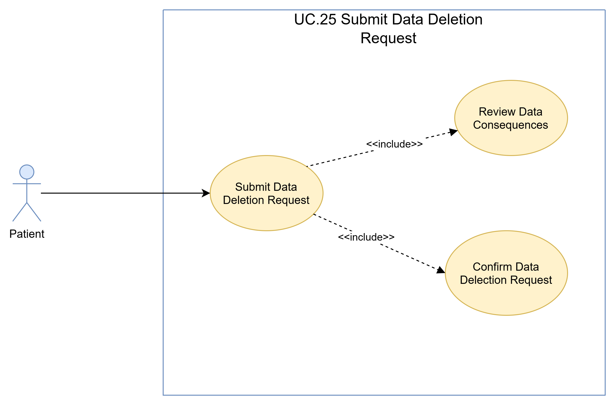
- Use Case Specification
Use Case ID | UC.25
Use Case Name | Submit Data Deletion Request
Created by | Bao Nguyen |  | Last updated by |  | Bao Nguyen
Date Created | Sep 20, 2026 |  | Date last updated |  | Sep 20, 2026
Actors | Patient
Brief Description | A patient submits a request to delete their personal or health data in order to exercise their data subject rights as stipulated by the Personal Data Protection Law 2025 and Decree 356/2025/ND-CP. The request will be routed to the administrator's processing queue.
Goal | Ensure patients' rights to withdraw consent and request data deletion in accordance with legal regulations.
Trigger | The patient selects "Send data deletion request" within the Account Settings / Consent Management interface.
Pre-conditions | - The patient has logged into their DrugTime account.  - The patient accesses the correct privacy settings screen.
Post-conditions | Data deletion requests are logged to the compliance queue with a timestamp.
Main Flow | Step | Actor Action |  | System Response
Main Flow | 1 | The patient opens the app and accesses the menu: Account Settings -> Privacy Management. |  | The system displays consent settings and the "Submit data deletion request" option.
Main Flow | 2 | The patient selects "Submit data deletion request." |  | The system displays a warning screen regarding the scope of data to be deleted and the consequences (loss of medication history, unlinking of family connections, etc.).
Main Flow | 3 | The patient selects a reason and clicks "Confirm request submission." |  | The system logs data deletion requests, along with timestamps, into the admin processing queue.
Main Flow | 4 |  |  | The system displays the notification: "Your data deletion request has been successfully submitted and will be processed in accordance with regulations."
Alternative Flow | Alternative 1: Patient changes mind and cancels request before confirmation
Alternative Flow | Step | Actor Action |  | System Response
Alternative Flow | 1 | The patient selects "Submit data deletion request." |  | The system displays a warning screen regarding the scope of data to be deleted and the consequences (loss of medication history, unlinking of family connections, etc.).
Alternative Flow | 2 | The patient selects "Cancel". |  | System for closing the screen while retaining account data.
Exception Flow | Exception 1: Internet connection lost while sending request
Exception Flow | Step | Actor Action |  | System Response
Exception Flow | 1 | The patient opens the app and accesses the menu: Account Settings -> Privacy Management. |  | The system attempts to display consent settings and the "Submit data deletion request" option but fail due to lost connection
Exception Flow | 2 |  |  | The system displays the message: "Unable to send request due to a network connection loss. Please try again later."
Priority | High
Business Rule | BR-06, BR-25

- Prototype
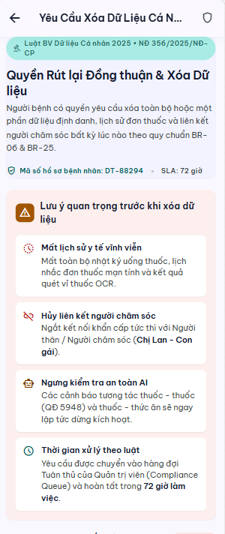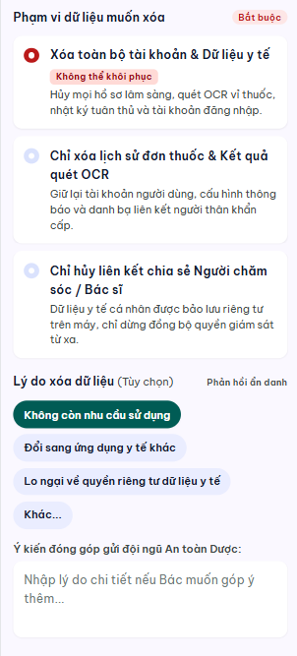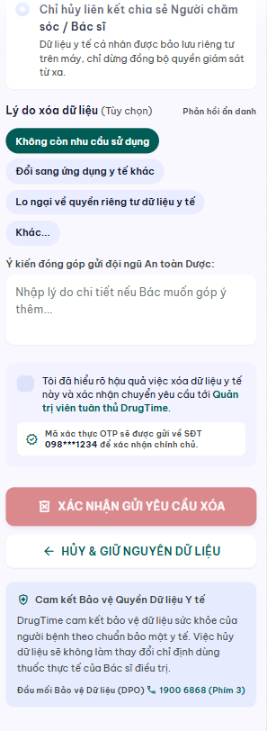

UC 26: Manage Privacy, Compliance and Sensitive-Data Access
- Use Case Diagram
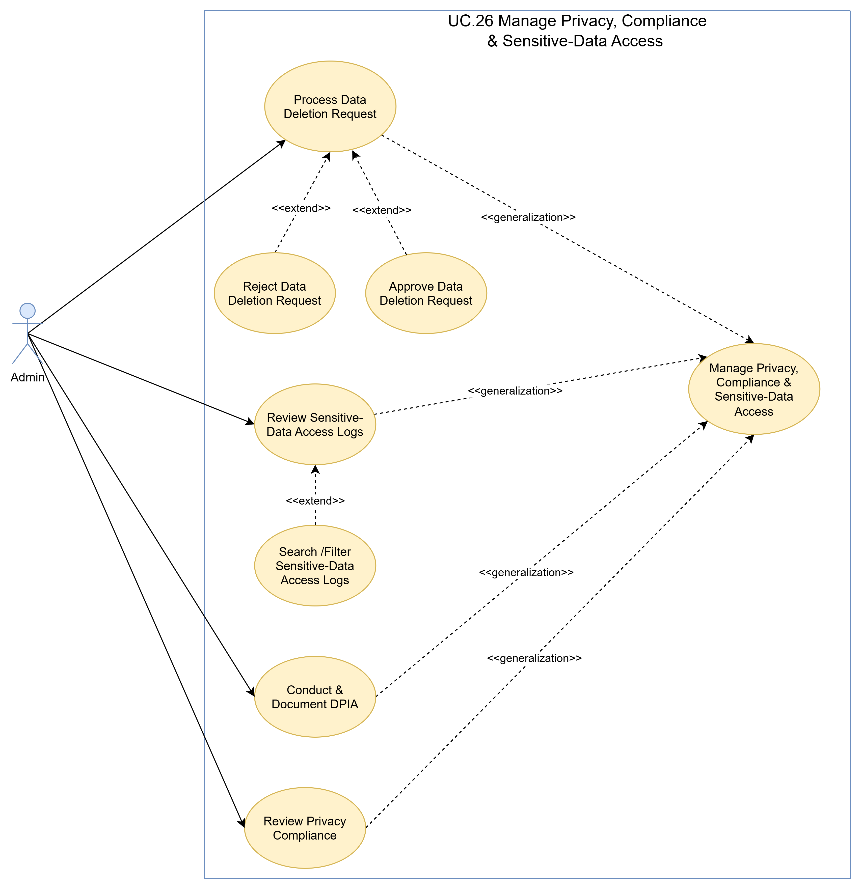
- Use Case Specification
Use Case ID | UC.26
Use Case Name | Manage Privacy, Compliance and Sensitive-Data Access
Created by | Bao Nguyen |  | Last updated by |  | Bao Nguyen
Date Created | Sep 20, 2026 |  | Date last updated |  | Sep 20, 2026
Actors | Admin
Brief Description | The administrator monitors compliance with the 2025 Personal Data Protection Law and Decree 356/2025/ND-CP, conducts Personal Data Processing Impact Assessments (DPIA), processes user requests for data deletion or withdrawal of consent, and audits access logs for sensitive health data.
Goal | Ensure transparency, comply with laws on personal data protection, and control the entire flow of sensitive medical information within the system.
Pre-conditions | The admin has logged into the Admin Web Dashboard with Compliance Administrator privileges.
Post-conditions | - Data deletion requests are executed or approved.  - The updated DPIA report  - Audit logs of sensitive data access are closely monitored.
Main Flow A | A. View and check the sensitive data access log.  Trigger: The admin selects the "Sensitive Data Access Log" tab.  Result: Display a list of instances where patient health data was accessed by family members or administrators.
Main Flow A | Step | Actor Action |  | System Response
Main Flow A | 1 | Navigate to the "Sensitive Data Access Log" page. |  | Display a log table containing the following fields: Timestamp, User ID, Role, Patient Accessed, and Scope of Data Viewed.
Main Flow A | 2 | Filter logs by time range, Patient ID, or Family Member ID, or filter denied access attempts. |  | Display audit log records that meet the search criteria.
Main Flow B | B. Processing requests for data deletion and withdrawal of consent from patients.  Trigger: The admin selects the "Data Deletion Queue / Approval" tab.  Result: Request for data deletion/withdrawal of consent approved and implemented.
Main Flow B | Step | Actor Action |  | System Response
Main Flow B | 1 | Click the "Data Deletion Request" tab. |  | Display a list of pending data deletion requests submitted by patients.
Main Flow B | 2 | Select a data deletion request and verify the data subject's information. |  | Display request details and the scope of data to be processed.
Main Flow B | 3 | Click "Approve & Execute Data Deletion" |  | The system deletes or disables the corresponding personal/medical data in the database in accordance with regulations.
Main Flow B | 4 |  |  | Record the completion status in the compliance database and send a confirmation notification.
Main Flow C | C. Conduct and document the personal data processing impact assessment.  Trigger: The admin selects the "DPIA Record Management" function.  Result: The DPIA record for the new sensitive data processing flow has been logged.
Main Flow C | Step | Actor Action |  | System Response
Main Flow C | 1 | Select "Create new DPIA" before implementing a new sensitive data flow. |  | Display the DPIA assessment form in accordance with Decree 356/2025/ND-CP.
Main Flow C | 2 | Enter information regarding risk assessment, protective measures, and the scope of data processing. |  | Verify the validity of the DPIA documentation.
Main Flow C | 3 | Click "Approve DPIA dossier". |  | Save the DPIA record to the compliance database to serve as a basis for audits.
Main Flow D | D PDPL 2025 / Decree 356 Compliance Review and Assessment  Trigger: The admin selects "2025 PDPL Compliance Check."  Result: Display an overview report on distinct consent collection rates, consent withdrawals, and data safety status.
Main Flow D | Step | Actor Action |  | System Response
Main Flow D | 1 | Access the compliance overview screen. |  | Display compliance metrics: 100% of transactions with valid authorization, database encryption status, number of resolved requests.
Alternative Flow | Alternative 1: The administrator denied the data deletion request due to legal retention obligations.
Alternative Flow | Step | Actor Action |  | System Response
Alternative Flow | 1 | The admin enters the legal reason for refusing the deletion and clicks "Refuse". |  | The system saves the rejection status along with the reason and notifies the patient.
Exception Flow | Exception 1: Error during automatic data deletion execution in the database.
Exception Flow | Step | Actor Action |  | System Response
Exception Flow | 1 | Click "Approve & Execute Data Deletion" |  | The system attempts to delete or disable the corresponding personal/medical data in the database in accordance with regulations but fail
Exception Flow | 2 |  |  | The system reports: "Unable to permanently delete data due to database integrity constraints. The data has been marked as hidden, and the task has been assigned to technical staff."
Priority | High
Business Rule | BR-25, BR-26, BR-27, BR-28

- Prototype
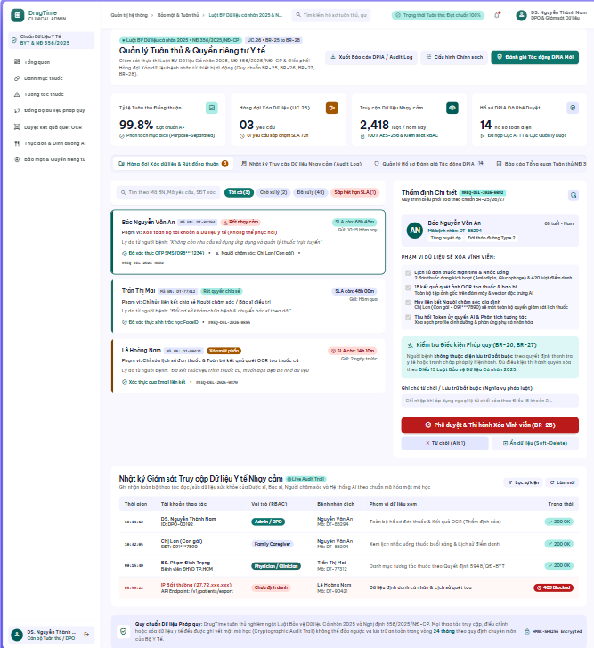

Software Quality Attributes

Usability
- Provide a dedicated Simple Mode.
- Use a simplified, high-contrast UI.
- Support low-tech-literacy users.

Reliability
- Provide manual medication entry when blister recognition or catalog matching fails.
- Require explicit user confirmation for scanned medication information.
- Drug and interaction information must use approved Vietnamese sources.
- Interaction and AI results must not be presented as diagnosis or treatment decisions.

Security
- Apply purpose-separated consent for personal and health data.
- Support consent withdrawal and data deletion.
- Restrict Family Member access according to explicit Patient consent.
- Log access to sensitive health data.
- Comply with applicable Vietnamese personal-data protection requirements.

Maintainability
- Support adding new modules and features in Phase 2.
- Minimize impact on existing components when extending the system.

Portability
- Support the DrugTime mobile application on Android and iOS.
- Use Flutter native builds for the mobile application.

Performance
- Process and deliver reminder notifications within 2 seconds under normal load.
- Process dose-confirmation actions within 2 seconds under normal load.
- Maintain at least 99% uptime for reminders, adherence tracking, and drug lookup.

Software Design Description

Sequence Diagrams

Register User Account
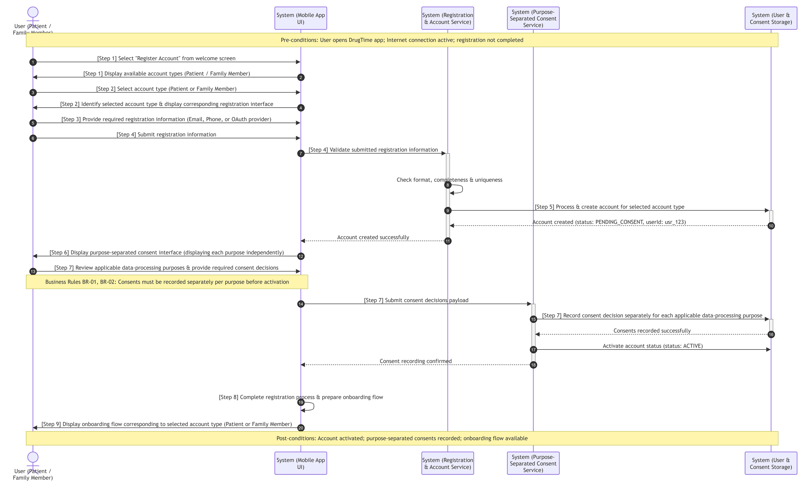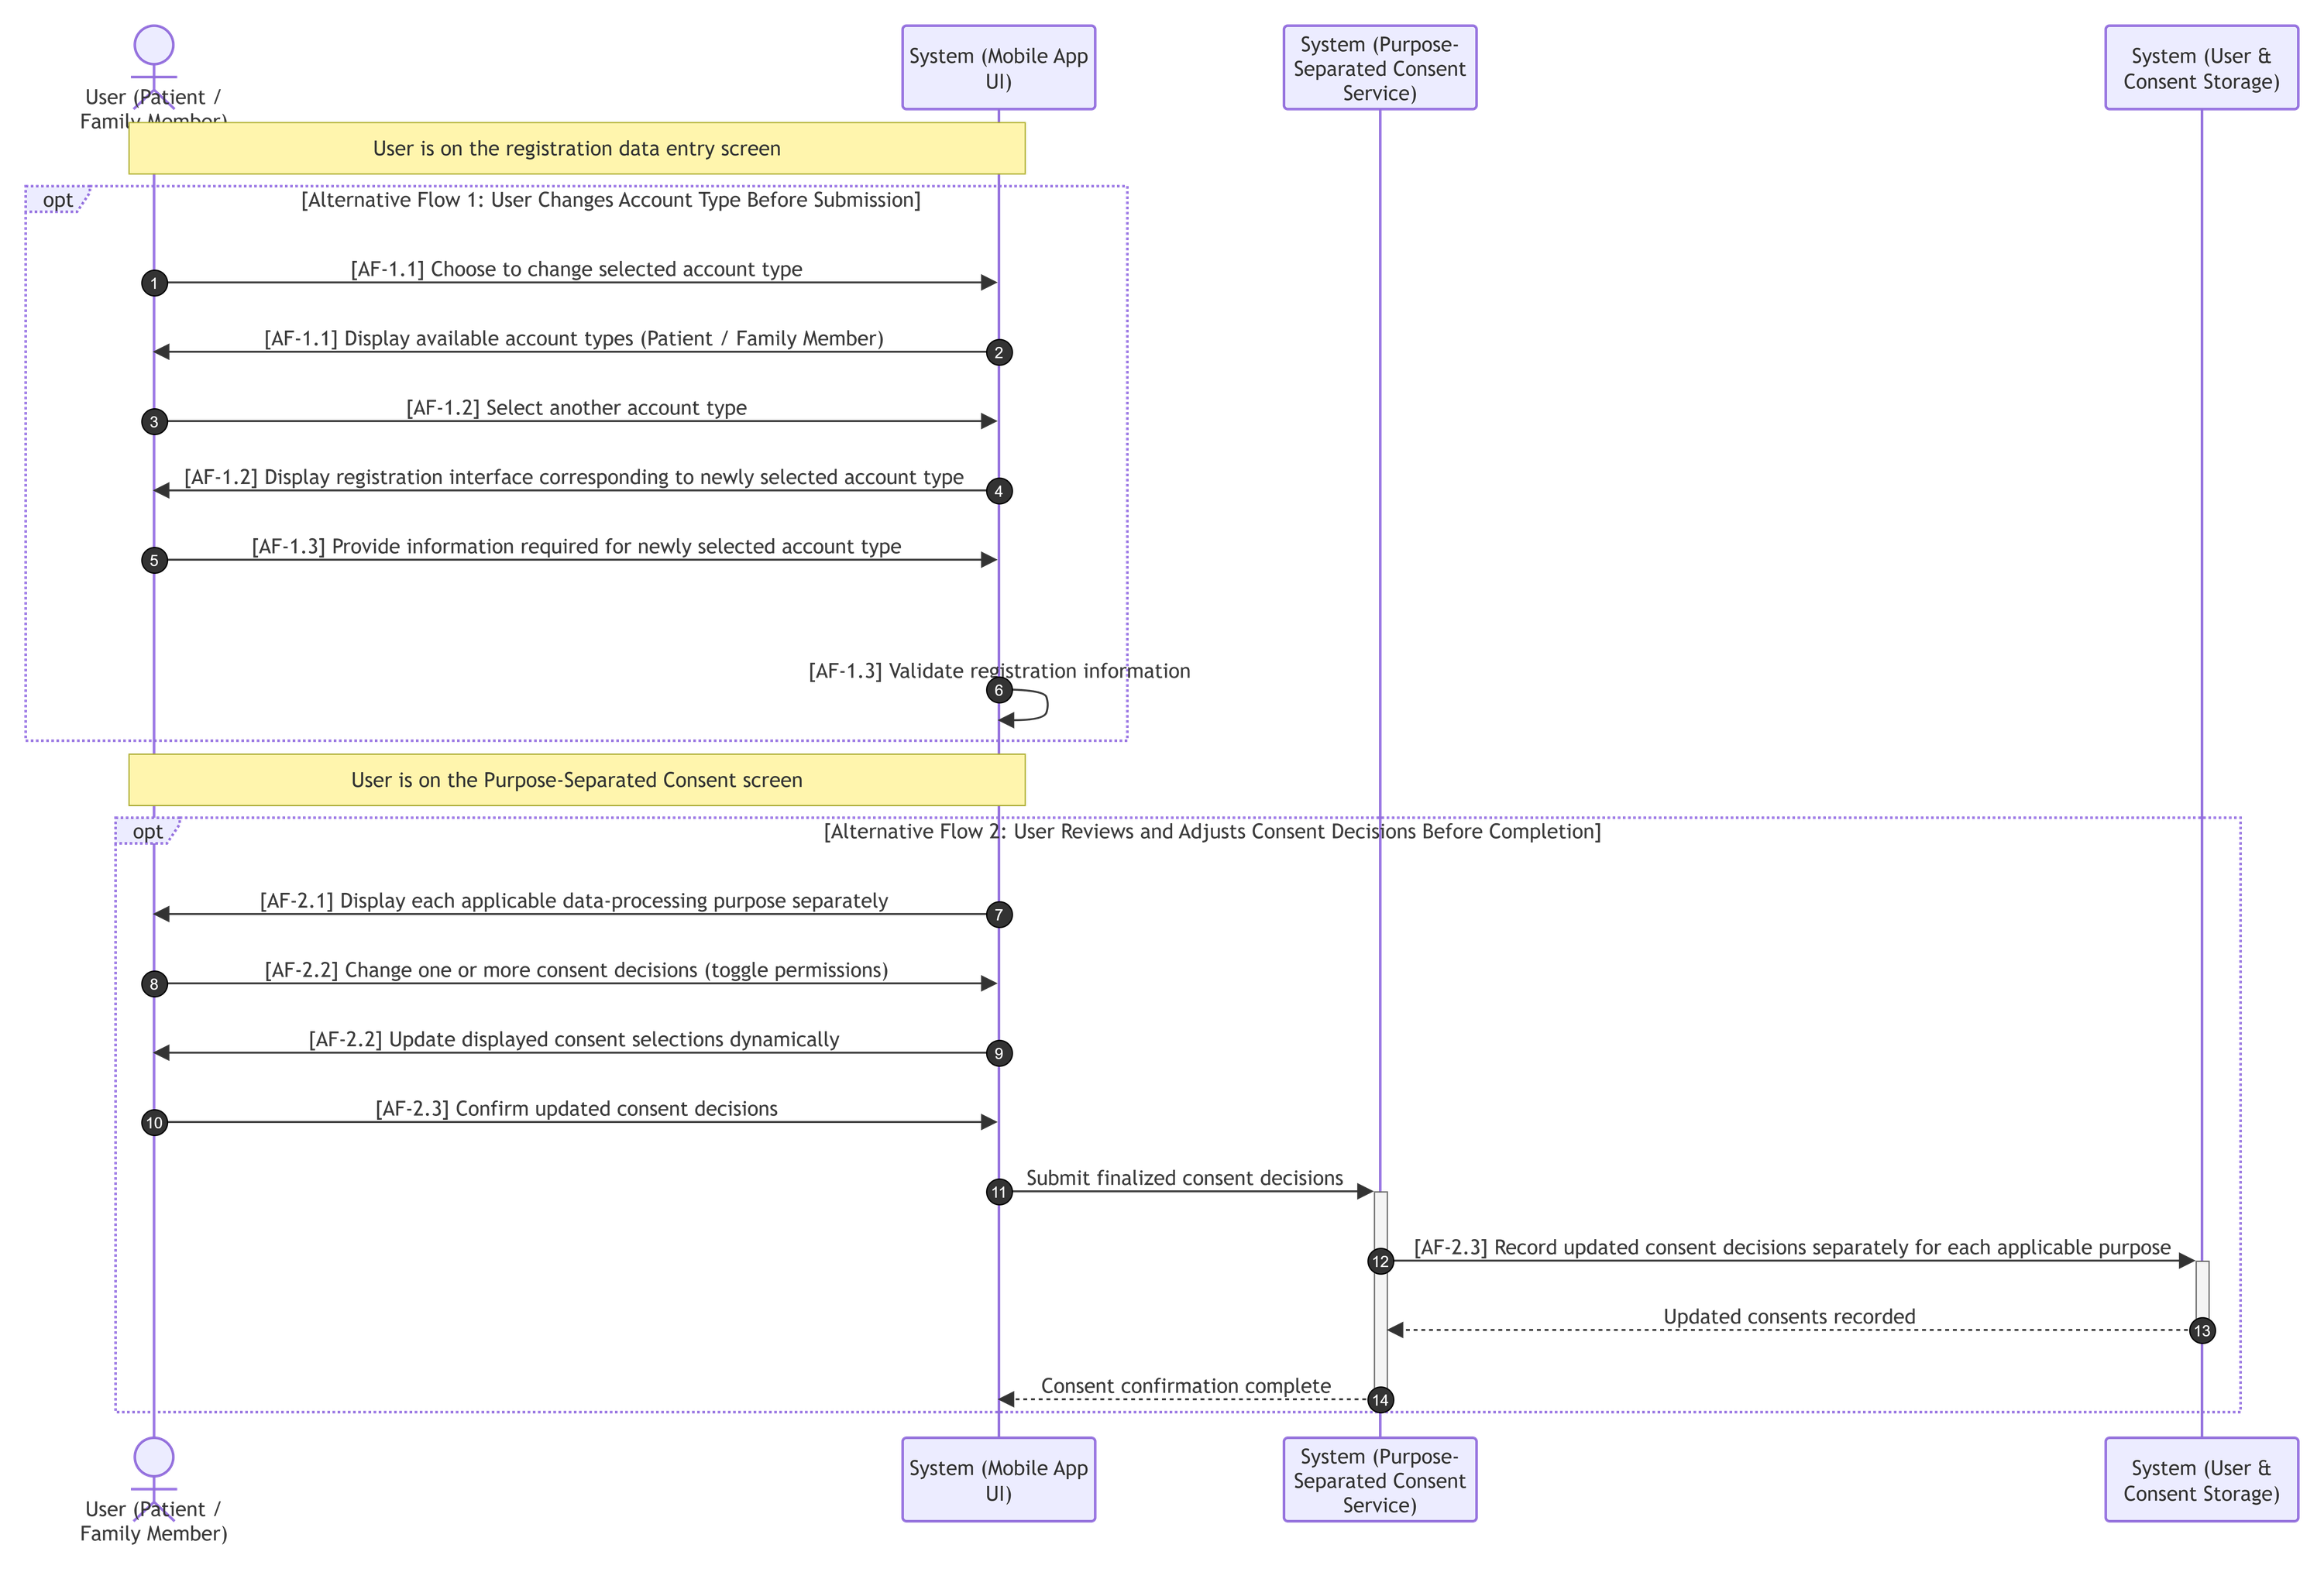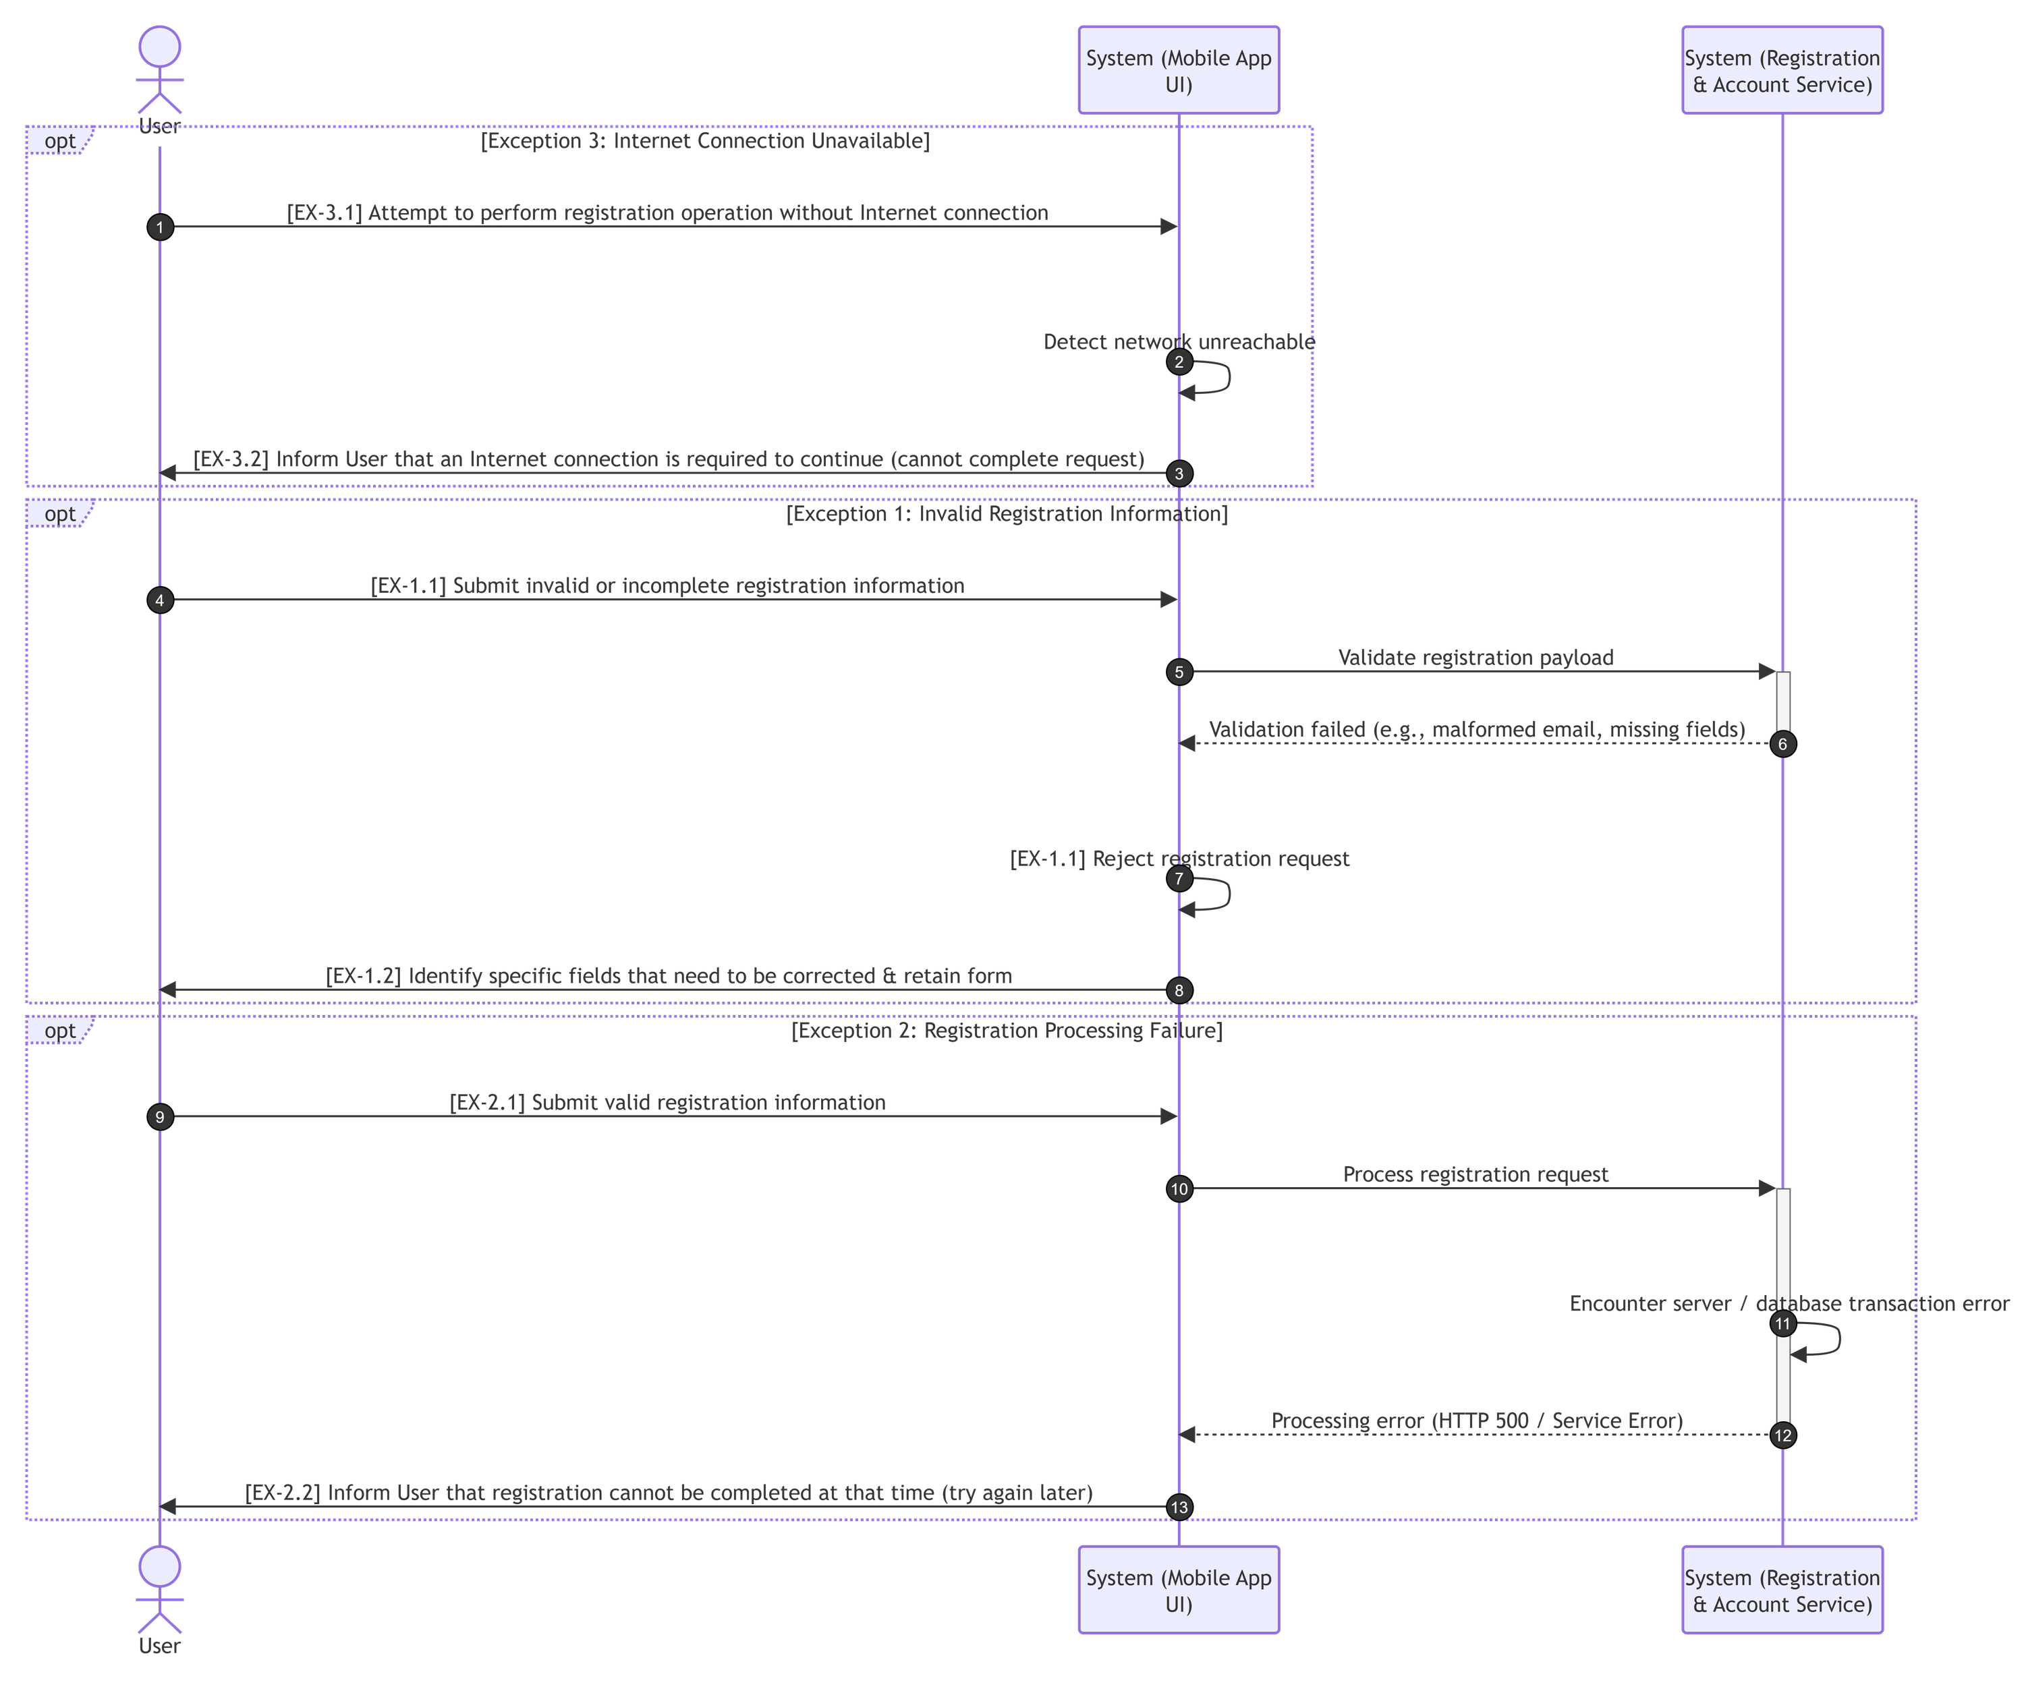

Authenticate User
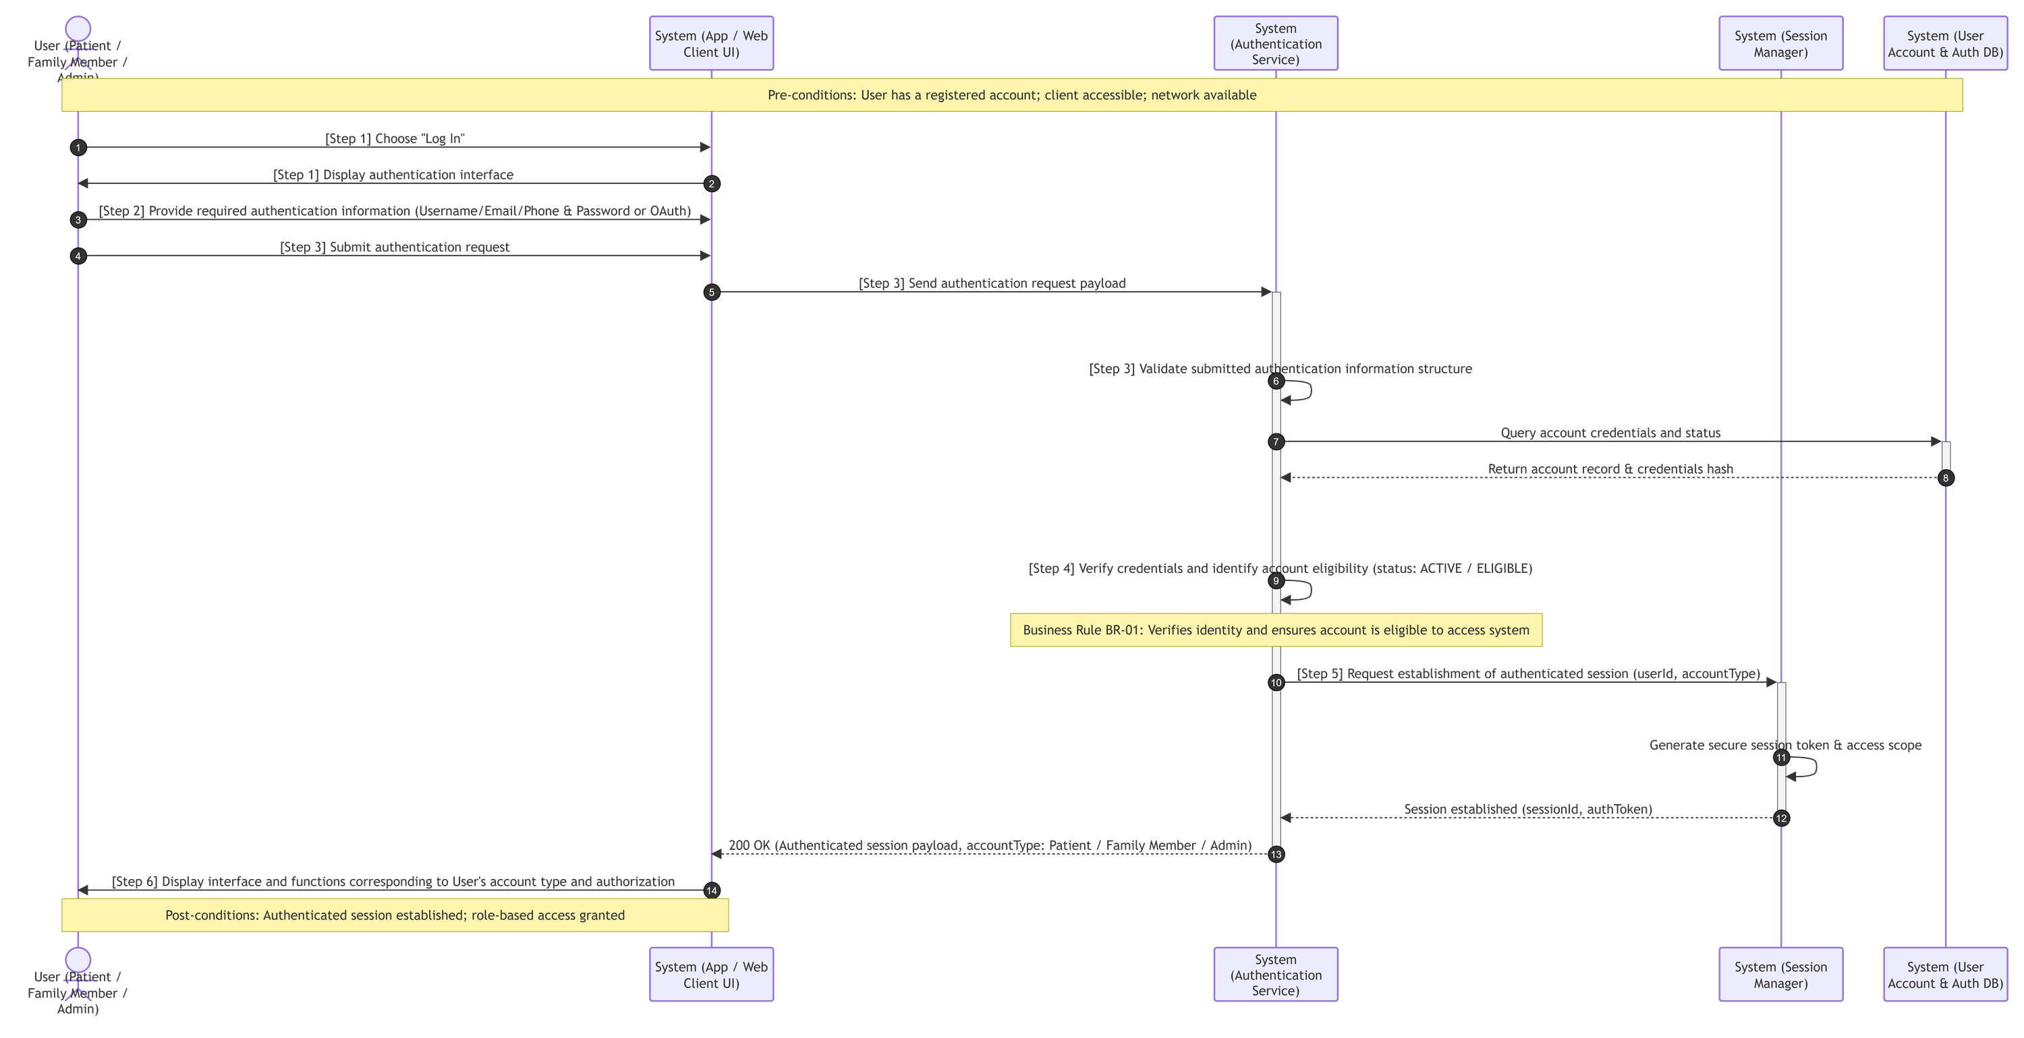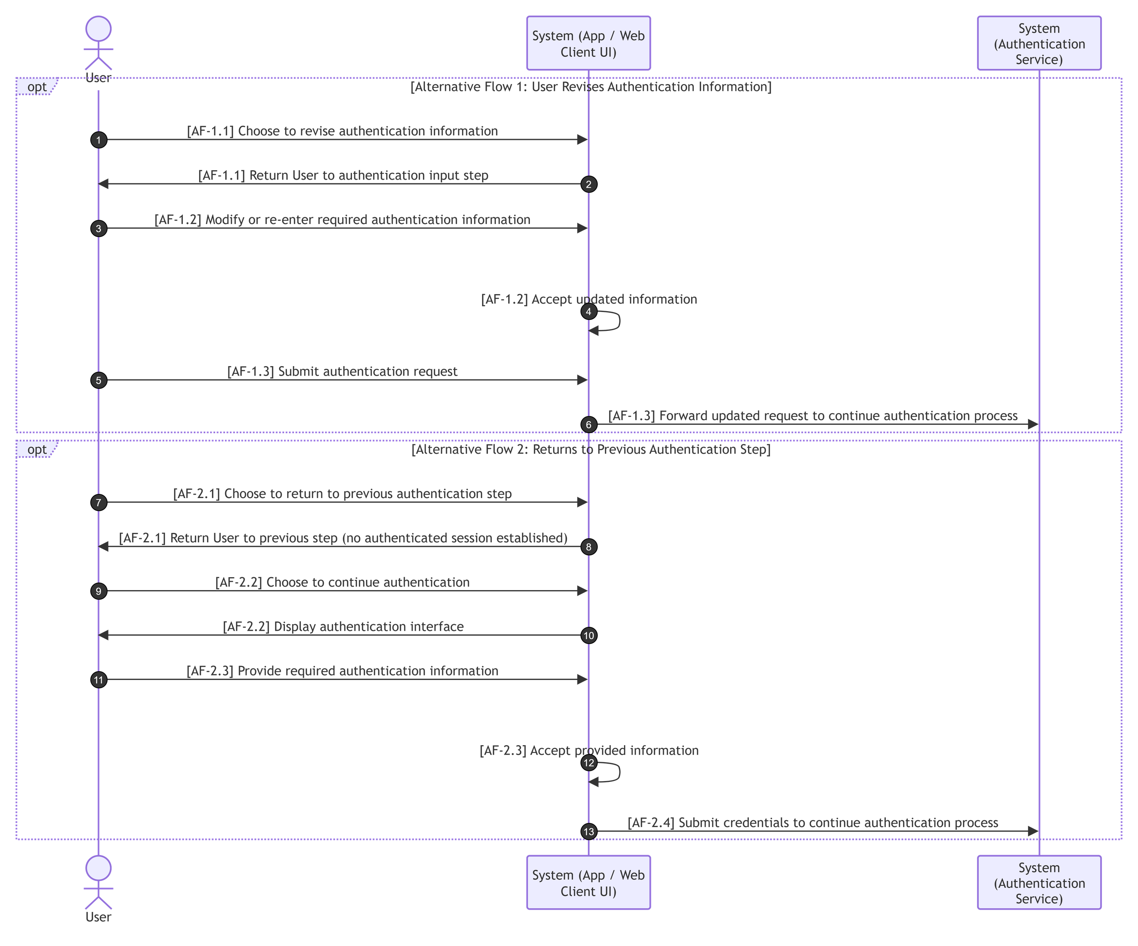

Manage Purpose-Separated Consent
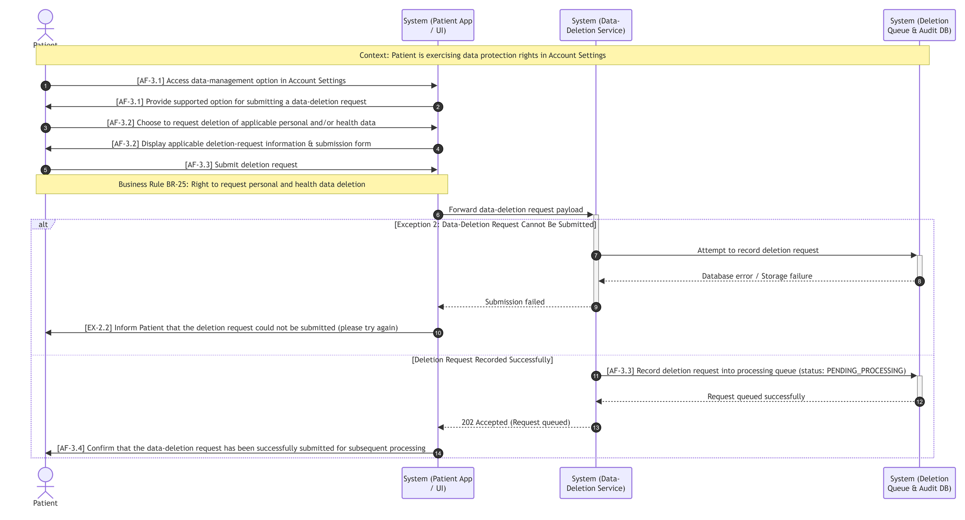

Manage Patient Health Profile

Add Medication Manually

Add Medication by Blister-Pack Scan

Review and Confirm Scanned Medication

Manage Recorded Medication

Manage Medication Schedule

Receive Medication Dose Reminder

Confirm Medication Dose Intake

Track Medication Adherence History

Link Family Caregiver Account

Manage Caregiver Permissions

Manage Multiple Linked Patients

Look Up Drug Information

Check Drug-Drug Interaction

Check Drug-Food Interaction

Generate AI Meal Suggestion

Configure Simple Mode Display

Manage Medication Catalogue

Manage Interaction Catalogue

Synchronize Regulatory Drug Data

Review Unmatched Medication Scan Results

Submit Data-Deletion Request

Manage Privacy, Compliance and Sensitive-Data Access

Activity Diagrams

Register User Account
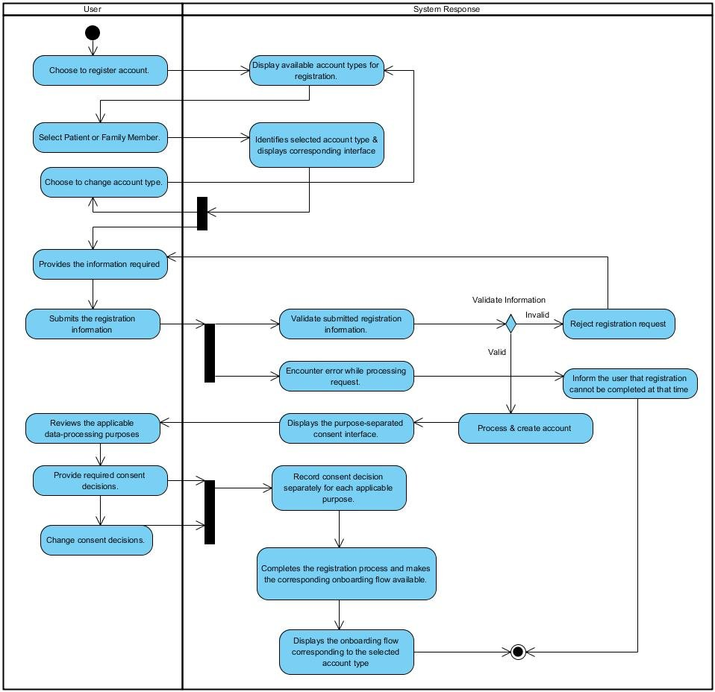

Authenticate User
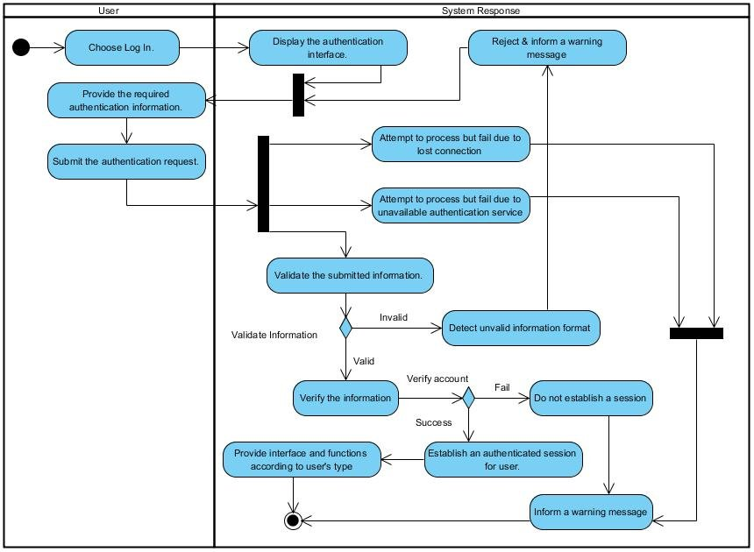

Manage Purpose-Separated Consent
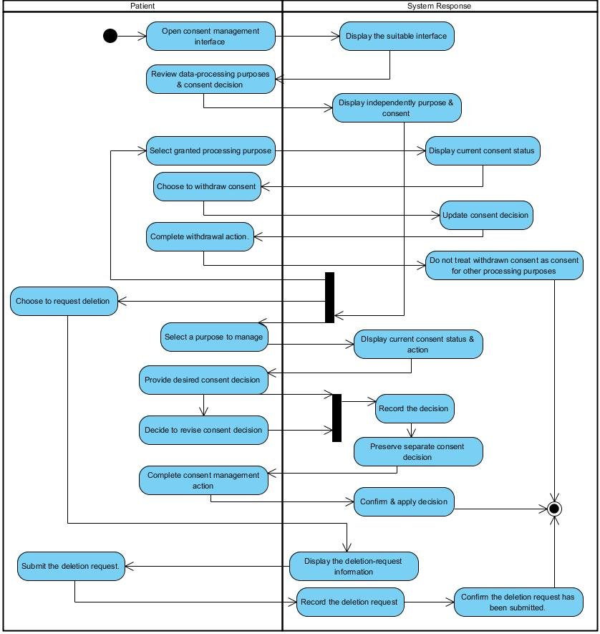

Manage Patient Health Profile

Add Medication Manually

Add Medication by Blister-Pack Scan

Review and Confirm Scanned Medication

Manage Recorded Medication

Manage Medication Schedule

Receive Medication Dose Reminder

Confirm Medication Dose Intake
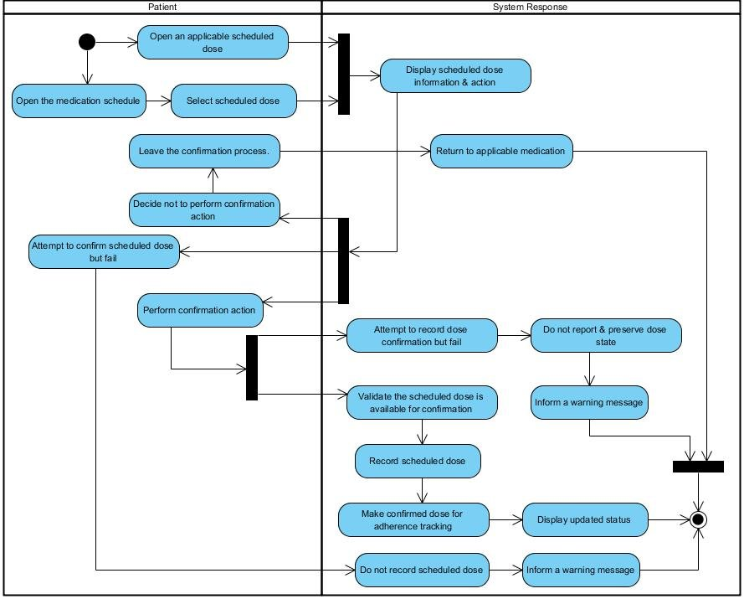

Track Medication Adherence History

Link Family Caregiver Account

Manage Caregiver Permissions

Manage Multiple Linked Patients

Look Up Drug Information

Check Drug-Drug Interaction

Check Drug-Food Interaction

Generate AI Meal Suggestion

Configure Simple Mode Display

Manage Medication Catalogue

Manage Interaction Catalogue

Synchronize Regulatory Drug Data

Review Unmatched Medication Scan Results

Submit Data-Deletion Request

Manage Privacy, Compliance and Sensitive-Data Access

State Diagram

Class Diagram

Allocation Diagram

Appendix A: Glossary

BC | Business Constraint
TC | Technical Constraint
FR | Functional Requirement
QA | Quality Attribute
UC | Use case
BR | Business rule

